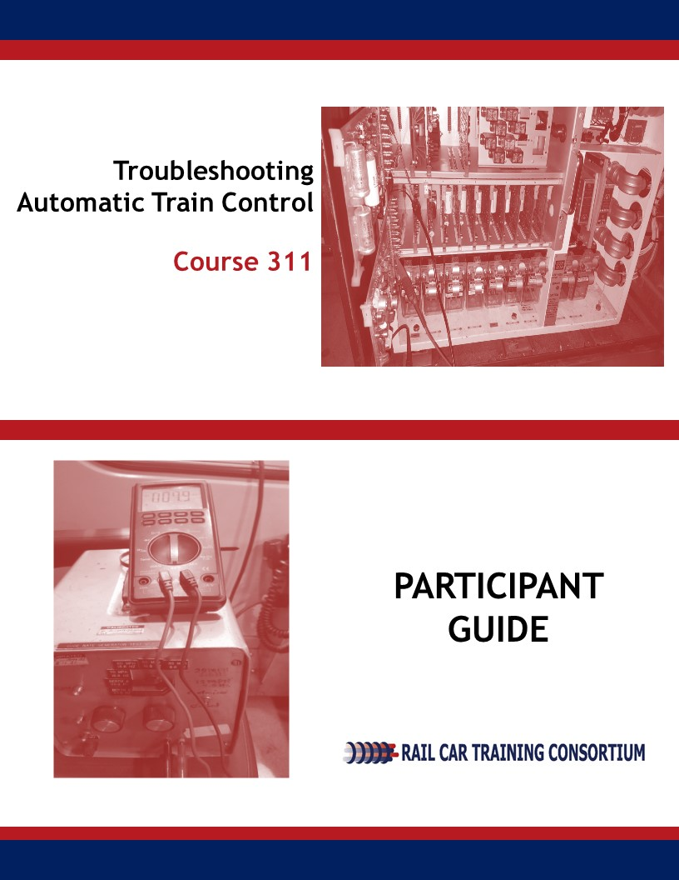

Automatic Train Control

Troubleshooting

Course 311

Participant Guide

July 2018
Rail Car Training Consortium

REVISION INDEX

Any additions, deletions, or revisions are to be listed below.

Revision No. | Date | Section | Description of Change | Revision Author
01 | 2-2019 |  | Tech Edits | YOUNGBLUTH
02 | 3-2019 |  | Edits | K.Ribaudo

Disclaimer: This course is intended to educate employees of public transportation systems that have agreed to voluntarily participate in the Rail Car Training Consortium. It is intended only as informal guidance on the matters addressed, and should not be relied upon as the only method or manner for performing the tasks or work outlined in the materials. Anyone using this document or information provided in the associated training program should rely on his or her own independent judgment or, as appropriate, seek the advice of a competent professional in determining the exercise of care in any given circumstances. These materials are based on compendiums of knowledge from transit employees, manufacturers and outside consultants, each of whom may approach a repair, update, or maintenance in their own unique way. Always follow the safety and maintenance procedures from your own agency, union, relevant OEM(s) and/or regulatory organizations. In addition, the course materials include examples from member agencies, nomenclature, procedures, and configurations which can vary from one transit location to another. The document that you are now referencing may have been modified by the Consortium member. For the original versions, please go to TransitTraining.net or contact the Transportation Learning Center.

The Rail Car Training Consortium, its participating agencies and labor unions, as well as the Transportation Learning Center, make no guaranty or warranty as to the accuracy or completeness of any information provided herein. The Rail Car Training Consortium, its participating agencies and labor unions, as well as the Transportation Learning Center, disclaim liability for any injury or other damages of any nature whatsoever, directly or indirectly, resulting from the use of or reliance on this document or the associated training program.

Note: All images contained within this document were contributed by Rail Car Training Consortium members unless otherwise noted.

How to Use the Participant Guide
Purpose of the Course

Course 211: Inspection and Maintenance of Automatic Train Control, provides participants with an overview of how to inspect and maintain Automatic Train Control system. This course is intended to prepare the participant to inspect and maintain the Automatic Train Control system in a transportation maintenance facility.

Approach of the Book

Each course Module begins with an outline, a statement of purpose and objectives, and a list of key terms. The outline will discuss the main topics to be addressed in the Module. A list of key terms identifies important terminology that will be introduced in this Module. Learning objectives define the basic skills, knowledge, and abilities course participants should be able to demonstrate to show that they have learned the material presented in the Module. Exercises are built in throughout the course materials to assist the participants in learning and reviewing key information.

Table of Contents
How to Use the Participant Guide iii
Module 1 Troubleshooting Exterior ATC Components 1
1-1 Overview 2
1-2 Troubleshooting Antenna/Receiver Coils 3
1-3 Troubleshooting Speed Sensors 4
1-4 Troubleshooting Train ID 4
1-5 Summary 5
Module 2 Troubleshooting Interior ATC Components 6
2-1 Overview 8
2-2 Troubleshooting CPU Board and Interface Board 9
2-3 Troubleshooting Relays 9
2-4 Troubleshooting Power Supply 10
2-5 Troubleshooting Decelerometer 10
2-6 Troubleshooting Aspect Display Unit 11
2-7 Troubleshooting Bypass Switch 12
2-8 Troubleshooting Master Controller 12
2-9 Troubleshooting Operator Acknowledgment Button 13
2-11 Summary 14

Module 1

Troubleshooting Exterior ATC Components
Outline
  - Overview
  - Antenna/ Receiver Coil
  - Speed Sensor
  - Train ID
Purpose and Objectives
The purpose of this Module is to provide participants with an overview to troubleshooting exterior Automatic Train Control (ATC) components.
Following the completion of this Module, the participant should be able to complete the objectives with an accuracy of 75% or greater:
- Demonstrate the ability to explain and apply troubleshooting methods for:
  - Antenna
  - Receiver Coil
  - Speed sensor
  - Train ID
Key Terms
- Antenna  - Receiver Coil | - Speed Sensor | - Train ID

  - overview
In Course 300, Troubleshooting Principles, the participant was provided with an overview of the troubleshooting process along with related general strategies, tips and pitfalls. This course, Course 311, builds on the earlier troubleshooting course and focuses on commonly reported problems with the ATC subsystems.
Troubleshooting is a systematic approach to find the source of a problem in an effort to restore a component, operation or process. Because there are so many variances in rail car types and systems, this course cannot be a one-size-fits-all course on ATC. The goal of this course is to identify common troubleshooting scenarios that the rail car technician can analyze and apply to similar situations in their role at their transportation agency. This Module will focus on exterior components of the ATC systems.
This course is broken up into two modules and will cover troubleshooting tips and strategies for:
- ATC exterior components
- ATC interior components
This Module jumps right into troubleshooting ATC exterior components. For each component discussed in this Module, a troubleshooting table is presented with three columns:
- Symptom
- Probable Cause
- Corrective Action
Symptom | Probable Cause | Corrective Action

The tables presented are useful however, further agency specific information may be needed. Therefore, participants are encouraged to add their notes and observations to these tables during training.

Preparing for troubleshooting is an important first step. Therefore, before you begin to troubleshoot equipment it is important to always:
- Wear proper clothing and footwear;
- Ground all equipment;
- Assemble all test equipment;
- Assemble all required documentation.
  - troubleshooting Antenna/Receiver coils
Problems with the antennas and receiver coils are typically reported by the train operator. The operator may experience problems while on their route, at which time the train will be taken out of service.
SYMPTOM | PROBABLE CAUSE | CORRECTIVE ACTION
Unable to call route, loss of wayside, loss of cab speed | Signal strength is not strong enough | - Visual inspection  - Antenna and cables are secure  - No visible cracks  - Measure signal strength of the antenna to see how well it is receiving  - Replace antenna if signal strength is bad  - Retest
Agency Specific:
Agency Specific:

  - troubleshooting speed sensors
Problems with speed sensors are often communicated by the train operator. Maintenance technicians will then follow the general troubleshooting procedures listed below.
SYMPTOM | PROBABLE CAUSE | CORRECTIVE ACTION
Incorrect gap set on speed sensor | Speed sensor installed incorrectly | - Reinstall speed sensor  - Use a multimeter to check cable connections
Correct speed not sensed
Physically broken by wayside
Excessive panic braking
Speed is not transmitted correctly
Agency Specific:
Agency Specific:

  - troubleshooting train id
On newer rail vehicles, the manufacturer puts in a Train ID before the vehicle is sent to the agency. With newer cars, the ID is a digital number placed into the car, within the management system. There is no troubleshooting procedure for the Train ID. Older vehicles may differ. Refer to your individual agency for specific information.
Procedure for Troubleshooting Train ID:

1-5 summary
This Module provided a framework for rail car technicians to approach troubleshooting of the major components of the ATC system. The recommendations in this Module should be applied in conjunction with those in practice at the participant’s agency.

Module 2

Troubleshooting Interior ATC Components
Outline
  - Overview
  - CPU Board/Interface Board
  - Relays
  - Power Supply
  - Decelerometer
  - Aspect Display Unit
  - Bypass Switch
  - Master Controller
  - Operator Acknowledgment Button
  - Summary
Purpose and Objectives
The purpose of this Module is to provide participants with an overview to troubleshooting interior ATC components.
Following the completion of this Module, the participant should be able to complete the objectives with an accuracy of 75% or greater:
- Demonstrate the ability to explain and apply troubleshooting methods for:
  - CPU Board/Interface Board
  - Relays
  - Power Supply
  - Decelerometer
  - Aspect Display Unit
  - Bypass Switch
  - Master Controller
  - Operator Acknowledgment Button
  - P Signal Generator

Key Terms
- ATC  - CPU Board  - Decelerometer | - Interface Board  - Relays  - Power Supply  - P Signal Generator | - Aspect Display Unit  - Master Controller  - Bypass Switch  - Operator Acknowledgment Button

2-1 overview
In Course 300, Troubleshooting Principles, the participant was provided with an overview of the troubleshooting process along with related general strategies, tips and pitfalls. This course, Course 311, builds on the earlier troubleshooting course and focuses on commonly reported problems with the ATC systems.
Troubleshooting is a systematic approach to find the source of a problem in an effort to restore a component, operation or process. Because there are so many variances in rail car types and systems, this course cannot be a one-size-fits-all course on troubleshooting ATC. The goal of this course is to identify common troubleshooting scenarios that the rail car technician can analyze and apply to similar situations in their role at their transportation agency. This Module will focus on exterior components of the ATC systems.
This course is broken up into two modules and will cover troubleshooting tips and strategies for:
- ATC exterior components
- ATC interior components
This Module jumps right into troubleshooting ATC exterior components. For each component discussed in this Module, a troubleshooting table is presented with three columns:
- Symptom
- Probable Cause
- Corrective Action
Symptom | Probable Cause | Corrective Action
The tables presented are useful however, further agency specific information may be needed. Therefore, participants are encouraged to add their notes and observations to these tables during training.

2-2 troubleshooting CPU Board and interface board
The troubleshooting procedures are similar for the CPU Board and Interface Board and will be discussed together. Problems with these components may be reported by the train operator when the train is in service or by the rail car technician during daily inspection and preventive maintenance.
SYMPTOM | PROBABLE CAUSE | CORRECTIVE ACTION
Loss of communication | - Loose cables  - PCB damage  - Smoke damage  - Loose board | - Power on/off  - Visual inspection  - PTU test  - Check for power input/output  - Check OEM specific fault logs  - Replace Boards  - Perform functional test
Loss of display
Loss of speed commands
Dead car
Tripped circuit breakers
Agency Specific:

Agency Specific:

2-3 troubleshooting Relays
Problems with relays are reported by the train operator. At some agencies, the operator can override relay issues by going into Bypass mode. At others, a road crew will need to be dispatched to the location of the train or the train will have to be towed to the maintenance shop.
SYMPTOM | PROBABLE CAUSE | CORRECTIVE ACTION
No operation | Faulty relay | Remove relay and perform calibration test.
Doors will not open | Door Relay  - Bad relay  - Faulty wiring | Remove relay and perform calibration test
 |  | Replace relay
Agency Specific:
Agency Specific:

2-4 troubleshooting power supply
Problems with the Power Supply can be communicated by the operator while the train is in service or by the technician during daily inspection. General troubleshooting procedures are as follows:
SYMPTOM | PROBABLE CAUSE | CORRECTIVE ACTION
No power to ADU | Loose cables | Check cabling between ADU and ATP. Tighten as necessary
No power to ATP enclosure | Output less than 5.00 Vdc | Replace the system power supply PCB
 | Incorrect incoming voltage | Check power switch, power filter, and internal power wiring
Agency Specific:

Agency Specific:

2-5 troubleshooting decelerometer
The general troubleshooting procedure for the decelerometer is as follows. Always refer to your agency for specific information related to the rail vehicles at your agency.
SYMPTOM | PROBABLE CAUSE | CORRECTIVE ACTION
Fault Code: not measuring correct change in velocity of rail vehicle | Installed incorrectly | Check proper installation Check calibration
 |  | Replace if calibration fails
Agency Specific:

Agency Specific:

2-6 troubleshooting aspect display unit
Problems with the Aspect Display Unit may be reported by the train operator while the train is in service or via the technician during a daily departure test. General troubleshooting procedures are as follows:
SYMPTOM | PROBABLE CAUSE | CORRECTIVE ACTION
Cannot suppress buttons | Spilled coffee, debris | - Visual inspection  - Run PTU test: test for functional operation and connection  - Replace if functional test fails  - Run functional test again
No power | Cabling between ADU and ATP enclosure | Check the ATP to ADU wiring
 | If one cab ADU operates OK but the other cab ADU does not, it is probably a failed ADU | Replace ADU
Agency Specific:

Agency Specific:

2-7 troubleshooting bypass switch
Depending on rail vehicle, the Bypass Switch may perform different functions and be located in different areas. Always refer to your individual agency. In the chart below are some general troubleshooting procedures for the Bypass Switch. Typically, when a Bypass Switch is replaced it is then sent back to the shop to verify everything is in working order. If it is confirmed the switch is OK, it will be put back into service.
SYMPTOM | PROBABLE CAUSE | CORRECTIVE ACTION
Switch does not turn on | - Humidity  - Oil/dirt/debris | - Clean  - Replace
 | Loose connections | Tighten connections
Agency Specific:

Agency Specific:

2-8 troubleshooting master controller
General troubleshooting procedures for the Master Controller can be found below.
SYMPTOM | PROBABLE CAUSE | CORRECTIVE ACTION
Emergency brake/track brakes: Reading below master controller is giving incorrect reading of position | Master controller is out of alignment (gives incorrect reading to system) | Replace (and send back for testing)
Agency Specific:

Agency Specific:

2-9 Troubleshooting operator acknowledgment button
Problems with the Operator Acknowledgment button may be reported by the train operator or rail vehicle technician, while performing maintenance.
SYMPTOM | PROBABLE CAUSE | CORRECTIVE ACTION
Cannot suppress button | Debris, spilled liquid | Clean and/or replace
Agency Specific:
Agency Specific:

2-11 summary
This Module provided a framework for rail car technicians to approach troubleshooting of the major components of the ATC system. The recommendations in this Module should be applied in conjunction with those in practice at the participant’s agency.

