Page Intentionally Left Blank

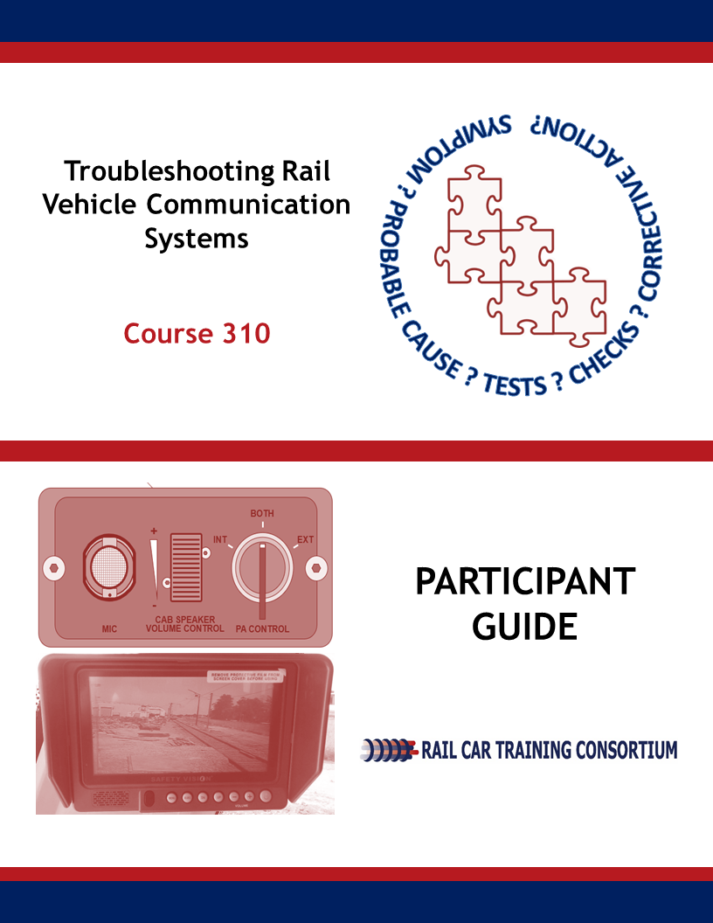

Rail Vehicle Communication Systems

Troubleshooting

Course 310

Participant Guide

June 2019 DRAFT
Rail Car Training Consortium

REVISION INDEX
Any additions, deletions, or revisions are to be listed below.

Revision No. | Date | Section | Description of Change | Revision Author
1 | 6-29-19 |  | Technical Edits | K.Youngbluth

DISCLAIMER: This course is intended to educate employees of public transportation systems that have agreed to voluntarily participate in the Rail Car Training Consortium. It is intended only as informal guidance on the matters addressed, and should not be relied upon as the only method or manner for performing the tasks or work outlined in the materials. Anyone using this document or information provided in the associated training program should rely on his or her own independent judgment or, as appropriate, seek the advice of a competent professional in determining the exercise of care in any given circumstances. These materials are based on compendiums of knowledge from transit employees, manufacturers and outside consultants, each of whom may approach a repair, update, or maintenance in their own unique way. Always follow the safety and maintenance procedures from your own agency, union, relevant OEM(s) and/or regulatory organizations. In addition, the course materials include examples from member agencies, nomenclature, procedures, and configurations which can vary from one transit location to another. The document that you are now referencing may have been modified by the Consortium member. For the original versions, please go to TransitTraining.net or contact the Transportation Learning Center.

The Rail Car Training Consortium, its participating agencies and labor unions, as well as the Transportation Learning Center, make no guaranty or warranty as to the accuracy or completeness of any information provided herein. The Rail Car Training Consortium, its participating agencies and labor unions, as well as the Transportation Learning Center, disclaim liability for any injury or other damages of any nature whatsoever, directly or indirectly, resulting from the use of or reliance on this document or the associated training program.

NOTE: All images contained within this document were contributed by Rail Car Training Consortium members unless otherwise noted.

How to Use the Participant Guide

Purpose of the Course
Course 310: Troubleshooting of Rail Vehicle Communication Systems provides participants with an overview to the troubleshooting procedures followed for the rail vehicle’s communication system and its individual components.
Approach of the Book
Each course module begins with an outline, a statement of purpose and objectives, and a list of key terms. The outline will discuss the main topics to be addressed in the Module. A list of key terms identifies important terminology that will be introduced in this Module. Learning objectives define the basic skills, knowledge, and abilities course participants should be able to demonstrate to show that they have learned the material presented in the Module. Exercises are built in throughout the course materials to assist the participants in learning and reviewing key information.

Table of Contents
Module 1 Troubleshooting Rail Vehicle Communication System Components 1
1-1 Overview 3
1-2 Automatic vs. Manual Announcements 4
1-3 Public Address System (PA System) 5
1-4 Public Address System Components 7
1-5 Related Components 11
1-6 Scenario Based Learning Examples 12
1-7 Summary 12

Module 1

Troubleshooting Rail Vehicle Communication System Components
Outline
  - Overview
  - Automatic vs. Manual Announcements
  - Public Address System
  - Public Address Components
  - Related Components
  - Scenario Based Learning Examples
  - Summary
Purpose and Objectives
The purpose of this Module is to provide participants with an understanding of common troubleshooting scenarios for the rail vehicle’s communication system and its components.
Following the completion of this Module, the participant should be able to complete the objectives with an accuracy of 75% or greater:
- Demonstrate the ability to troubleshoot communication system components to include:
  - Centralized Communication Control Unit
  - Automatic Announcement Control Panel (AACP)
  - Microphone and Radio
  - Public Address System
  - Passenger Intercom Unit (PIU)
  - Speakers & Pre-Amp
  - Antennas
  - Radio
  - GPS

Key Terms
- Centralized Communication Control Unit  - Microphone  - Radio  - GPS | - Automatic Announcement Control Panel  - Passenger Intercom Unit  - Speakers  - Tag Readers | - Antennas  - Public Address System (PA System)  - Pre-Amp  - Manual Announcements
  - overview
In Course 300, Troubleshooting Principles, the participant was provided with an overview of the troubleshooting process along with related general strategies, tips and pitfalls. This course, Course 310, builds on the earlier troubleshooting course and focuses on commonly reported problems with the Communication System and its components.

Troubleshooting is a systematic approach to find the source of a problem in an effort to restore a component, operation or process. Because there are so many variances in rail car types and systems, this course cannot be a one-size-fits-all course on troubleshooting communication systems. The goal of this course is to identify common troubleshooting scenarios that the rail car technician can analyze and apply to similar situations in their role at their transportation agency.
This course will cover troubleshooting tips and strategies for:
- Incoming Data
- Outgoing Data
- Video Surveillance Data
Course 310 jumps right into troubleshooting communication system components. For each component discussed in this Module, a troubleshooting table is presented with three columns shown below.

Symptom | Probable Cause | Corrective Action

The tables presented are useful however, additional agency specific information may be needed. Therefore, participants are encouraged to add their notes and observations to these tables during training.
Preparing for troubleshooting is an important first step. Therefore, before you begin to troubleshoot equipment it is important to always:
- Wear proper clothing and footwear;
- Ground all equipment;
- Assemble all test equipment;
- Assemble all required documentation.

  - Automatic vs. manual announcements
When troubleshooting the Communication System, the technician first needs to discern if the problem is stemming from the automatic announcements or manual announcements. Although troubleshooting procedures will vary by agency, the following chart will help to identify where the problem is coming from. Figure 1.1 identifies common problems associated with the Automatic Announcements of the Public Address System (PA System).
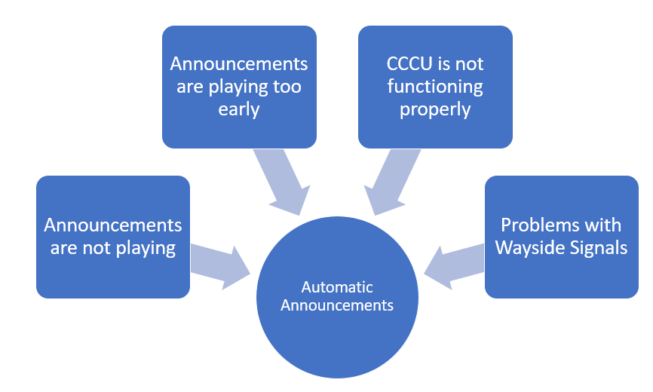
Figure 1.1 Automatic Announcement Troubleshooting Problems
Figure 1.2 identifies when common problems that are associated with the Manual Announcements of the PA System.
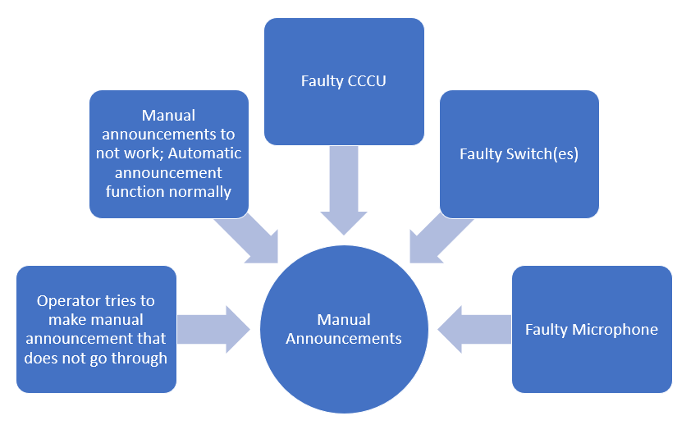
Figure 1.2 Manual Announcement Troubleshooting Problems
Determining whether the communication system failures are associated with the automatic or manual announcements, will better help the technician to troubleshoot and determine a solution to the problem.

1-3 public address system (PA System)
The following chart identifies common troubleshooting problems with the PA System.
SYMPTOM | PROBABLE CAUSE | CORRECTIVE ACTION
PA pushbutton is pressed and nothing happens | - Power supply unit issue  - Networking cable issue  - Debris  - Defective push button  - Operator error | - PA console replaced*  - Free-up or replace PA push button
PA pushbutton light does not light when button is pressed
PA announcement is not played on all speakers
Agency Specific:

In addition to the examples above, some agencies are able to use a PTU to troubleshoot the PA system. Using a PTU device, the technician can use a web browser to determine if the network connection for the PA system is working.
*When the PA console is removed and replaced, the entire unit is replaced; individual pieces of equipment are not replaced. The entire console is then sent to the electronics shop to be repaired and used at a later time.
Passenger Intercom Unit (PIU)
The Passenger Intercom Unit troubleshooting chart is provided below. In situations where “Replace PIU” is identified as the corrective action, the entire PIU unit is replaced, as opposed to individual pieces.
SYMPTOM | PROBABLE CAUSE | CORRECTIVE ACTION
Call button pressed and nothing happens on PIU unit | Loose connection | Re torque connections
 | Defective PIU pushbutton | Replace PIU
LED does not illuminate when PIU pushbutton is pressed | Defective LED | Replace LED
Chime is not heard on PIU when pushbutton is pressed | Defective speaker | Perform a speaker PIU diagnostic
 |  | Replace PIU
Passenger cannot hear operator voice when pushbutton is pressed | - Defective microphone  - Volume control adjusted correctly | Perform a microphone PIU diagnostic
 |  | Replace PIU
Operator does not receive PIU call from passenger | - Wiring, harness  PIU defective  - Network problem | Repair wiring or change harness  Replace PIU
Agency Specific:
  - public address System components
Centralized Communication Control Unit (CCCU)
Rail vehicles may have one CCCU, while others may have two; one on the A end and the other on the B end of the vehicle.
If the CCCU is replaced, the defective equipment is brought back to the shop where it is repaired and used at a later date.
SYMPTOM | PROBABLE CAUSE | CORRECTIVE ACTION
Internal failure; issue with power | Undervoltage condition | Check circuit breaker, fuses, power supply and inverter  Replace CCCU
 | Loose wiring
 | Corrupt software | Reprogram CCCU
Agency Specific:
Automatic Announcement Control Panel (AACP)
The Automatic Announcement Control Panel (AACP) may also be referred to as the Console Control Head or Train Operation Touch Screen (TOTS). Similar to other communication system components, a Portable Test Unit (PTU) can perform diagnostic tests and troubleshoot the AACP. The PTU can connect to a web browser to check the network connection of the AACP. Additionally, like a cell phone, many times the AACP simply needs to be turned off and powered back on to resolve issues.
SYMPTOM | PROBABLE CAUSE | CORRECTIVE ACTION
AACP does not work; sound is not heard and display is inoperative | Loose connections | Tighten connections
 | Defective AACP | Replace AACP
Incorrect announcement is played on AACP | Database is out of date | Update database
 | Defective Tag Reader | Inspect Tag Reader
 | Incorrect wheel size | Replace train wheels
Agency Specific:
Microphone and Radio
Troubleshooting the cab’s microphone and radio is fairly limited. Typically, both the microphone and radio are replaced if there are problems. Procedures do vary by agency and OEM and therefore, it is important to refer to your agency’s specific troubleshooting procedures. Space is provided for additional scenarios to be noted.
SYMPTOM | PROBABLE CAUSE | CORRECTIVE ACTION
Broken gooseneck; microphone can’t stand | Wear and Tear | Replaced
Hand-held set; mechanism that activates talk buttons has problems | Defective set | Replaced
Agency Specific:
Pre-Amp and Amplifier
As discussed in Course 110, the Communication System’s amplifiers help to adjust speaker volume in relation to ambient noise. A pre-amp is a signal that is filtered before being sent to the amplifier. Common amplifier troubleshooting examples are provided below. Use the space provided for additional agency specific examples.
SYMPTOM | PROBABLE CAUSE | CORRECTIVE ACTION
Multiple speakers not working | - Network issue  - Power issue  - Functional issue  - Gum/debris over microphone | - Check wiring  - Check harness  - Replace amplifier
Output level is too high/low | Ambient noise sensing microphone/knob is not set correctly | - Check wiring  - Check ambient noise mic  - Replace mic  - Turn volume louder  - Inspect Pre-amp
 | Software issue | Update software
Agency Specific:
Speakers
Below are common speaker troubleshooting examples. It should be noted that speakers are not rebuilt.
SYMPTOM | PROBABLE CAUSE | CORRECTIVE ACTION
Noisy speakers | Cracked webbing | Speaker replaced
Inoperative speakers | - Speaker not “ON”  - Wiring, connector | - Check speaker control knob and power  - Speaker replaced
Speaker blown | Amplifier sending too much power | - Speaker replaced.  - Inspect pre-amp and amplifier for defects
Agency Specific:

PIU Console
General PIU Console troubleshooting examples are provided below. If the symptoms and probable causes indicate the PIU console should be replaced, it is sent the overhaul shop. Technicians will then repair the faulty PIU console to be used at a later time.
SYMPTOM | PROBABLE CAUSE | CORRECTIVE ACTION
No power to PIU Console | Converter issue, CCU issue, loose wiring | Diagnose by following schematics
 | Faulty button | Replace button
Bad Signal | Faulty PIU, loose connections | Replace PIU, tighten loose connections
Agency Specific:
GPS
Troubleshooting is relatively limited for the GPS. If it is determined the GPS is not working, the technician should first check for a signal. If there is no signal, and the train was indoors, the technician should move the train outdoors. If there continues to be no signal, the next troubleshooting step is to check the antenna. While examining the antenna, questions to ask yourself include, “Is the antenna ripped off? Are there any cracks in the Antenna?” After assessing the condition of the antenna, if there is still no GPS signal, the cabling going to the antenna should be checked for cracks or rips. If there is a faulty antenna or cable, they are replaced.
Rail Vehicle Signs; Interior and Exterior
The scope of the rail car technician’s troubleshooting will be limited with regards to Destination, Run and Side signs. At some agencies, the operator is responsible for setting the destination signs. At other agencies, the sign settings are preset before the operator leaves the yard. In this situation, the Operator has to key in his Operator ID, then route (block) number. This will populate information such as train destination, station times of arrival, views of next stops. This information is tied into automatic voice announcements and is all tracked and stored in an on-vehicle database.

1-5 related components
Antennas
Troubleshooting antennas is relatively limited. Minor problems, such as cracks and loose connections, are replaced. Issues beyond those are outsourced to a different department within the rail agency.
SYMPTOM | PROBABLE CAUSE | CORRECTIVE ACTION
Signal not being received | Check connections | Repair/replace antenna
Cracked/broken antenna | Wear and tear | Replace antenna
Agency Specific:
Video and Camera System
Troubleshooting the video and camera is extremely limited for the rail car technician. At most agencies, rail car technicians will only replace a camera that isn’t functioning properly. Typically, agencies have a separate video and camera crew that is responsible for maintenance and troubleshooting of the video and camera system. Additionally, some rail car maintenance supervisors will have access to remove DVRs from the vehicle in the event of an emergency event and investigation. The video/camera system will bookmark whenever any of the PIU buttons are pressed. This is to document activities that are happening in a rail car to be viewed at a later date by law enforcement or the rail agency, if necessary
Communication System Dead Areas
Operators are likely to experience dead areas in areas such as, tunnels, hilly areas, and certain parts of underground tracks, where the communication equipment does not work. Operators are typically well aware of these dead zones. In the event of an emergency underground, and while the rail vehicle is in a communication dead zone, there are emergency telephone systems (ETS). The emergency telephones systems are usually identified by a special colored light or by signage located sporadically throughout the underground area. In this type of situation, the operator will locate an emergency phone and stop the train to make an emergency communication call to central control. In San Francisco, for example, the hilly terrain provides plenty of dead zones for operators. Operators are unable to use a cell phone while in the operator’s cab. In the event of an emergency, the operator will have to stop the train and get out of the cab to use their cell phone and make an emergency call.

1-6 scenario based learning examples
Learning Application 1.1 – Scenario Based Learning
The two scenarios below are examples of field problems in troubleshooting the Communication system. These scenarios are based on real situations.

When reading each scenario, consider the problem and determine:
- What part of the communication system/equipment is involved?
- What are the likely probable causes?
- What are possible corrective actions
Your instructor will have the solutions to these problems (Learning Application 1.1 Answers – Appendix A) to verify your ideas when you are finished.
Scenario 1
A patron has tried to make a call over the PIU. The Operator receives the message however, it is coming in gargled.
Scenario 2
A patron has made a call on a PIU. The Operator receives the call and when he responds, his message is coming in gargled to the patron.
  - summary
This Course provided the learner with common troubleshooting scenarios for troubleshooting the rail vehicle’s communication system and its components. Learners were provided with common symptoms, probable causes and corrective actions. Finally, scenario-based problems were provided to put the content into real life context. As always, refer to your agency for specific troubleshooting information and procedures,

