PAGE INTENTIONALLY LEFT BLANK

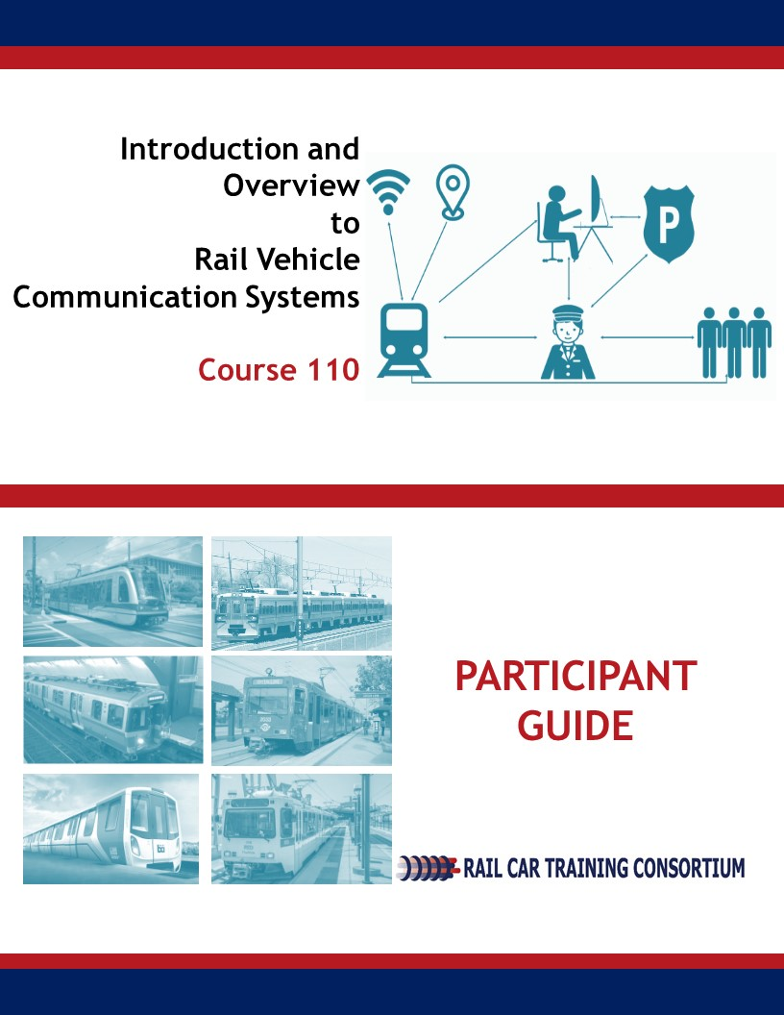

|  |
| --- |
| Communication Systems  **Introduction and Overview**  **Course 110** |
| **Participant Guide**  **June 2019 DRAFT** |
|  |
| Rail Car Training Consortium |

**REVISION INDEX**

Any additions, deletions, or revisions are to be listed below.

|  |  |  |  |  |
| --- | --- | --- | --- | --- |
| **Revision No.** | **Date** | **Section** | **Description of Change** | **Revision Author** |
|  |  |  |  |  |
|  |  |  |  |  |
|  |  |  |  |  |
|  |  |  |  |  |
|  |  |  |  |  |
|  |  |  |  |  |

**Disclaimer**: This course is intended to educate employees of public transportation systems that have agreed to voluntarily participate in the Rail Car Training Consortium. It is intended only as informal guidance on the matters addressed, and should not be relied upon as the only method or manner for performing the tasks or work outlined in the materials. Anyone using this document or information provided in the associated training program should rely on his or her own independent judgment or, as appropriate, seek the advice of a competent professional in determining the exercise of care in any given circumstances. These materials are based on compendiums of knowledge from transit employees, manufacturers and outside consultants, each of whom may approach a repair, update, or maintenance in their own unique way. Always follow the safety and maintenance procedures from your own agency, union, relevant OEM(s) and/or regulatory organizations. In addition, the course materials include examples from member agencies, nomenclature, procedures, and configurations which can vary from one transit location to another. The document that you are now referencing may have been modified by the Consortium member. For the original versions, please go to TransitTraining.net or contact the Transportation Learning Center.

The Rail Car Training Consortium, its participating agencies and labor unions, as well as the Transportation Learning Center, make no guaranty or warranty as to the accuracy or completeness of any information provided herein. The Rail Car Training Consortium, its participating agencies and labor unions, as well as the Transportation Learning Center, disclaim liability for any injury or other damages of any nature whatsoever, directly or indirectly, resulting from the use of or reliance on this document or the associated training program.

**Note**: All images contained within this document were contributed by Rail Car Training Consortium members unless otherwise noted.

**How to Use the Participant Guide**

**Purpose of the Course**

Course 110: Introduction and Overview to Rail Vehicle Communication Systems provides participants with an overview to the Communication System components and tools used in the field. This course is intended to prepare the participant to inspect and maintain rail vehicle doors in a Rail Transportation System maintenance facility.

**Approach of the Book**

Each course Module begins with an outline, a statement of purpose and objectives, and a list of key terms. The *outline* will discuss the main topics to be addressed in the Module. A list of *key terms* identifies important terminology that will be introduced in this Module. *Learning objectives* define the basic skills, knowledge, and abilities course participants should be able to demonstrate to show that they have learned the material presented in the Module. *Exercises* are built in throughout the course materials to assist the participants in learning and reviewing key information.

Table of Contents

Module 1 Principle of Operation of Communication Systems 1

1-1 Overview 2

1-2 Principle of Operation 2

1-3 Types of Communication 5

1-4 Summary 6

Module 2 Rail Vehicle Communication System Components 7

2-1 Overview 8

2-2 Vehicle Internal Components 10

2-3 Vehicle External Components 17

2-4 Summary 20

Module 3 Communication System Tools 22

3-1 Overview 23

3-2 Communication System Tools 23

3-3 Summary 33

List of Figures

Figure 2.1 LRV Component Diagram. *Courtesy of CATS and Metro Transit* 9

Figure 2.2 PA Amplifier. *Courtesy of WMATA* 10

Figure 2.3 AACP. *Courtesy of SDMTS* 11

Figure 2.4 RV Signs. *Courtesy of Metro Transit* 11

Figure 2.5 RV Camera. *Courtesy of SDMTS* 12

Figure 2.6 Rack front view. *Courtesy of NFTA* 13

Figure 2.7 Microphone. *Courtesy of Metro Transit* Figure 2.8 Gooseneck Microphone. *Courtesy of CATS* 13

Figure 2.9 Radio. *Courtesy of SDMTS* 13

Figure 2.9 PIU. *Courtesy of Metro Transit* 14

Figure 2.11 Stop Request. *Courtesy of SDMTS* 15

Figure 2.12 PA Button. *Courtesy of SDMTS* 15

Figure 2.13 Speakers. *Courtesy of SDMTS* 16

Figure 2.14 Interior and Exterior View of APC. *Courtesy of SDMTS* 17

Figure 2.15 Camera. *Courtesy of Metro Transit* 18

Figure 2.16 TWC Controls. *Courtesy of SDMTS* 19

Figure 3.1 Allen Key. *Courtesy of SACRT* 24

Figure 3.2 Diagonal Cutters. *Courtesy of SACRT* 24

Figure 3.3 Radio. *Courtesy of SACRT* 25

Figure 3.4 Heat Gun. *Courtesy of SACRT* 25

Figure 3.5 Heat Shrink. *Courtesy of SACRT* 26

Figure 3.6 PTU. *Courtesy of SACRT* 26

Figure 3.7 Pink Extractor. *Courtesy of SACRT* 27

Figure 3.8 Pliers. *Courtesy of SACRT* 27

Figure 3.9 Socket Set. *Courtesy of SACRT* 28

Figure 3.10 Schematic Diagram. *Courtesy of SACRT* 29

Figure 3.11 Screw Driver. *Courtesy of SACRT* 30

Figure 3.12 Soldering Iron. *Courtesy of SACRT* 30

Figure 3.13 Tool Set. *Courtesy of SACRT* 31

Figure 3.14 Torx Set. *Courtesy of SACRT* 31

Figure 3.15 Voltmeter. *Courtesy of SACRT* 32

Figure 3.16 Wire Crimpers. *Courtesy of SACRT* 32

Module 1

*Principle of Operation of Communication Systems*

**Outline**

* 1. ****Overview****
  2. ****Principle of Operation****
  3. ****Types of Communication****
  4. ****Summary****

**Purpose and Objectives**

The purpose of this Module is to provide participants with an overview of the principle of operation for different types of communication systems onboard the rail vehicle.

Following the completion of this Module, the participant should be able to complete the objectives with an accuracy of 75% or greater:

* Explain the principle of operation of communication systems
* Explain different types of communication, which include:
  + Communication between operator and public;
  + Communication between operator and control center; and
  + Communication between vehicle and control center.

**Key Terms**

|  |  |  |
| --- | --- | --- |
| * **Analog** | * **Local Area Network (LAN)** |  |

* 1. overview

Vehicle communication systems provide a means for important and vital information to be disseminated to passengers via a variety of methods. Communication can be transmitted via manual or automated public announcements from the operator. In addition, communication systems allow for two-way communication between the rail vehicle and central control and/or between the vehicle and operator / onboard personnel. It is important to note that communication systems are one of the most rapidly changing systems onboard a rail vehicle due to the constant advancements in technology. This Module will provide an overview on the principle of operation of rail vehicle communication systems.

* 1. Principle of Operation

The following diagram provides a visual representation of the general principle of operation of rail vehicle communications systems to include, ***what***information is being communicated, ***methods*** used to communicate information and the ***equipment*** used.

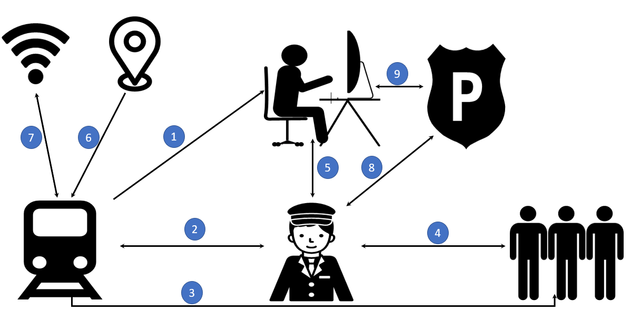

|  |  |
| --- | --- |
| ***What*** information is being communicated; ***Methods*** used to communicate information; and ***Equipment*** used. | |
| *Communication between vehicle and control center* | ***What:*** Video Surveillance feed; LRV/consist location & makeup; fault logs; real time data gathering, data logs and passenger counts  ***Method:*** Train-to-Wayside Antenna or RFID; WIFI  ***Equipment:*** Train-to-Wayside Antenna Loop or RFID; WIFI Antenna; Network Card |
| *Communication between rail vehicle and operator* | ***What:*** LRV status information for operator  ***Method:*** Train Operator Display; Indicators and Gages  ***Equipment:*** Train Operator Display; Indicators and Gages |
| *Communication between rail vehicle and passengers* | ***What:*** Automated and/or prerecorded Informational messages, such as identifying the next stop; audible and visual indicators such as door status.  ***Method:*** Public Address System; Interior & Exterior Signage  ***Equipment:*** Interior and Exterior Signage; Interior & Exterior Speakers; Pre-recorded Announcements are Tied to Locations via GPS Locating or other means of vehicle location tracking |
| *Communication between operator and passengers* | ***What:*** Informational messages made by the operator; next stop requests; passenger-initiated communication with the operator on LRV conditions or emergencies  ***Method:*** Public Address System; Passenger Intercom  ***Equipment***: Operator Handset or Microphone & Speaker; Interior & Exterior Speakers; Interior & Exterior Signage; Passenger Intercom; Door Speaker/Chime/Buzzer & Indicator Lights |
| *Communication between operator and control center* | ***What:*** Command, control & status  ***Method:*** Two-way Radio  ***Equipment:*** Handset or Microphone & Speaker; Transceiver; Antenna |
| *Communication between rail vehicle via GPS* | ***What:*** GPS Location  ***Method:*** GPS  ***Equipment:*** GPS Antenna |
| *Communication between rail vehicle via Wi-Fi* | ***What:*** Wi-Fi  ***Method:*** Wi-Fi  ***Equipment:*** Wi-Fi Antenna and Router |
| *Communication between operator and transit police* | ***What:*** Direct communication when necessary  ***Method:*** Two-way radio  ***Equipment:*** Handset or Microphone & Speaker; Transceiver; Antenna |

There are two main types of communication systems; **Analog** and Local Area Network, or **LAN**. The operator sees little difference between the two systems, however the differences are observable during the maintenance process. The table below identifies the similarities and differences between the Analog and LAN systems.

|  |  |  |
| --- | --- | --- |
| **FUNCTION** | **ANALOG** | **LAN** |
| Public Announcements (internal and external) | Y | Y |
| PIU Interface | Y | Y |
| Radio Interface | Y | Y |
| Passenger Stop Request | Y | Y |
| Cab-to-Cab Communication | Y | Y |
| Door Chimes | Y | Y |
| Automatic Announcements | N | Y |
| Digital Destination Signs | N | Y |
| Digital Passenger Information Signs | N | Y |

* 1. Types of communication

This section will provide an overview to three different types of communication, to include:

* Communication between operator and public
* Communication between operator and control center
* Communication between rail vehicle and control center

The components and features in this section will be discussed in greater detail in Module 2 of this course.

**Communication Between Operator and Public**

Communication between the rail vehicle operator and public includes:

* Automated announcements; both internal and external;
* Automated next stop signs;
* Passenger stop requests;
* Cab-to-Cab communication;
* Door chimes;
* Public Address (PA) system, which allows the operator to communication with the public both on and off the train;
* Passenger stop requests; and
* Passenger Intercom Unit (PIU), which is used to communicate via passenger to operator and vice versa, in the event of an emergency.

**Communication Between Operator and Control Center**

Communication between the operator and control center includes:

* Separate dedicated radio channel for the operator and control center/dispatch to communication;
* Radio and/or portable radio that operators have in the cab.

Situations in which the operator must get permission from control in order to proceed, include, but are not limited to:

* The rail vehicle is pulling out of the yard and a switch has to be moved;
* Maintenance is working on the track and the vehicle must move to another track;
* MOW is out on the line.

**Communication Between Vehicle and Control Center**

Communication between vehicle and control center includes:

* Train-to-Wayside Communication (TWC) loops that communicate with antennas underneath the train;
* Wi-Fi to download data from train;
* Separate radio used for communication between the operator and control center.

1-4 summary

This Module differentiated between three different types of communication on the rail vehicle; Communication between Operator and Public, Operator and Control Center and Vehicle and Control Center. The theory of operation of the communication system was discussed and includes: *What* information is being communicated, *method* to communicate the information and *equipment* used to communicate information was also discussed.

Module 2

*Rail Vehicle Communication System Components*

**Outline**

* 1. ****Overview****
  2. ****Vehicle Internal Components****
  3. ****Vehicle External Components****
  4. ****Summary****

**Purpose and Objectives**

The purpose of this Module is to provide participants with detailed information on internal and external components of the communication system.

Following the completion of this Module, the participant should be able to complete the objectives with an accuracy of 75% or greater:

* Identify and explain communication system components.

**Key Terms**

|  |  |  |
| --- | --- | --- |
| * **Passenger Intercom Unit (PIU)** * **Microphone** * **Central Communication Control Unit (CCCU)** * **Speakers** | * **Automatic Vehicle Identification (AVI)** * **Amplifier** * **Camera** * **Video** * **Half-Duplex** * **PTU** | * **Automatic Announcement Control Panel (AACP)** * **Automatic Passenger Counting (APC)** * **Wi-Fi** * **GPS** * **Multi-Function Vehicle Bus (MVB)** |

2-1 overview

This Module will guide the participant through communication system specific components. Module 2 is divided into two sections; Vehicle Internal Components and Vehicle External Components. Component that will be discussed in Module 2 include:

|  |  |
| --- | --- |
| **Vehicle Internal** | **Vehicle External** |
| Amplifiers | Amplifiers |
| Automatic Announcement Control Panel (AACP) | Automatic Passenger Counting (APC) |
| Automatic Vehicle Identification (AVI) | Camera and Video System |
| Camera and Video System | GPS |
| Centralized Communication Control Unit (CCCU) | Manual Announcement Operations Control Center (OCC) |
| Microphone and Radio | Speakers |
| Passenger Emergency Alarm Button | Train-to-Wayside Controls (TWC) |
| Passenger Intercom Unit (PIU) | WiFi |
| Passenger Stop Request |  |
| Public Address (PA) System |  |
| Speakers |  |
| WiFi |  |

**Figure 2.1** provides an internal and external diagram view of CATS and Metro Transit’s Siemens Light Rail Vehicles, with several communication system components identified. Make, model and location of components will vary by agency but the image below provides an example for learning purposes.

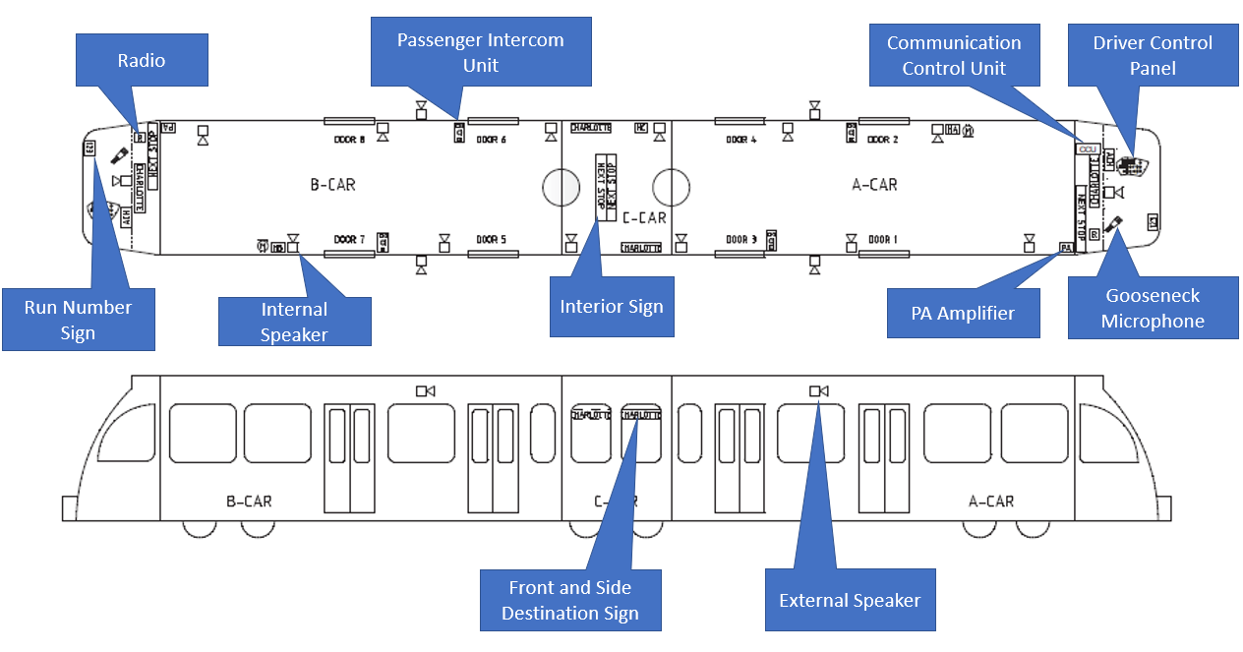

Figure 2.1 LRV Component Diagram, Courtesy of CATS and Metro Transit

The Communication System is a crucial system to ensure safe and efficient operation. This Course will guide the learner through identifying components which make up the communication system and their function. The functions of communication system can be grouped, as follows:

**Public Address**

Audio Announcement

* Communications from operator
* Communications from yard
* Automatic Announcements

**Visual Announcement**

* Block number information
* Final/Next station information
* Driver ID information
* Service information

**Intercommunications**

* Passenger Intercom
* Cab to Cab
* Radio

2-2 vehicle internal components

**Amplifier and Pre-Amp**

Rail vehicles will have Public Address (PA) and internal amplifiers. Amplification is fundamental to modern electronics. Rail vehicle amplifiers help to increase the volume of pre-recorded messages or the operator’s voice on the train. The **internal PA** amplifiers adjust the audio level of the interior speakers with respect to ambient noise level. A **pre-amp** converts a weak signal to a level strong enough to then be sent to the amplifier. Without a pre-amp, the final sound would be distorted.

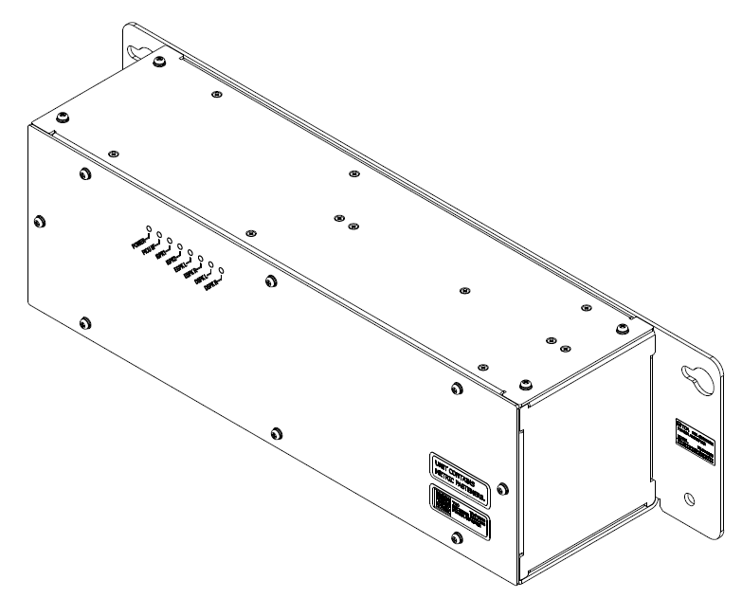

Figure 2.2 PA Amplifier. Courtesy of WMATA

**Automatic Announcement Control Panel (AACP)**

The AACP is used to store pre-recorded audio and display information correlated to specific routes. There is one AACP in each operator’s cab. The functions of the AACP include:

* Allows operator to select route
* Enables automatic announcements over PA system
* Ability for operator to broadcast special messages over PA system
* Display destination and next station stop signs

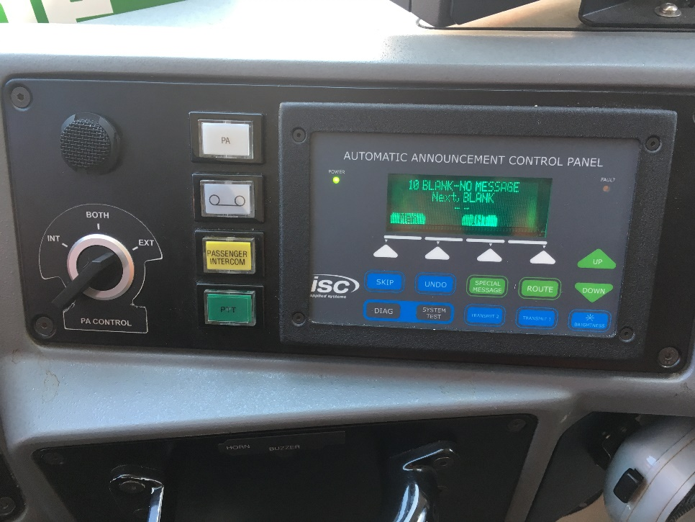

Figure 2.3 AACP, Courtesy of SDMTS

**Automatic Vehicle Identification (AVI)**

The AVI communicates signs on the rail vehicle. Signs include front destination, run number and internal and external side destination. All signs are constructed with LEDs.

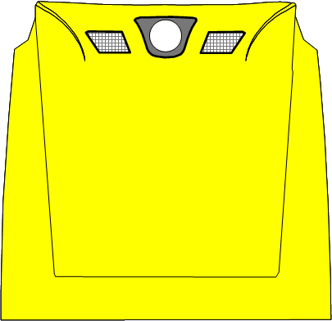

* **Front Destination**: Mounted on the interior cab windshield facing forward. The final destination of vehicle is pre-programmed and displayed.
* **Run Number**: The run number is typically 3 numbers and located on the front of the vehicle. The run number sign is pre-programmed.
* **Internal**: Displays the next station stop and pre-programmed special announcements. These signs are located outside the operator’s cab and facing the passengers.

Figure 2.4 RV Signs. Courtesy of Metro Transit

* **Internal and External Side Destination**: displays the same message both internally and externally and communicate final destination of rail vehicle.

**Cameras and Video System**

The rail vehicle will have cameras and a video system onboard. The number of interior cameras will vary depending on make and model of the rail vehicle. Interior cameras are mounted in the ceiling of car and monitor passenger area of the rail vehicle. All images are time and date stamped and stored in the operator’s cab. The camera and video system are typically accessed if the vehicle is involved in an incident or accident. In a situation like this, with the use of a PTU, the video is downloaded and turned over to the proper authorities.

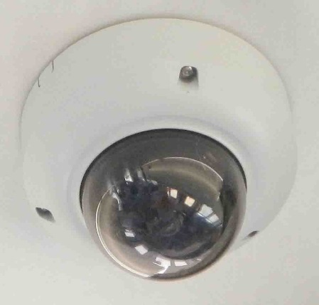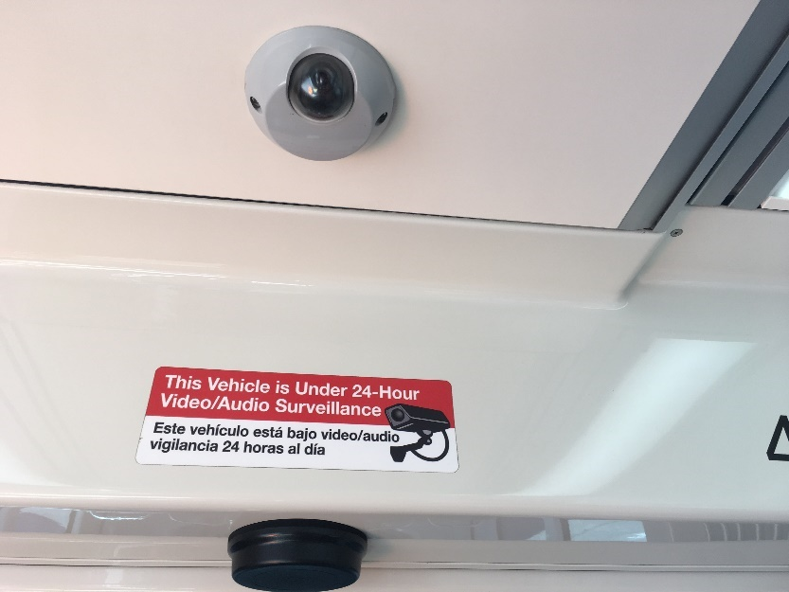

Figure 2.5 RV Camera. Courtesy of SDMTS

**Centralized Communication Control Unit (CCCU)**

There is one CCCU per rail vehicle located in the A-cab. The CCCU is the “heart” of the communication system and its functions include:

* Provides route information
* Allow communication between all rail vehicles in the consist
* Stores data and audio files for automated announcements
* Manages and logs errors for health management
* Receives location and GPS information
* Coordinates automated announcements based on tracking information
* Performs self-check of communication system components
* Sets route and next station stop, programs train number
* Multi-function vehicle bus (MVB)

|  |  |  |
| --- | --- | --- |
| Figure 2.6. Rack front view. Courtesy of NFTA  Now that you have learned about the CCCU, watch the following video which was produced at SacRT.   |  |  | | --- | --- | |  | Watch video on the centralized communication control unit.  <https://vimeo.com/343046416> If prompted for a password, type in “railcar.” | |
|  |

|  |  |
| --- | --- |
| Description: PowerPointBLUE.png | **Learning Application 2.1 – Centralized Communication Control Unit**  Together as a class, identify any additional functions of the CCCU at your agency. Take notes for future reference in the space provided below. |

|  |
| --- |
|  |
|  |
|  |
|  |

**Microphone**

The microphone is located in the operator’s cab and is used to communicate via the PA system to passenger. The type of microphone will vary by agency. Below are two examples of microphones that may be used.

|  |  |
| --- | --- |
|  |  |

Figure 2.7 Microphone. Courtesy of Metro Transit Figure 2.8 Gooseneck Microphone. Courtesy of CATS

**Radio**

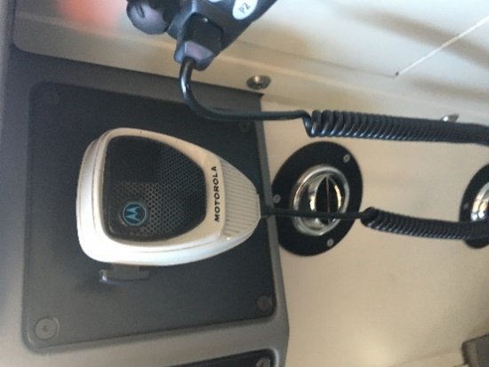The radio provides two-way voice communication between the operator and central control via radio frequency.

**Hand-held Radio**

In addition to the radio, the operator will always have a handset with him, in the event of an emergency.

Figure 2.9 Radio. Courtesy of SDMTS

**Passenger Intercom Unit (PIU)**

Passenger Intercom Units, or PIU, are strategically placed within the passenger compartments of the rail vehicle and allow for two-way communication between passengers and the operator. The PIU consists of a speaker, call button, microphone and talk LED, is only used in the event of an emergency (i.e. medical, fire, fight, etc.). In the event the PIU is pressed, there will be an audible alarm and an external blue/red light which identifies which area of the rail vehicle is having a problem. There are typically four (4) PIUs located in each rail vehicle.

|  |  |  |
| --- | --- | --- |
| ❶ | ❷ | ❸ |
|  |  |  |

Figure 2.10 PIU. Courtesy of Metro Transit

In the event of an emergency, the passenger will locate one of the PIUs located in the rail vehicle. The passenger will push the red button to alert the operator. The “PIU” button will then illuminate and the operator will press the button to acknowledge and listen to the call. Next, the operator will press the “PTT” button on the grab handle to communicate with the passenger. It is important to note most PIU systems will be enabled with **Half-Duplex**, in which the operator and passenger cannot speak at the same time.

**Passenger Stop Request**

Tape switches or dedicated buttons inside the rail vehicle that passengers push in order to notify the operator to stop the consist and the next stop. The stop notification clears/resets once the doors open. **Figure 2.11** is an example of a handicap stop request.

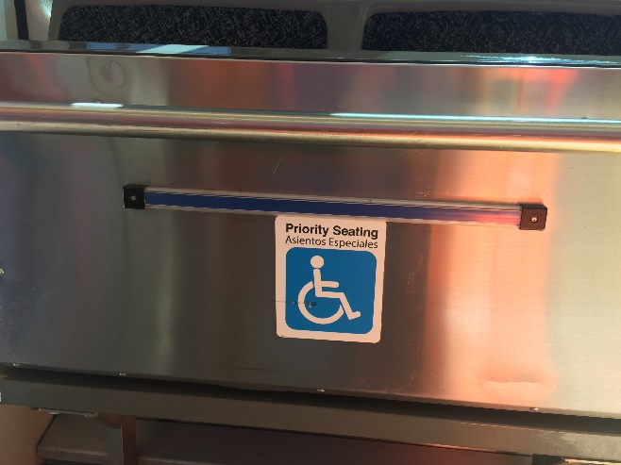

Figure 2.11 Stop Request. Courtesy of SDMTS

**Public Address System**

The Public Address (PA) system allows the operator to make announcements to passengers by using the active cab microphone. To do so, the operator will have to select the PA button on the PA panel. When the PA button is pushed and kept pressed, communication is established and routed to the speakers located inside the rail vehicle. Communication is ended when the PA button is released.



Figure 2.12 PA Button. Courtesy of SDMTS

**Speakers**

The number of internal speakers located in the rail vehicle will vary. Speakers are mounted in the cornice panel and positioned to provide the best possible sound to passengers. The speakers are used by the PA system function and the AACP.

|  |  |
| --- | --- |
| Figure 2.13 Speakers. Courtesy of SDMTS |  |

|  |  |
| --- | --- |
| Description: PowerPointBLUE.png | **Learning Application 2.2 – Internal Speakers**  Together as a class, identify the number and location of internal speakers on the rail vehicles at your agency. |

|  |
| --- |
|  |
|  |
|  |
|  |
|  |

**Wi-Fi**

Wireless connectivity, or Wi-Fi, allows a mobile phone or PC to connect to the internet. Wi-Fi uses radio signals between the enabled device and internet, allowing the device to receive information from the web.

The following video, filmed at SacRT, shows the Communication System components inside the operator’s cab.

|  |  |
| --- | --- |
|  | Watch video on Communication System Components  <https://vimeo.com/343086968> If prompted for a password, type in “railcar.” |

2-3 vehicle external components

**Amplifiers**

Just like internal amplifiers, rail vehicles will also have external amplifiers. Amplification is fundamental to modern electronics. Rail vehicle amplifiers help to increase the volume of pre-recorded messages or the operator’s voice on the train. The **external amplifiers** adjust the audio level of the exterior speakers with respect to ambient noise level.

**Automatic Passenger Counting (APC)**

The Automatic Passenger Counting (APC) feature tracks passengers entering and exiting the rail vehicle. The APC is a separate, standalone system, and not controlled by the CCCU. APC uses fuzzy logic algorithms to track people entering and exiting the vehicle. Multiple sensors track head and shoulders, which is a distinguishable geometric shape for people. If a passenger is standing in the doorway, the APC sensors are able to identify this, and will not count it towards additional passengers entering or exiting. When the rail vehicle finishes its service for the day, the APC automatically uploads the information to the Wi-Fi system, which is then loaded into the financial database. This information is used for government funding on a per passenger basis. The APC system is intuitive, in that it knows not count passengers getting on and off the train if it is not in service (i.e. operator performing a pre-trip inspection).

|  |  |
| --- | --- |
|  |  |

Figure 2.14 Interior and Exterior View of APC. Courtesy of SDMTS

**Camera and Video System**

The rail vehicle will have cameras and a video system on board. Side view cameras, located on the train’s exterior, are displayed on either side of the cab, that allow the operator to have a view of both sides of the rail vehicle.

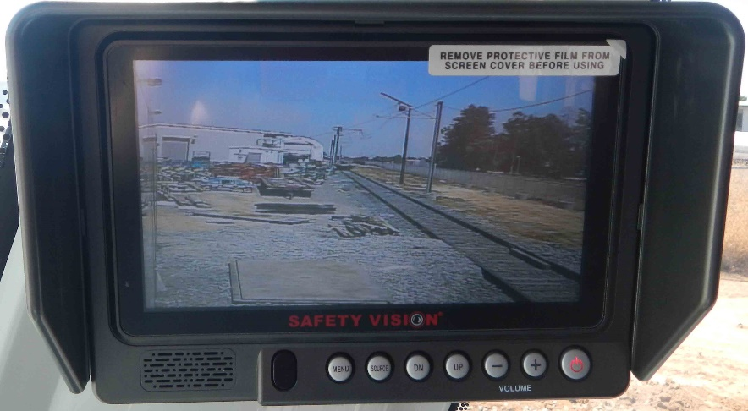

Figure 2.15 Camera. Courtesy of Metro Transit

**GPS**

GPS is used to track the movement and location of rail vehicles, in real time. GPS systems can help to improve punctuality, rail safety and overall efficiency.

**Speakers**

The number of external speakers located in the rail vehicle will vary. Speakers are mounted on the roof and located in the roof shrouds.

|  |  |
| --- | --- |
| Description: PowerPointBLUE.png | **Learning Application 2.3 – External Speakers**  Together as a class, identify the number and location of external speakers on the rail vehicles at your agency. |

|  |
| --- |
|  |
|  |
|  |

**Train-to-Wayside Communication (TWC) Controls**

TWC is when the rail vehicle communicates with the wayside equipment, such as, the signals, switches and control devices located along the railroad. Under each rail vehicle cab is an antenna and located along the tracks are antenna loops. As the rail vehicle passes over the antenna loops, it communicates with the antenna located under cab and the antennas have a brief communication with each other. The communication is one-way, from the train antenna to the track antenna. The rail vehicle communicates a simple **binary code** to communicate. A binary code is a coding system using digits 0 and 1 to represent a letter, digit, or other character in a computer. The binary code tells the system what route the rail vehicle on and what block number the train is located in. The antenna embedded in the track takes the information and feeds it back to the control center systems, which handle the automatic switching of switch points (i.e. lights, signals), which helps to determine when a train is at a particular point at a certain time.

When the operator programs the route number, the TWC communication notifies the antenna loop on the tracks which route the train is travelling so the automatic switches are set correctly. The TWC system also communicates which block number the train is located. The antenna on the train is always communicating with the antenna on the tracks and all of the information is sent to central control to keep trains running efficiently and safely.

**Train-to-Wayside Data Transfer**

Train-to-wayside data transfer involves transferring vehicle specific data, fault logs, equipment logs, camera images, equipment status, commercial log data. Inspection, via PTU, automatic test.

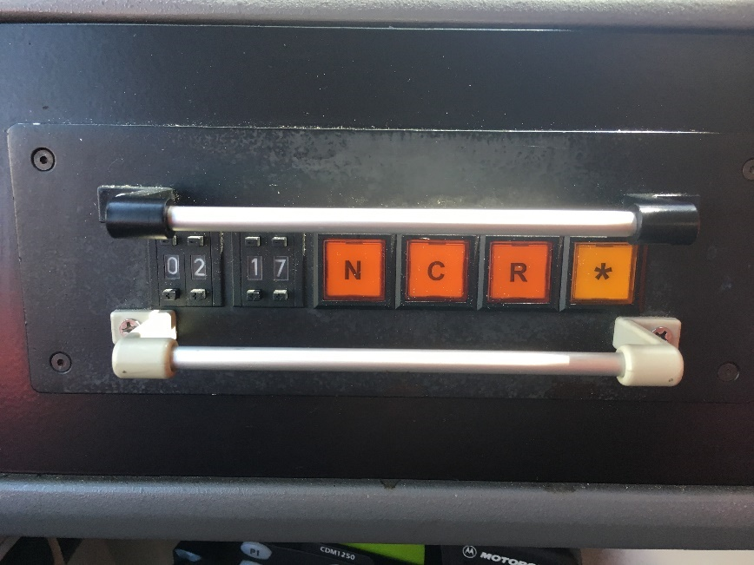

Figure 2.16 TWC Controls. Courtesy of SDMTS

**Wi-Fi**

Wireless connectivity, or Wi-Fi, allows a mobile phone or PC to connect to the internet. Wi-Fi uses radio signals to between the enabled device and internet, allowing the device to receive information from the web.

Now that you have learned about both internal and external components of the communication system, watch the following video produced at SacRT.

|  |  |
| --- | --- |
|  | Watch video on Communication System Components  <https://vimeo.com/343020307> If prompted for a password, type in “railcar.” |

|  |
| --- |
|  |

|  |  |
| --- | --- |
| Description: PowerPointBLUE.png | **Learning Application 2.4 – Other Components**  Together as a class, identify any other components, which make up the communication system used at your agency. Identify component and function in the table provided below. |

|  |  |
| --- | --- |
| Component | Function |
|  |  |
|  |  |
|  |  |

2-4 summary

This Module walked the learner through rail vehicle communication system internal and external components. A description and function of each component was explained. As always, refer to your individual agency for additional and specific information relating to your rail vehicle communication systems.

|  |  |
| --- | --- |
| **Vehicle Internal** | **Vehicle External** |
| Amplifiers | Amplifiers |
| Automatic Announcement Control Panel (AACP) | Automatic Passenger Counting (APC) |
| Automatic Vehicle Identification (AVI) | Camera and Video System |
| Camera and Video System | GPS |
| Centralized Communication Control Unit (CCCU) | Manual Announcement Operations Control Center (OCC) |
| Microphone and Radio | Speakers |
| Passenger Emergency Alarm Button | Train-to-Wayside Controls (TWC) |
| Passenger Intercom Unit (PIU) | WiFi |
| Passenger Stop Request |  |
| Public Address (PA) System |  |
| Speakers |  |
| WiFi |  |

Module 3

*Communication Systems Tools*

**Outline**

* 1. ****Overview****
  2. ****Tools used for Inspection and Maintenance of Communication Systems****
  3. ****Summary****

**Purpose and Objectives**

The purpose of this Module is to provide participants with an overview to tools used to inspect and maintain communication systems components.

Following the completion of this Module, the participant should be able to complete the objectives with an accuracy of 75% or greater:

* Demonstrate the ability to identify, use and explain communication systems specific tools

**Key Terms**

|  |  |  |
| --- | --- | --- |
| * **Allen set** * **Diagonal Cutters** * **Hand-held radio** * **Heat gun** * **Heat shrink** | * **Laptop/PTU** * **Pin extractor** * **Pliers** * **Ratchet/Socket set** * **Schematic Diagram** | * **Screw driver** * **Soldering iron** * **Torx/Tamper-proof torx** * **Voltmeter** * **Wire crimpers** * **Wire strippers** |

3-1 overview

This Module will identify and discuss tools the rail car technician will use to inspect and maintain rail vehicle communication systems and components. For a full list of rail vehicle tools, refer to course 100.

|  |  |  |
| --- | --- | --- |
| Module Section, Topic | Course Number and Title | TTN Link to Course |
| Module 4 – Section 4: Hardware and Tools for Rail Vehicle Maintenance and Repair | Course 100: Introduction and Overview of Rail Vehicle Systems, Maintenance and Inspection | [Course 100](https://www.transittraining.net/courseware/details/course-100-introduction-and-overview-of-rail-vehicle-systems-operation) |

3-2 communication systems tools

Although the rail car technician will use many tools within the scope of their job, the following tools are directly related to repair, inspection and main of communication system components and will be discussed in this Module.

* Allen Set/Hex Key
* Diagonal Cutters
* Hand-held Radio
* Heat Gun
* Heat Shrink – Plastic Tubing
* Laptop/PTU
* Pin Extractor
* Pliers
* Ratchet/Socket Set
* Schematic Diagram
* Screwdriver
* Soldering Iron
* Test Tools/Specialty Tools/Tool Set
* Torx Set/Tamper-proof Torx set
* Voltmeter (VOM)
* Wire Crimpers
* Wire stripper

**Allen Set/Hex Key**

A hex key, Allen key or Allen wrench is a tool used to drive bolts and screws with hexagonal sockets in their heads.



Figure 3.1 Allen Key. Courtesy of SACRT

**Diagonal Cutters**

**Diagonal Cutting Pliers** have a short jaw and beveled cutting edges. These pliers are used to cut wires, or snip off the extended leads of discrete electronic components. This basic hand tool is found in most technicians’ tool inventory.

Figure 3.2 Diagonal Cutters. Courtesy of SACRT

**Hand-held Radio**

**Radio** is the practice or science of communicating over a distance by converting sounds or signals into electromagnetic waves and transmitting these directly through space, without connecting wires, to a receiving set, which changes them back into sounds, signals, etc.

A **two-way radio** is a radio that can do both; transmit and receive a signal (a transceiver). A **broadcast** receiver can only receive content. A two-way radio (transceiver) allows the operator to have a conversation with other similar radios operating on the same radio frequency (channel). Two-way radios are available in mobile, stationary base and hand-held portable configurations.

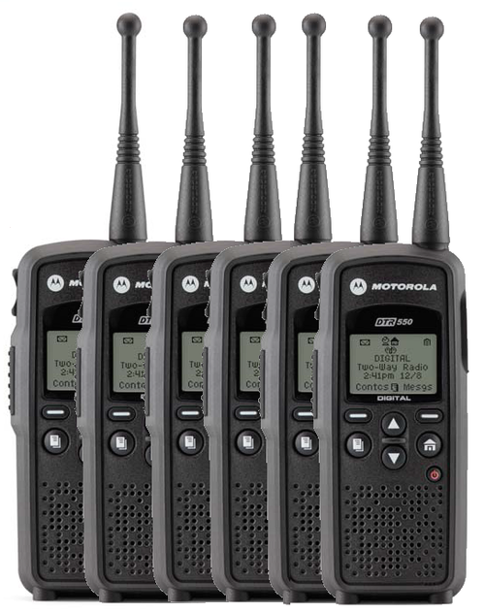

Figure 3.3 Radio. Courtesy of SACRT

**Heat Gun**

A **heat gun** is a hand-held device used to emit a stream of hot air, usually at temperatures between 100 °C and 550 °C (200-1000 °F), with some hotter models running around 760 °C (1400 °F). Heat guns usually have the form of an elongated body pointing at what is to be heated, (it resembles the shape of a gun) with a handle fixed to it at right angles and a trigger, in the same general layout as a handgun. Heat guns are often used to shrink plastic such as heat shrink used in the repair of electronic devices.



Figure 3.4 Heat Gun. Courtesy of SACRT

**Heat Shrink – Plastic Tubing**

2:1 shrink ratio (shrinks to ½ its original diameter) lengthwise shrinkage approximately 5-7% during shrink process.



Figure 3.5 Heat Shrink. Courtesy of SACRT

**Laptop/PTU**

Laptop Computer, or PTU, is a portable computer used for diagnostic interface with microprocessor-controlled systems such as communication equipment installed in passenger rail vehicles. They are used to test and verify the operational status of electronic systems. PTU’s are often but not always Laptop Computers which can be used to diagnose problems, verify proper system operation or updated software and operational parameters.

**Cabling** is the cables and connection devices needed to create the communication system connectivity. Cabling provides the physical electrical interface needed for the communication of devices that make up the communication system.

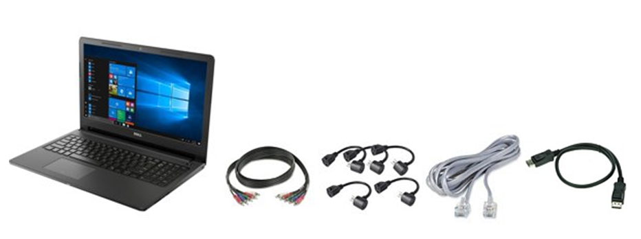

Figure 3.6 PTU. Courtesy of SACRT

**Pin Extractor**

Many electrical projects require proper assembly tools as well as terminal removal tools. Simply slide the pin removal tool between the actuator and switch body for the actuator to pop right off. The connector line removal tools are important to use when you need to replace a terminal or re-splice and crimp a wire or terminal.



Figure 3.7 Pink Extractor. Courtesy of SACRT

**Pliers**

Pliers are a tool with two handles at one end and two hard, flat, metal parts at the other. Pliers are used for holding or pulling out things such as nails, or for bending or cutting wire.



Figure 3.8 Pliers. Courtesy of SACRT

**Ratchet/Socket Set**

Ratchet/Socket wrench is a type of wrench or spanner that has a socket attached at one end, usually used to turn a fastener. The most prevalent form is the ratcheting socket wrench, is often informally called a **ratchet**. A ratcheting socket wrench is the device within a hand tool in which a metal handle is attached to a ratcheting mechanism, which attaches to a socket. This in turn fits onto a type of bolt or nut. Pulled or pushed in one direction, the ratchet loosens or tightens the bolt or nut attached to the socket. Turned the other direction, the ratchet does not turn the socket but allows the ratchet handle to be re-positioned for another turn while staying attached to the bolt or nut.



Figure 3.9 Socket Set. Courtesy of SACRT

**Schematic Diagram**

A schematic diagram is a simplified diagram showing the interconnection of components or units that make up an integrated circuit or system. The schematic diagram is similar to a road map showing how a system or circuit works. The schematic is a useful document used in connecting and troubleshooting electronic systems and signal tracing in systems such as the Passenger Rail Vehicle Communication System.

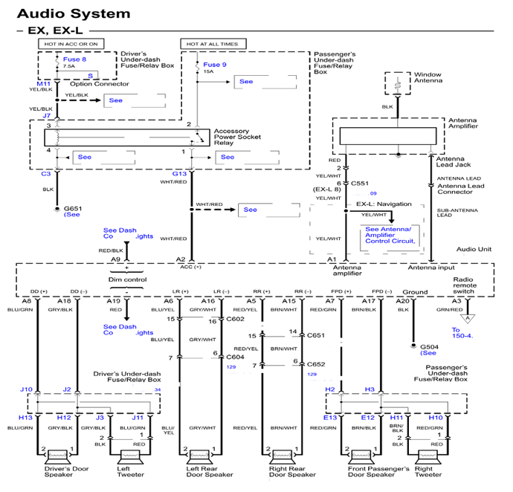

Figure 3.10 Schematic Diagram. Courtesy of SACRT

**Screw Driver**

A screwdriver is a tool that is used for turning screws. It consists of a metal rod with a flat or cross-shaped end that fits into the top of the screw. A hand tool for tightening or loosening a screw, consisting of a handle attached to a long, metal shank, which tapers and flattens out to a tip that fits into the slotted head of a screw.

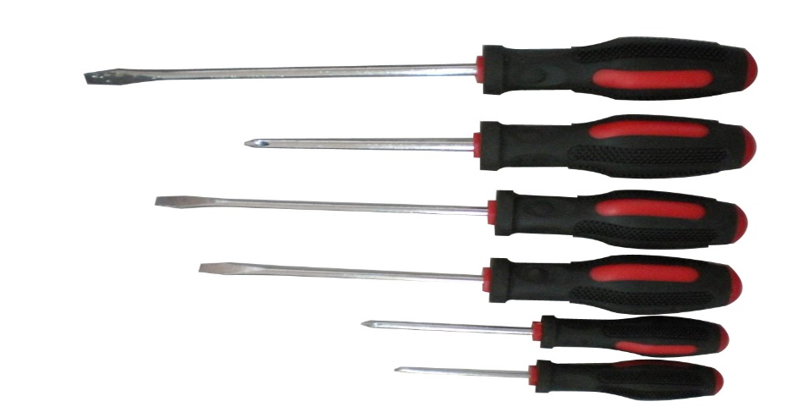

Figure 3.11 Screw Driver. Courtesy of SACRT

**Soldering Iron**

A **soldering iron** is a hand tool used in soldering. Used in the repair of electronic devices, it supplies heat to melt solder so that it can flow into the joint between two workpieces.



Figure 3.12 Soldering Iron. Courtesy of SACRT

**Test Tools/Specialty Tools/ Test Set**

Special designed test equipment used in the repair and testing of system devices. These Test Tools can include mockup units, which allow the testing of discrete system components, or verify proper operation of the system or subsystem.



Figure 3.13 Tool Set, Courtesy of SACRT

**Torx Set**

A trademark for a screw with a head having a socket shaped like a six-pointed star and for a screwdriver with a tip that fits it. The image on the right shows a **tamper proof torx**, which has a tit in the screw. A special torx tool is required to remove this type of screw.

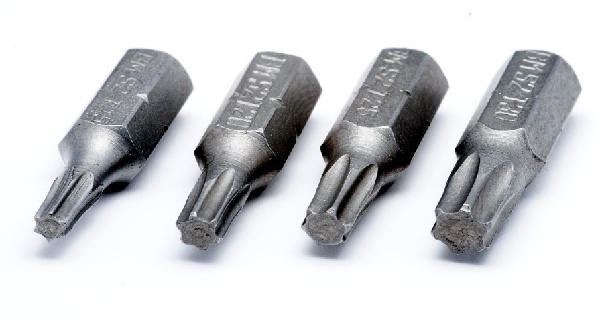

Figure 3.14 Torx Set, Courtesy of SACRT

**Voltmeter (VOM)**

The multi-meter is a compact electronic device (usually hand-held) that measures AC and DC voltage, amperes (current) and ohms (resistance).

The device goes by several commonly used names such as volt-ohm-meter (VOM), multi-tester, multi-meter and others.

The device has two electrical wire leads, red and black, and a dial to select the setting/mode. Various tests can be run and measurements made depending upon the setting. Electronic versions of the multi-tester are called a DMM (digital multi-meter) or DVOM (digital volt-ohm-meter).

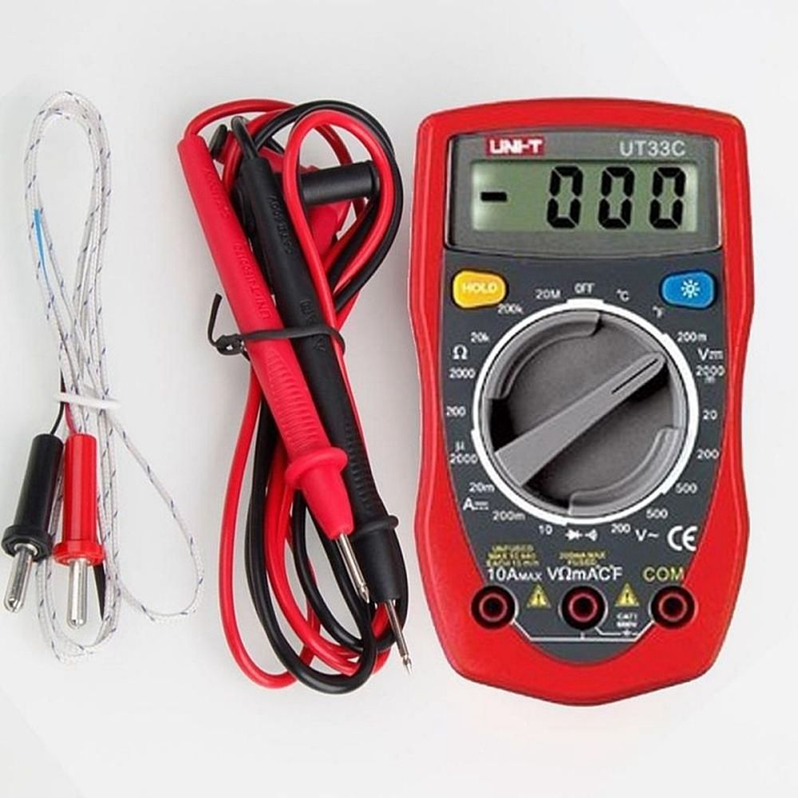

Figure 3.15 Voltmeter. Courtesy of SACRT

**Wire Crimpers**

The metal wires are joined together via a special connector. Stripped wire (often stranded) is inserted through the correctly sized opening of the connector, and a crimper is used to tightly squeeze the opening against the wire.



Figure 3.16 Wire Crimpers. Courtesy of SACRT

|  |  |
| --- | --- |
| Description: PowerPointBLUE.png | **Learning Application 3.1 – Other Tools**  Together as a class, identify other tools which may be used within the scope of inspecting and maintaining rail vehicle communication systems. Identify tool and function in the table provided below. |

|  |  |
| --- | --- |
| Tool | Function |
|  |  |
|  |  |
|  |  |

3-3 summary

This Module provided an extensive overview to different tools the rail car technician may use within their scope of inspection and maintenance of the rail vehicle communication system. As always refer to your individual agency for processes and procedures before beginning maintenance on the rail vehicle