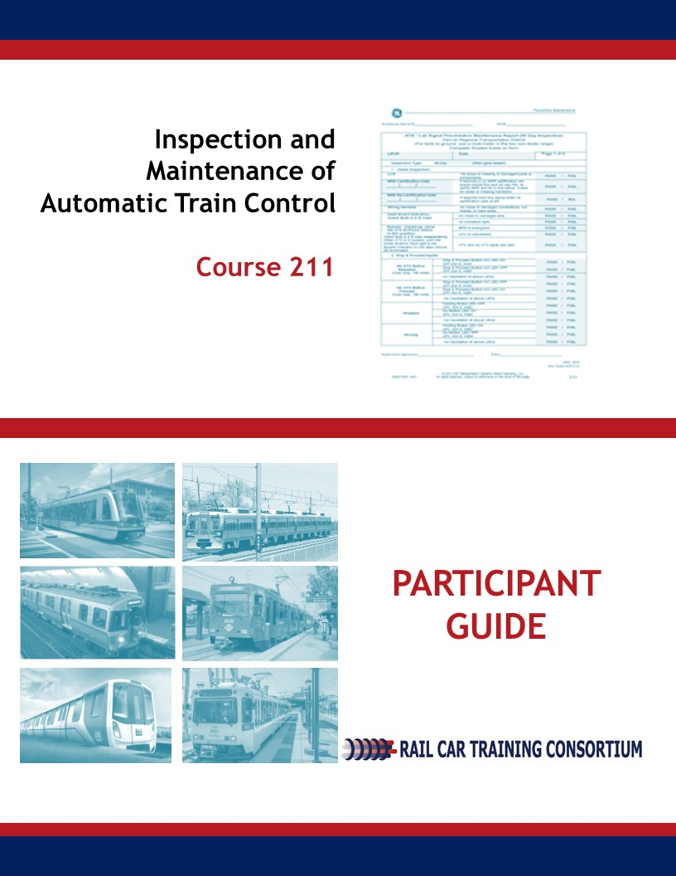

|  |
| --- |
| Automatic Train Control  **Inspection and Maintenance**  **Course 211** |
| **Participant Guide**  **June 2018** |
|  |
| Rail Car Training Consortium |

**REVISION INDEX**

Any additions, deletions, or revisions are to be listed below.

|  |  |  |  |  |
| --- | --- | --- | --- | --- |
| **Revision No.** | **Date** | **Section** | **Description of Change** | **Revision Author** |
| 01 | 2-2019 |  | Tech Edits | YOUNGBLUTH |
| 02 | 3-2019 |  | Edits | K.Ribaudo |
|  |  |  |  |  |
|  |  |  |  |  |
|  |  |  |  |  |
|  |  |  |  |  |

**Disclaimer**: This course is intended to educate employees of public transportation systems that have agreed to voluntarily participate in the Rail Car Training Consortium. It is intended only as informal guidance on the matters addressed, and should not be relied upon as the only method or manner for performing the tasks or work outlined in the materials. Anyone using this document or information provided in the associated training program should rely on his or her own independent judgment or, as appropriate, seek the advice of a competent professional in determining the exercise of care in any given circumstances. These materials are based on compendiums of knowledge from transit employees, manufacturers and outside consultants, each of whom may approach a repair, update, or maintenance in their own unique way. Always follow the safety and maintenance procedures from your own agency, union, relevant OEM(s) and/or regulatory organizations. In addition, the course materials include examples from member agencies, nomenclature, procedures, and configurations which can vary from one transit location to another. The document that you are now referencing may have been modified by the Consortium member. For the original versions, please go to TransitTraining.net or contact the Transportation Learning Center.

The Rail Car Training Consortium, its participating agencies and labor unions, as well as the Transportation Learning Center, make no guaranty or warranty as to the accuracy or completeness of any information provided herein. The Rail Car Training Consortium, its participating agencies and labor unions, as well as the Transportation Learning Center, disclaim liability for any injury or other damages of any nature whatsoever, directly or indirectly, resulting from the use of or reliance on this document or the associated training program.

**Note**: All images contained within this document were contributed by Rail Car Training Consortium members unless otherwise noted.

**How to Use the Participant Guide**

**Purpose of the Course**

Course 211: Inspection and Maintenance of Automatic Train Control, provides participants with an overview of how to inspect and maintain Automatic Train Control system. This course is intended to prepare the participant to inspect and maintain the Automatic Train Control system in a transportation maintenance facility.

**Approach of the Book**

Each course Module begins with an outline, a statement of purpose and objectives, and a list of key terms. The *outline* will discuss the main topics to be addressed in the Module. A list of *key terms* identifies important terminology that will be introduced in this Module. *Learning objectives* define the basic skills, knowledge, and abilities course participants should be able to demonstrate to show that they have learned the material presented in the Module. *Exercises* are built in throughout the course materials to assist the participants in learning and reviewing key information.

Table of Contents

**How to Use the Participant Guide** ii

Module 1 General Inspection Procedures 1

1-1 Overview 2

1-2 Preparing for Inspection and Maintenance 3

1-3 Inspection and Maintenance Schedules 4

1-4 Summary 8

Module 2 ATC System Testing 9

2-1 Overview 10

2-2 ATC System Tests 10

2-3 Summary 15

Module 3 Exterior Components 16

3-1 Overview 17

3-2 Antenna/Receiver Coils 17

3-3 Speed Sensors 18

3-4 Train ID 19

3-5 Summary 20

Module 4 Interior Components 21

4-1 Overview 23

4-2 CPU Board/Interface Board 23

4-3 Relays/Vital Relays 24

4-5 Power Supply 25

4-6 Decelerometer 27

4-8 Aspect Display Unit 27

4-9 Bypass Switch 28

4-10 Master Controller 29

4-11 Operator Acknowledgment Button 31

4-12 P Signal Generator 31

4-13 Summary 33

List of Figures

Figure 1.1 Example OEM Recommended Schedule. Courtesy of RTD 5

Figure 1.2 PM Sheet. Courtesy of GCRTA 6

Figure 3.1, Antenna. Courtesy of CTA 17

Figure 3.2 Speed Sensor. Courtesy of MTA 19

Figure 4.1 Receiver Board. Courtesy of MTA...………………………………………………...24 Figure 4.2 Multifunction Board. Courtesy of PATCO 24

Figure 4.3 Relays. Courtesy of MTA 25

Figure 4.4 Power Supply. Courtesy of PATCO 26

Figure 4.5 Decelerometer. Courtesy of MTA 27

Figure 4.6 Aspect Display Unit. Courtesy of PATCO 28

Figure 4.7 Bypass Switch. Courtesy of MTA 29

Figure 4.8 Master Controller. Courtesy of MTA 30

Figure 4.9 Operator Acknowledgment Button. Courtesy of PATCO 31

Module 1

*General Inspection Procedures*

**Outline**

* 1. **Overview**
  2. **Preparing for Inspection and Maintenance**
  3. **Inspection and Maintenance Schedules**
  4. **Summary**

**Purpose and Objectives**

The purpose of this Module is to provide participants with an overview to general inspection procedures, in relation to Automatic Train Control (ATC).

Following the completion of this Module, the participant should be able to complete the objectives with an accuracy of 75% or greater:

* Explain the difference between scheduled and unscheduled maintenance;
* Explain pre-inspection procedures; and
* Explain how inspection schedules work.

**Key Terms**

|  |  |  |
| --- | --- | --- |
| * **Preventive Maintenance** * **Scheduled Maintenance** | * **Unscheduled Maintenance** * **Sensory Inspection** | * **Original Equipment Manufacturer (OEM)** |

* 1. overview

Maintenance can be defined as the method that equipment is kept in its existing condition; preserved or protected; or kept from failure or decline. The ultimate goal of maintenance is to provide optimal reliability to meet safety standards and provide onboard services for rail passengers and crew. Reliability is “the probability or duration of failure-free performance under stated conditions.”

There are two (2) categories of maintenance: unscheduled and scheduled. Unscheduled maintenance is unfortunately unavoidable. One example of this type of maintenance is to repair sensitive edges that are not detecting obstructions. Unscheduled maintenance is sometimes referred to as reactive maintenance, corrective maintenance, breakdown maintenance, or run-to-fail maintenance. Thorough, predictive maintenance can decrease the amount of unscheduled maintenance that a rail car technician will encounter.

Scheduled (preventive) maintenance is the proactive approach of scheduling maintenance in order to preserve, protect, and keep rail car systems from failure or decline. Scheduled maintenance includes predictive maintenance and preventive maintenance. Scheduled maintenance serves two purposes: To keep equipment working properly and to extend the life of the equipment. Sometimes in the process of performing scheduled maintenance, the technician may encounter a situation where the corrective action (repair or replace components) may need to happen. Scheduled maintenance is generally guided by the agency’s requirements, regulatory and code requirements, technical safety requirements, in-service inspection and testing, engineering decisions, and Original Equipment Manufacturer (OEM) recommendations.

This Module guides the participant through the essential steps in performing inspection and maintenance of the ATC subsystems. Before each set of maintenance steps, this course always lists the first step as “Follow safety rules.” Safety can never be overstressed when performing work around rail vehicles.

|  |  |
| --- | --- |
| caution | **Warning: Safety Precautions!** |
| * All agency regulations, precautions, and procedures concerning working in the rail maintenance shop should be strictly followed. * Only qualified personnel should handle maintenance, troubleshooting and repairs of a rail car’s ATC system. * Check that equipment is in no-voltage condition. * Be aware of pinch-point exposure and risk. |

1-2 Preparing for Inspection and Maintenance

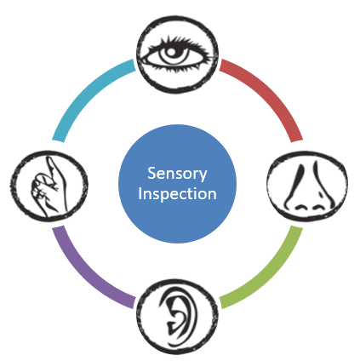Sensory Inspection

Relying on the physical senses of sight, smell, hearing, and touch, an experienced rail car technician will conduct a sensory inspection while inspecting and maintaining the rail vehicle ATC system.

Below are some symptoms that, when identified with your senses, may indicate a problem with some components of the ATC subsystem. With more experience, the technician will become more familiar with the normal sights, smells, sounds, and the feel of the system. During a sensory inspection, check for deviations from this norm. Some examples are provided in the table below. Refer to your individual agency for specific symptoms to identify during a sensory inspection.

|  |  |  |
| --- | --- | --- |
| **Sense** | **Check For** | **Agency Specific** |
| Sight | * Damage from wayside debris * Alignment for receiver coils * Loose connections * Missing hardware |  |
| Smell | * Burning |  |
| Hearing | * Rattling of loose components * Relay specific noises |  |
| Touch | * Receiver coils tight * Check connections |  |

1-3 Inspection and Maintenance Schedules

Each Transportation System schedules periodic inspection and maintenance of each of their rail vehicles’ ATC subsystems by following cycles recommended by the rail car industry, OEMS, or a combination of both. Generally, these schedules are based on time; for example, specific maintenance is required after a specific number of hours that a rail car is in operation; or on distance--the number of miles that the rail car is in operation. In addition, there are also maintenance schedules recommended by the manufacturers or OEMs that are considered by agencies.

Scheduled Maintenance

Scheduled maintenance involves the inspection and maintenance of the rail vehicle ATC system and components that are performed on a regular schedule in order to lessen the likelihood of failure. Scheduled maintenance has many advantages:

* Better conservation of components and equipment, increase life expectancy of equipment, thereby eliminating premature replacement of machinery and equipment.
* Timely, routine repairs circumvent fewer large-scale repairs.
* Reduced cost of repairs by reducing secondary failures. When parts fail in service, they usually damage other parts.
* Improved safety and quality conditions.

**OEM-Recommended Schedules**

Each rail vehicle’s ATC system is provided with inspection and maintenance schedules recommended by the OEM. These are commonly referred to as “service manuals” and are made available for rail car technicians during training and while they are working on the rail vehicles. See Figure 1.1 for an example of an OEM-Recommended Schedule provided by Denver RTD.

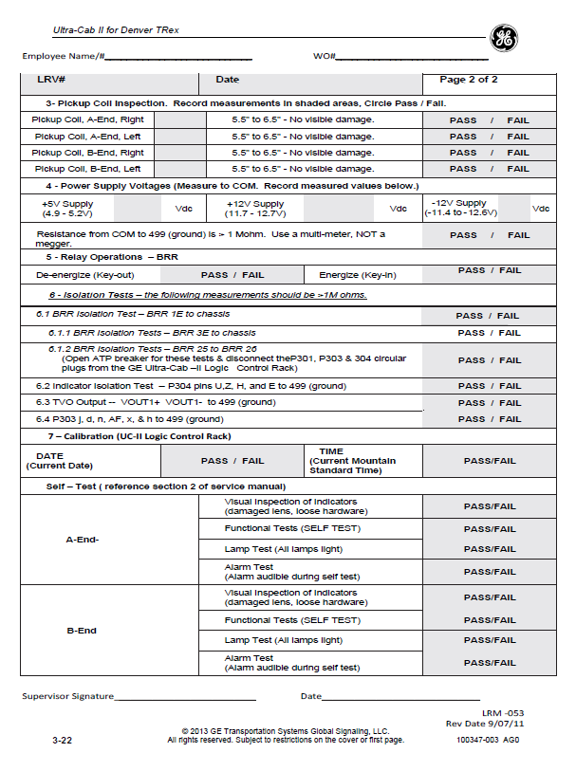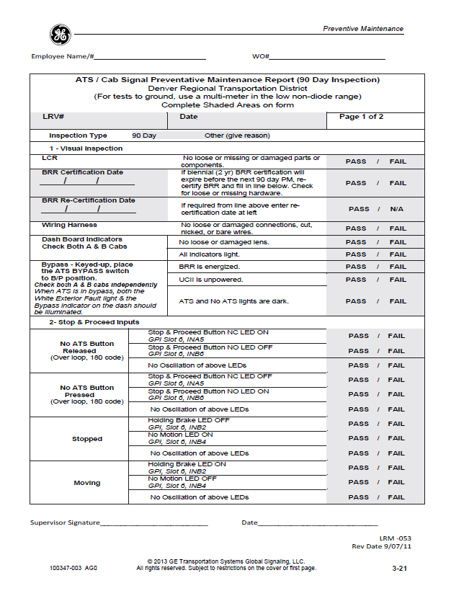

Figure 1.1Example OEM Recommended Schedule. Courtesy of Denver RTD

|  |  |
| --- | --- |
| Preventive Maintenance (PM) Sheets  Rail car machinery and equipment deteriorate with age and use. Routine inspection and cyclical maintenance ensure passenger safety and keep rail cars running efficiently and on schedule.  Agencies use written procedures and checklists to ensure that essential tests and checks are applied to all rail car equipment. Generally known as **preventive maintenance (PM)** **sheets**. A sample is shown in **Figure 1.2.**  Lists vary by type, model, and configuration of door equipment and include OEM and agency recommendations. Technicians are expected to check off the inspection or service applied to the door system component that they are inspecting or that they are maintaining. All procedures are recorded and entered in a computer database where further analysis and reporting can be done, if necessary. | Figure 1.2 PM Sheet. Courtesy of GCRTA |

|  |  |
| --- | --- |
| Description: PowerPointBLUE.png | **Learning Application 1.1**  With the help of your instructor, examine the PM sheets and OEM Recommended Schedules for inspection and maintenance that your agency uses for the ATC system. Discuss the following questions as a class. Write important notes for future reference. |
| 1. | Attach a copy of a blank PM Sheet to your class notes. What are the different elements of a PM sheet at your agency compared to what is discussed in this Module? |
| 2. | Where are the procedures (or manuals) stored in your agency’s maintenance shop? |
| 3. | How can the procedures be accessed while working on the rail car? |
| 4. | In the space below, write down other specific instructions regarding written procedures for completing the inspection and maintenance PM sheet/checklist. |

|  |
| --- |
|  |
|  |
|  |
|  |
|  |
|  |
|  |
|  |
|  |
|  |
|  |
|  |

1-4 Summary

This Module differentiated between unscheduled and scheduled maintenance. The rail car technician is expected to work within both types of methods and emphasized the importance of scheduled maintenance. Scheduled maintenance is performed to keep equipment working properly and to extend the life of equipment, and the safety of those who use rail transportation.

Finally, the Module presented the opportunity for rail car technicians to familiarize themselves with standard PM sheets and to examine the requirements of their agencies for ensuring effective inspection and maintenance of rail vehicle.

Module 2

*ATC System Testing*

**Outline**

* 1. ****Overview****
  2. ****ATC System Tests****
  3. ****Summary****

**Purpose and Objectives**

The purpose of this Module is to provide participants with an understanding of different ATC system tests.

Following the completion of this Module, the participant should be able to complete the objectives with an accuracy of 75% or greater:

* Demonstrate the ability to perform ATC system specific tests.

**Key Terms**

|  |  |  |
| --- | --- | --- |
| * **Automatic Train Control (ATC)** * **Daily Safety Test (DST)** * **Code Rate Detection Current Reading Test** | * **Visual Inspection of Under-Car and In-Car Equipment** * **Wheel Size Calibration** * **Continuity Test** | * **Current Test** * **ATP Functional Test** * **Loop Current Test** |

2-1 overview

During inspection and maintenance, several tests will be performed to ensure all systems and equipment are working properly. Tests will vary by agency but may include:

* Daily Safety Test
* Visual Inspection of under-car and in-car equipment
* Wheel calibration
* Current Tests
* ATP Functional Test
* Loop Current Test
* Code Rate Detection Current Reading Test
* Continuity Test
* Checking Speed Commands

2-2 atc system tests

**Daily Safety Test (DST)**

The Daily Safety Test or DST, also referred to as a Departure Test, must be performed before the train enters revenue service. Prior to initiating a DST, a visual inspection of the ATC equipment is required. The DST tests the following functions to ensure they are in proper working order:

* ADU Lamp Test
* ADU Alarm Test
* Cab Selection Relay Test
* Receiver Coils Continuity Test
* Cab Signal Sensitivity Test
* Cab Signal Detection, Decoding and Aspect Display
* Vehicle Speed Determination
* V-zero Determination
* Overspeed Detection
* Emergency Brake Application
* All doors closed signal

Before a DST is initiated, certain conditions must be met:

* A or B-cab keyed
* Master controller is full brake position
* Not in Reverse running mode
* V-zero achieved
* Emergency brake outputs are released
* ATP not bypassed
* No calibration utility active
* All doors closed signal

The following Case Study provided by CATS outlines the process followed for a DST on their rail vehicles.

|  |
| --- |
| **Case Study 2.1 – Charlotte Area Transit System (CATS) LRV Departure Test Procedure**   1. Initiate the Departure Test by pressing the ATP pushbutton on the ADU. 2. Verify that the ATP indicator on the ADJU flashes once per second. 3. Verify that all green LED segments in the speed ring and all segments in the digital speed display illuminate, and the ATP alarm annunciates for two (2) seconds. 4. Verify that all green LED segments in the speed ring and all segments in the digital speed display extinguish, and ATP alarm becomes silent. The ATP indicator still flashes. 5. Verify that all red LED segments in the speed ring illuminate for two (2) seconds. 6. Verify that all red LED segments in the speed ring extinguish, and ATP indicator is still flashing. 7. The ATP system verifies continuity of the A- and B-end receiver coils. No Operator verification is required. This test takes approximately eight (8) seconds. 8. Verify that the ADU indicates a 0-mph speed limit (no-code) for four (4) seconds, then ramps the indicated speed up to 2 mph (overspeed) and back down to 0 mph (underspeed). 9. Verify that the ADU indicates a 15-mph speed limit (75 code rate) for four (4) seconds, then ramps the indicated speed up to 17 mph (overspeed) and back down to 14 mph (underspeed). 10. Verify that the ADU indicates a 25-mph speed limit (120 code rate) for four (4) seconds, then ramps the indicated speed up to 27 mph (overspeed) and back down to 24 mph (underspeed). 11. Verify that the ADU indicates a 35-mph speed limit (180 code rate) for four (4) seconds, then ramps the indicated speed up to 37 mph (overspeed) and back down to 34 mph (underspeed). 12. Verify that the ADU indicates a 45-mph speed limit (210 code rate) for four (4) seconds, then ramps the indicated speed up to 47 mph (overspeed) and back down to 44 mph (underspeed). 13. Verify that the ADU indicates a 55-mph speed limit for four (4) seconds, then ramps the indicated speed up to 57 mph (overspeed) and back down to 54 mph (underspeed). 14. Verify that the ADU indicates a 10-mph speed limit for four (4) seconds. Verify ADU alarm beeps once and YARD indicator illuminates. Verify indicated speed ramps up to 12 mph (overspeed) and back down to 9 mph (underspeed). 15. Verify that the ADU shows a 10-mph speed limit (no code), then ramps the indicated speed up to 12 mph (overspeed) and back down to 9 mph (underspeed), and that the YARD indicator remains illuminated. 16. Verify that the ADU indicates a 55-mph speed limit, then ramps the indicated speed up to 57 mph (overspeed) and back down to 54 mph (underspeed), and that the YARD indicator extinguishes. 17. Verify that the ADU indicates a speed of 54 mph for one (1) second. 18. Verify that the ADU indicates a speed of 55 mph for one (1) second, then 56 mph for one (1) second, and that the red LED segments illuminate to indicate speed in excess of speed limit (no overspeed condition). 19. Verify that the ADU indicates a speed of 58 mph, flashing red LED segments and flashing digital speed display for one (1) second. Verify Mandatory Brake application and no Emergency Brake application. 20. Verify that the ADU indicates a speed of 56 mph for one (1) second. Verify Mandatory Brake still applied and no Emergency Brake application. 21. Verify that the ADU indicates a speed of 53 mph underspeed condition for one (1) second. Verify Mandatory Brake not set and no Emergency Brake application. 22. Verify that the ADU indicates a 45-mph speed limit (simulated overspeed due to downward code change), flashing red LED segments from 45 to 53 mph, and flashing digital speed display 23. Verify Mandatory Brake application due to overspeed. Verify Emergency Brake application within three (3) seconds due to failure to achieve brake rate. 24. Verify that the ADU indicates a speed of 3 mph for one (1) second. Verify that the Emergency Brake remains applied. 25. Verify that the ADU ramps indicated speed down to 0 mph. If indicated in the cab, verify that Mandatory and Emergency Brakes are released. 26. Verify that all ADU speed and speed limit indications extinguish. 27. Verify ATP pushbutton/indicator lights solid to indicate Departure Test pass status. 28. Report test results to supervision with any discrepancies noted while the test was running. |

|  |  |
| --- | --- |
|  | **Instructional Video -** Watch the instructional video which showcases the Daily Departure Test technicians perform on rail vehicles at PATCO. Afterwards, discuss the similarities and differences between PATCO’s DST and your agency. *Click the “play” button to the left and enter password: railcar* |
|  | |
|  | |
|  | |
|  | |
|  | |
|  | |
|  | |
|  | |
|  | |
|  | |
|  | |
|  | |

**Visual Inspection of Under Car and In-Car Equipment**

The technician shall inspect all equipment located under the rail vehicle on both ends including, antennas, coils and hardware. Additionally, the technician shall also inspect all equipment located inside the rail vehicle for any signs of wear or damage.

**Wheel Size Calibration**

The technician shall inspect rail vehicle wheels for:

* Wear and tear;
* Flat spots which can cause wheels to get out of round.

Profiling is important to prevent derailment. Technicians can use a PTU to identify the correct wheel size. To confirm correct wheel size, the technician will take the wheel diameter. The wheel diameter will then be input into the PTU to ensure the wheel size is correct.

**Current Tests**

During a Current Test, the technician shall test how many millivolts the receiver coils are picking up. To do so, the technician shall place the loop underneath the receiver coil and send out a code (pulse rate) from the ATP simulator. The technician will take the reading inside the ATP box to measure the voltage.

**ATP Functional Test**

The ATP Functional Test simulates speed codes to ensure the rail vehicle responds to all of the codes. The ATP functional test is performed from the ATP simulator.

**Loop Current Test**

The Loop Current test is performed on the Wayside equipment and tests the marker detection unit.

**Code Rate Detection Current Reading Test**

During a Code Rate Detection Current Reading Test, the technician shall test how many millivolts the receiver coils are picking up. To do so, place the loop underneath the receiver coil and send out a code (pulse rate) from the ATP simulator. The technician will take the reading inside the ATP box to measure the voltage.

**Continuity Test**

The Continuity Test checks the receiver coils to determine they are receiving the correct signals. To do so, the technician shall take an ohm reading through the coils.

**Checking Speed Commands**

The Checking Speed Commands test simulates speed codes to ensure the rail vehicle responds to all. This test is performed by a switch on the ATP simulator. The timing at which speed commands will be checked will vary by agency. For example, at GCRTA, tests are performed every month whereas WMATA performs their tests every 3 months. Refer to your agency for specific timing on Speed Commands testing.

|  |  |
| --- | --- |
| Description: PowerPointBLUE.png | **Learning Application 2.1 – Other ATC System Tests**  Identify other ATC systems tests that were not discussed in this Module. Take notes in the table provided for future reference. |

|  |
| --- |
|  |
|  |
|  |
|  |
|  |
|  |
|  |

2-3 summary

This Module presented the participant with the various ATC system/subsystem tests. Depending on the ATC system used, not all tests will need to be performed. This Module also afforded the opportunity for participants to view an instructional video on performing a DST. ATC system tests discussed in this Module include:

* Daily safety test
* Inspection of under-car equipment
* Wheel size calibration
* Current Tests
* ATP functional test
* Loop current test
* Code rate detection test
* Continuity test
* Checking speed commands

Module 3

*Exterior Components*

**Outline**

* 1. ****Overview****
  2. ****Antenna/Receiver Coils****
  3. ****Speed Sensors****
  4. ****Train ID****
  5. ****Summary****

**Purpose and Objectives**

The purpose of this Module is to provide participants with an overview to inspecting and maintaining exterior ATC components.

Following the completion of this Module, the participant should be able to complete the objectives with an accuracy of 75% or greater:

* Demonstrate the ability to perform inspection and maintenance on exterior components:
  + Antenna/Receiver Coils
  + Speed Sensors
  + Train ID

**Key Terms**

|  |  |  |
| --- | --- | --- |
| * **Automatic Train Control (ATC)l** * **Speed Sensor** | * **Antenna** * **Train ID** | * **Receiver Coil** |

3-1 overview

This Module will guide the participant through the inspection and maintenance procedures on ATC system exterior components. As always, procedures will vary and you should always refer to your individual agency.

|  |  |
| --- | --- |
| caution | **Warning: Safety Precautions!** |
| * All agency regulations, precautions, and procedures concerning working in the rail maintenance shop should be strictly followed. * Ensure proper PPE is worn at all times. * Check that equipment is in no-voltage condition. * Be aware of pinch-point exposure and risk. |

* 1. Antenna/Receiver coils

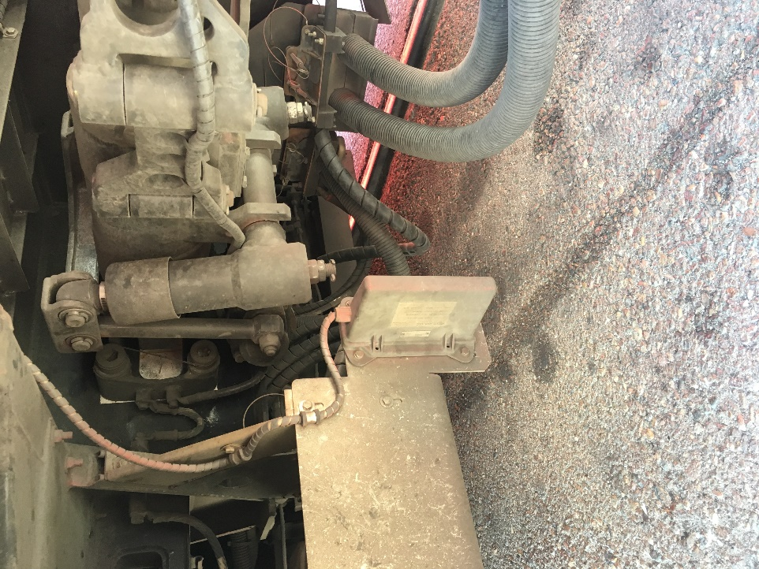Antennas transmit and receive data from the wayside to ATC rack in the rail vehicle and are typically inspected during periodic inspection. The general procedure for inspecting antennas is as follows:

1. Visual inspection
   1. Ensure mounting hardware is tightly secured.
   2. Check for cracks or damage to hardware.
   3. Check that harness is secured tightly.
2. Check coil value via a digital multimeter. Tap coil to see if value changes. If value changes, it indicates a bad connection.

If during the inspection process, any damage to component is observed, the technician shall replace the damaged component.

Figure 3.1, Antenna, Courtesy of CTA

|  |
| --- |
| **ANTENNA/RECEIVER COIL INSPECTION PROCEDURE** |
| **Agency Specific:** |
|  |
|  |
|  |
|  |
|  |
|  |
|  |

* 1. SPEED SENSORS

Speed sensors measure the axle speed. Speed sensors are visually inspected and if damaged, are replaced. The general procedure for inspecting a speed sensor is as follows:

1. Visual inspection:
   1. Check for damage to cables and connectors.
2. Measure speed sensors using an **ohmmeter** to ensure they meet the proper requirements.

*An ohmmeter is an electronic device that measures resistance in an electronic component or circuit.*

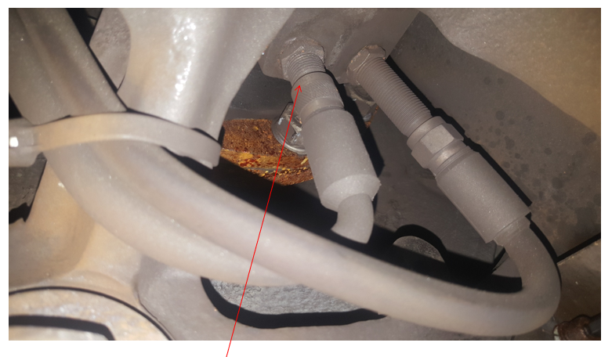

Figure 3.2 Speed Sensor, Courtesy of MTA

|  |
| --- |
| **SPEED SENSOR INSPECTION PROCEDURE** |
| **Agency Specific:** |
|  |
|  |
|  |
|  |
|  |
|  |
|  |

* 1. Train ID

Depending on agency, the Train ID component can be an exterior and/or interior component. For purpose of this training, Train ID will be discussed under the exterior component section.

The general inspection procedure is as follows:

1. Match the rail vehicle number to signal being received by wayside.

Module 3 covered ATC component inspection procedures. Make and model of rail vehicles will vary by agency, and therefore, common problems specific to one agency may not be relevant to another. The following learning application is intended for the participant to make note of common inspection problems specific to his agency regarding ATC **exterior** components.

|  |  |
| --- | --- |
| Description: PowerPointBLUE.png | **Learning Application 3.1 – Common Problems**  Together as a class, identify and discuss common problems specific to exterior ATC components. Participants are encouraged to take notes for future reference. |

|  |  |  |
| --- | --- | --- |
| **Common Problem** | **Common Causes** | **Corrective Action** |
|  |  |  |
|  |  |  |
|  |  |  |
|  |  |  |

* 1. Summary

This Module presented the participant with the inspection and maintenance procedures for ATC exterior components. As always, the procedures provided are general and you should always adhere to agency specific procedures. The components discussed in this Module included:

* Antenna/Receiver Coils
* Speed Sensors
* Train ID

Module 4

*Interior Components*

**Outline**

**4-1 Overview**

**4-2 CPU Board/Interface Board**

**4-3 Relays/Vital Relays**

**4-4 Power Supply**

**4-5 Decelerometer**

**4-6 Aspect Display Unit**

**4-7 Bypass Switch**

**4-8 Master Controller**

**4-9 Operator Acknowledgement Button**

**4-10 P Signal Generator**

**4-11 Summary**

**Purpose and Objectives**

The purpose of this Module is to provide participants with an overview to inspecting and maintaining interior components of the ATC system.

Following the completion of this Module, the participant should be able to complete the objectives with an accuracy of 75% or greater:

* Demonstrate the ability to inspect and maintain interior components:
  + CPU Board
  + Vital Relays
  + Power Supply
  + Interface Board
  + Decelerometer
  + Aspect Display Unit
  + Bypass Switch
  + Master Controller
  + Operator Acknowledgment Button
  + P Signal Generator

**Key Terms**

|  |  |  |
| --- | --- | --- |
| * **CPU Board** * **Vital Relays** * **Power Supply** * **Interface Board** | * **Decelerometer** * **Aspect Display Unit** * **Bypass Switch** | * **Master Controller** * **Operator Acknowledgment Button** * **P Signal Generator** |

4-1 Overview

This Module will guide the participant through the inspection and maintenance procedures on ATC system exterior components. As always, procedures will vary and you should always refer to your individual agency.

|  |  |
| --- | --- |
| caution | **Warning: Safety Precautions!** |
| * All agency regulations, precautions, and procedures concerning working in the rail maintenance shop should be strictly followed. * Ensure proper PPE is worn at all times. * Check that equipment is in no-voltage condition. * Be aware of pinch-point exposure and risk. |

4-2 CPU BOARDS/Interface board

CPU and Interface Boards follow the same inspection procedure and therefore, will be discussed in one section.

The **Interface Board** performs various functions, such as vital outputs, departure test signals, process speed sensor signals.

**CPU Boards** are made up of several **Printed Circuit Boards (PCBs)**, which control the logic power and ATO, ATP, ATCS and communication subsystems of ATC. CPU Boards are inspected two ways; as part of the DST, which was discussed in an earlier module, and also by way of visual inspection.

The general inspection procedure for CPU Boards and Interface Board is as follows:

1. Visual inspection
   1. Ensure there is no physical damage to CPU/Interface Board.

Damage to look for may include, burning smell or damaged connector.

If, during the visual inspection, the technician observes that there is physical damage to the CPU or Interface Board, the component is replaced in the shop, on the mainline, or in the heavy repair shop. If the Boards display a fault during the DST, the technician will create a workorder for the vehicle to be brought into the shop. **Figures 4.1** and **4.2** provide two different examples of boards.

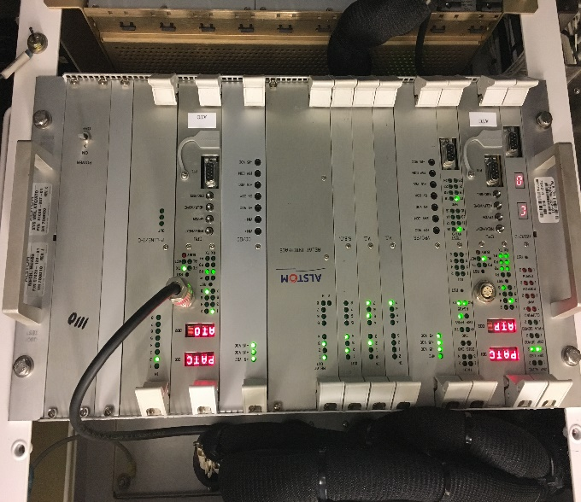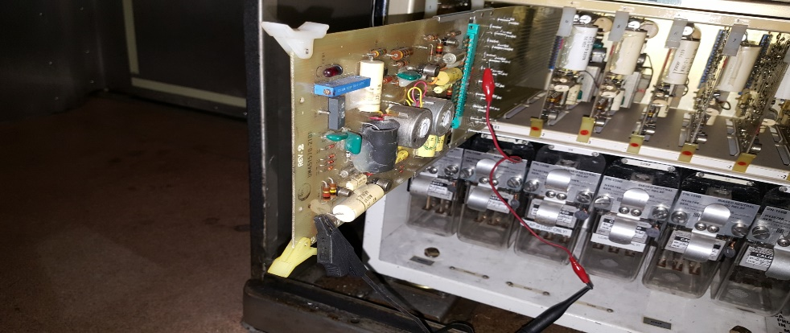

Figure 4.1 Receiver Board. Courtesy of MTA Figure 4.2 Multifunction Board. Courtesy of PATCO

|  |
| --- |
| **CPU/INTERFACE BOARD INSPECTION PROCEDURE** |
| **Agency Specific:** |
|  |
|  |
|  |
|  |
|  |

4-3 Relays/VITAL RELAYS

Vital Relays pick up or drop out depending on signal sent to the relay. The general procedure for inspecting vital relays is as follows:

1. Check relay pickup current *(use a multimeter and increase current to see if coils picks up.)*
2. Check relay drop out current *(use a multimeter and decrease current to see if coils drops out).*
3. Check contact resistance.
4. Clean.

If during the inspection process, the technician observes the vital relays do not pickup/drop signals as they should, the relay is replaced. The timeline for inspection of vital relays will vary by agency however, as an example, relays at GCRTA are removed from vehicles and inspected every 2 years. Additionally, vital relays are also checked daily during a functional test of the system to ensure they are functioning properly.

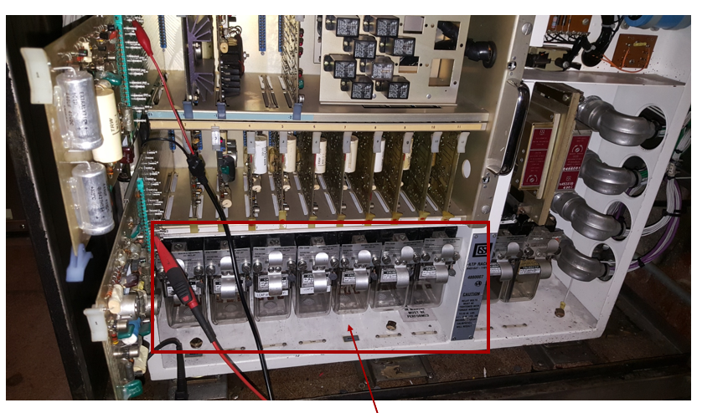

Figure 4.3 Relays, Courtesy of MTA

|  |
| --- |
| **VITAL RELAYS INSPECTION PROCEDURE** |
| **Agency Specific:** |
|  |
|  |
|  |
|  |
| **How often are relays/vital relays inspected?** |
|  |

4-4 POWER SUPPLY

The Power Supply board provides power to the ATC system and subsystems follows the same inspection procedures as the CPU Board. In addition to a visual inspection, the power supply is also inspected as part of the Daily Safety Test (DST). The general inspection procedure is as follows:

1. Visual inspection
   1. Ensure there is no physical damage to power supply.

If, during the visual inspection, the technician observes that there is physical damage to the power supply, the component is replaced in the shop, on the mainline, or in the heavy repair shop.

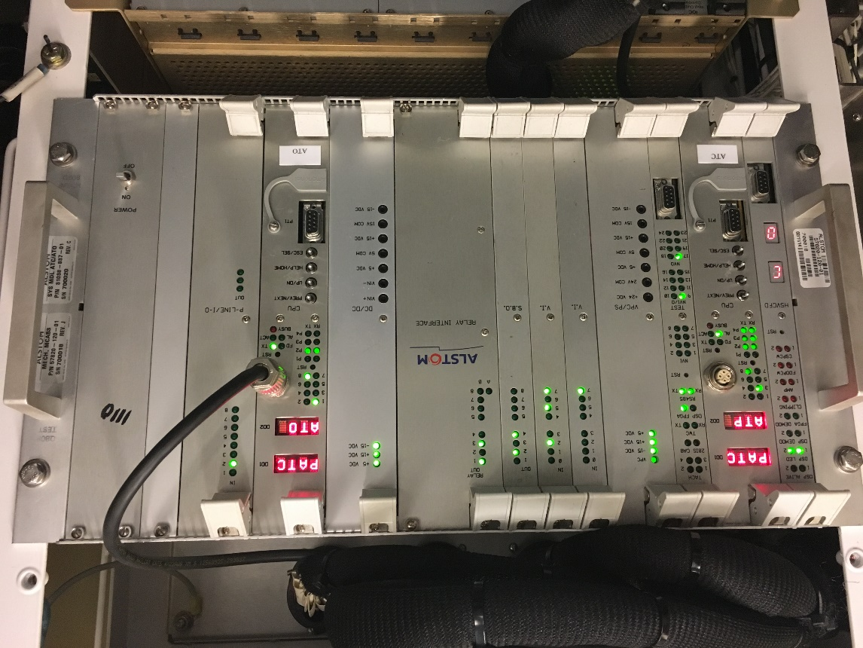

Figure 4.4 Power Supply. Courtesy of PATCO

|  |
| --- |
| **POWER SUPPLY INSPECTION PROCEDURE** |
| **Agency Specific:** |
|  |
|  |
|  |
|  |
|  |

* 1. Decelerometer

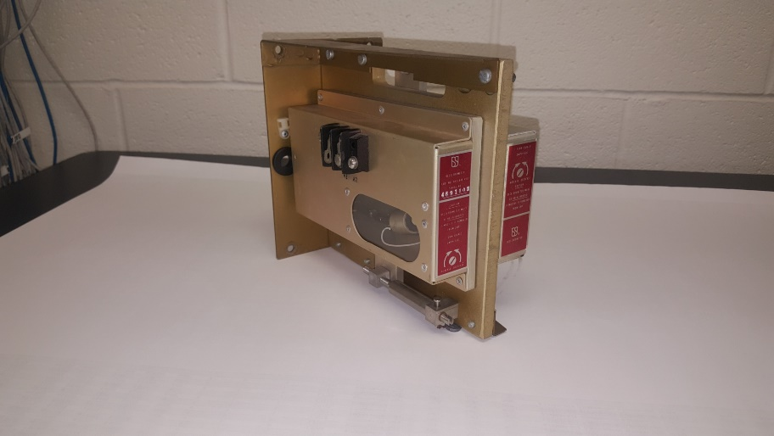The decelerometer measures the change in velocity of the rail vehicle. If found to be defective, the component is replaced. Calibration of the decelerometer is performed upon initial installation of the ATC system, any time the decelerometer module is removed from the equipment rack, or after any modification to the ATC system enclosure mounting. System maintenance tests are performed annually. The general inspection procedure is as follows:

1. Visual inspection
   1. With light and mirror, check for any physical damage.

Figure 4.5 Decelerometer, Courtesy of MTA

|  |
| --- |
| **DECELEROMETER INSPECTION PROCEDURE** |
| **Agency Specific:** |
|  |
|  |
|  |
|  |
|  |

4-6 ASPECT DISPLAY UNIT (ADU)

The Aspect Display Unit, also referred to as the console, is located in the operator’s cab. At most agencies, the inspection of the ADU is done by a self-test that is initiated when powering on the vehicle. Procedures may vary by agency.

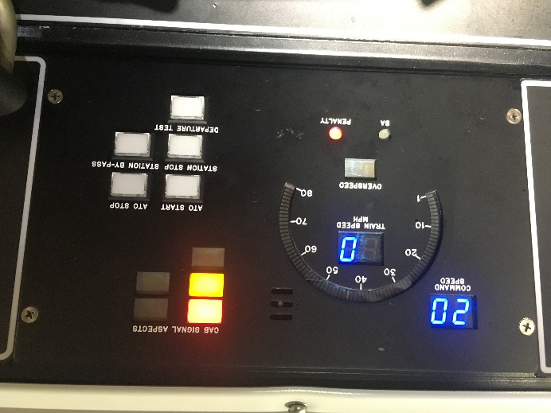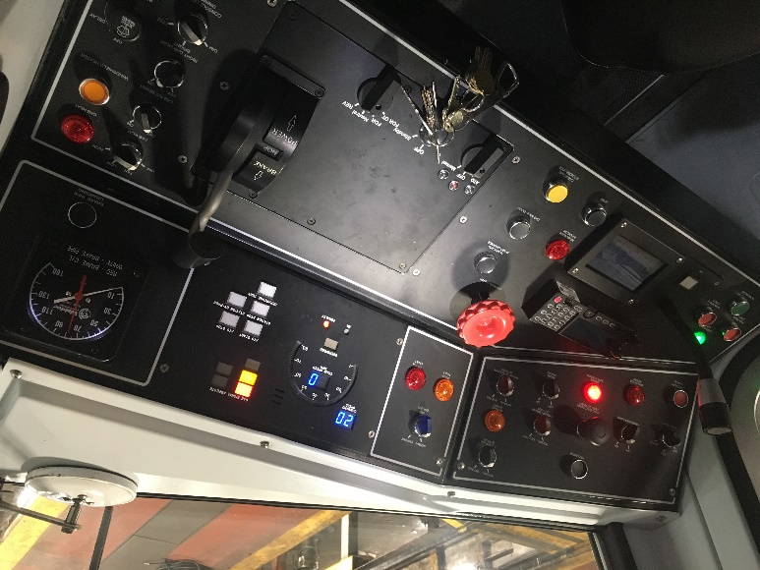

Figure 4.6 Aspect Display Unit. Courtesy of PATCO

|  |
| --- |
| **ASPECT DISPLAY UNIT INSPECTION PROCEDURE** |
| **Agency Specific:** |
|  |
|  |
|  |

4-7 BYPASS SWITCH

The By-Pass Switch is used when a failure to the ATC subsystem occurs. When activated, the by-pass switch disables normal ATC functions, including, overspeed protection, automatic brake request and alarms. The general inspection procedure is as follows:

1. Ensure proper operation of switch by cycling on/off to verify that the ATC bypass acknowledgment turns on.

The maintenance of the bypass switch includes keeping the switch clean and clear of debris. If the switch is faulty, it is replaced.

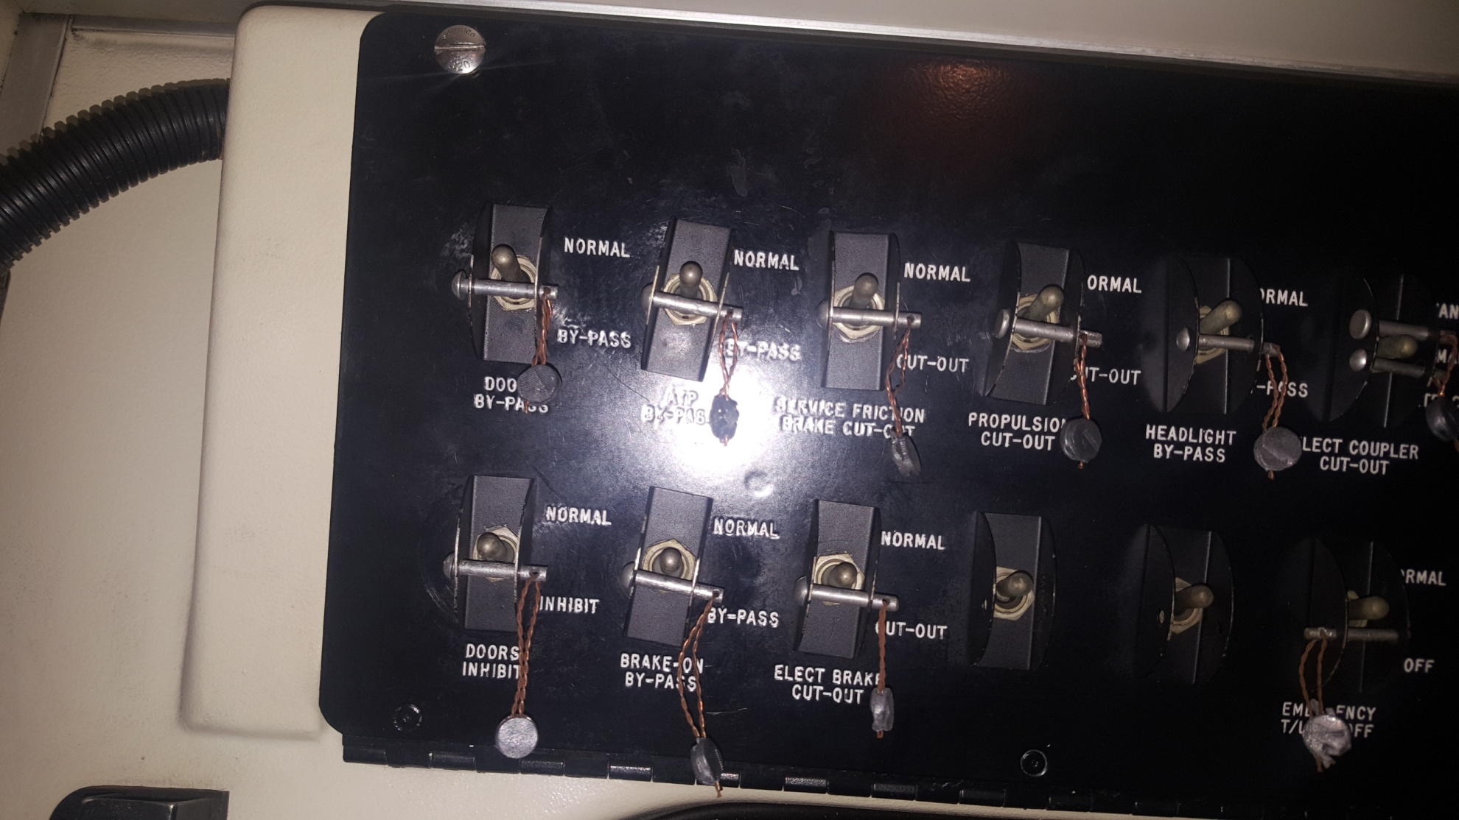

Figure 4.7 Bypass Switch, Courtesy of MTA

|  |
| --- |
| **DECELEROMETER INSPECTION PROCEDURE** |
| **Agency Specific:** |
|  |
|  |
|  |

4-8 MASTER CONTROLLER

The Master Controller controls the operational state of the rail car to include, speed request (linear) power, braking and emergency braking, and on/off power. The inspection procedure is as follows:

Using a portable test unit (PTU) to inspect the Master Controller, the technician shall:

1. Access the inspection checklist.
2. Verify positions of controller and ensure Master Controller is not faulty. The PTU will display if the Master Controller is out of alignment.
3. Perform a control and carbody spin test – *(apply 600v to vehicle).*
4. Perform a Deadman test. A Deadman test checks the Master Controller in the event of an emergency situation. If the Master Controller is released, the rail vehicle will go into emergency braking. The Deadman test is a 2-man task to inspect.
5. Submit procedure checklist.

If the Master Controller is damaged, it is replaced.

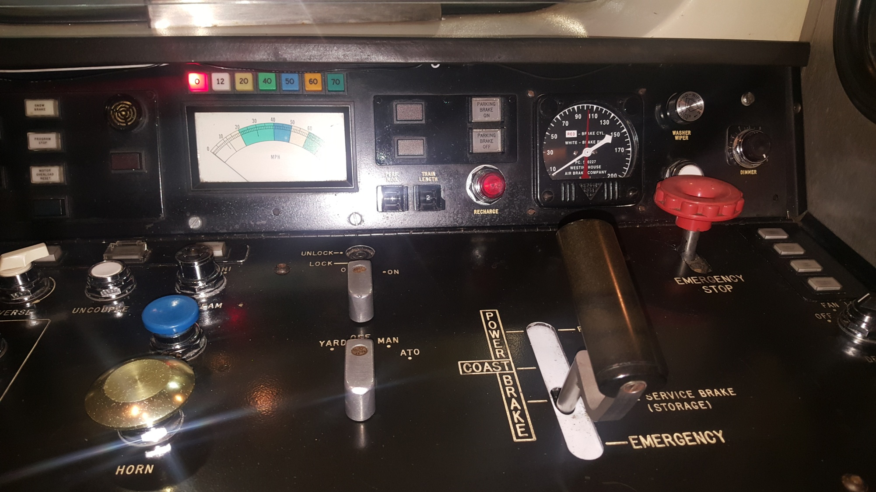

Figure 4.8 Master Controller, Courtesy of MTA

4-9 OPERATOR ACKNOWLEDGMENT BUTTON

The Operator Acknowledgment Button acknowledges an alarm in the event of an overspeed condition. The general inspection procedure is as follows:

1. Ensure acknowledgment light illuminates.
2. Ensure button functions as it should.
3. Inspect for any liquid or debris in switch.

If the button is faulty, it is replaced. The rail car technician should clean the button with an approved cleaner as part of the button’s maintenance.

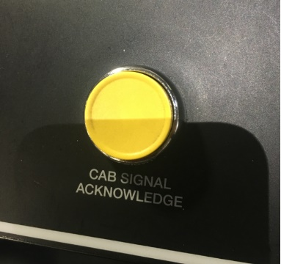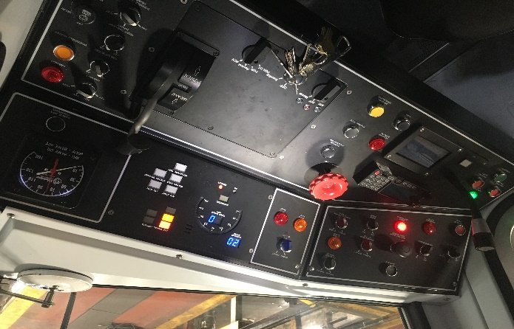

Figure 4.9 Operator Acknowledgment Button, Courtesy of PATCO

4-10 P SIGNAL GENERATOR

The P Signal Generator converts the 0-10-volt analog output in the EU unit to a current signal compatible with the propulsion system interface. A general inspection procedure is as follows:

1. Reset Vehicle on Board Computer (VOBC).
2. Confirm ATC subsystem is functional.

If a problem if determined with the P Signal Generator, the technician shall look for any trouble codes and repair. It is important to keep the P Signal Generator clean and dry.

|  |
| --- |
| **P SIGNAL GENERATOR INSPECTION PROCEDURE** |
| **Agency Specific:** |
|  |
|  |
|  |
|  |
|  |

Module 4 covered ATC component inspection procedures. Make and model of rail vehicles will vary by agency, and therefore, common problems specific to one agency may not be relevant to another. The following learning application is intended for the participant to make note of common inspection problems specific to his agency regarding ATC **interior** components.

|  |  |
| --- | --- |
| Description: PowerPointBLUE.png | **Learning Application 4.1 – Common Problems**  Together as a class, identify and discuss common problems specific to interior ATC components. Participants are encouraged to take notes for future reference. |

|  |  |  |
| --- | --- | --- |
| **Common Problem** | **Common Causes** | **Corrective Action** |
|  |  |  |
|  |  |  |
|  |  |  |
|  |  |  |

4-11 summary

This Module presented the participant with the inspection and maintenance procedures for ATC interior components. As always, the procedures provided are general and you should always adhere to agency specific procedures. Components discussed in this Module included:

* CPU Board/Interface Board;
* Relays/Vital Relays;
* Power Supply;
* Decelerometer;
* Aspect Display Unit;
* Bypass Switch;
* Master Controller;
* Operator Acknowledgement Button; and
* P Signal Generator.