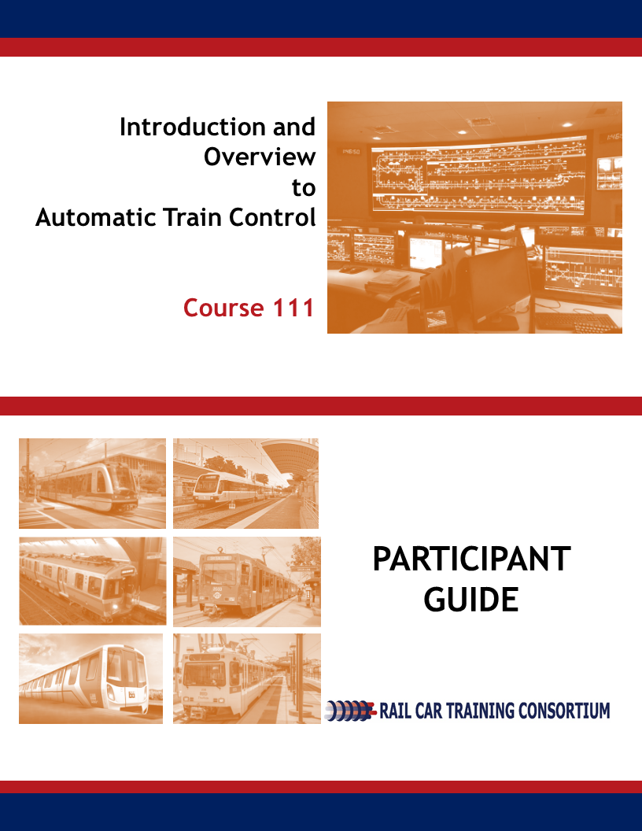
Introduction and Overview

Automatic Train Control

Course 111

Participant Guide

2018
Rail Car Training Consortium

REVISION INDEX

Any additions, deletions, or revisions are to be listed below.
Revision No. | Date | Section | Description of Change | Revision Author
1 | 12-2018 | All | Technical Writer Edits | K.Youngbluth
2 | 1-2019 | All | ISD Edits | K.Ribaudo

Disclaimer: This course is intended to educate employees of public transportation systems that have agreed to voluntarily participate in the Rail Car Training Consortium. It is intended only as informal guidance on the matters addressed, and should not be relied upon as the only method or manner for performing the tasks or work outlined in the materials. Anyone using this document or information provided in the associated training program should rely on his or her own independent judgment or, as appropriate, seek the advice of a competent professional in determining the exercise of care in any given circumstances. These materials are based on compendiums of knowledge from transit employees, manufacturers and outside consultants, each of whom may approach a repair, update, or maintenance in their own unique way. Always follow the safety and maintenance procedures from your own agency, union, relevant OEM(s) and/or regulatory organizations. In addition, the course materials include examples from member agencies, nomenclature, procedures, and configurations which can vary from one transit location to another. The document that you are now referencing may have been modified by the Consortium member. For the original versions, please go to TransitTraining.net or contact the Transportation Learning Center.

The Rail Car Training Consortium, its participating agencies and labor unions, as well as the Transportation Learning Center, make no guaranty or warranty as to the accuracy or completeness of any information provided herein. The Rail Car Training Consortium, its participating agencies and labor unions, as well as the Transportation Learning Center, disclaim liability for any injury or other damages of any nature whatsoever, directly or indirectly, resulting from the use of or reliance on this document or the associated training program.

Note: All images contained within this document were contributed by Rail Car Training Consortium members unless otherwise noted.

How to Use the Participant Guide
Purpose of the Course

Course 111: Introduction and Overview of Automatic Train Control provides participants with an overview to the automatic train control components, safe practices, and tools used in the field. This course is intended to prepare the participant to inspect and maintain the automatic train control system.

Approach of the Book

Each course Module begins with an outline, a statement of purpose and objectives, and a list of key terms. The outline will discuss the main topics to be addressed in the Module. A list of key terms identifies important terminology that will be introduced in this Module. Learning objectives define the basic skills, knowledge, and abilities course participants should be able to demonstrate to show that they have learned the material presented in the Module. Exercises are built in throughout the course materials to assist the participants in learning and reviewing key information.

Table of Contents
How to Use the Participant Guide iv
Module 1 General Safety Procedures 1
1-1 Overview 2
1-2 Safety Review 2
1-3 Overview to Automatic Train Control 9
1-4 Summary 11
Module 2 Automatic Train Protection (ATP) 12
2-1 Principles of Operation 12
2-2 Summary 18
Module 3 Automatic Train Operation (ATO) 19
3-1 Principles of Operation 20
3-2 Summary 20
Module 4 Train to Wayside Communication (TWC) 22
4-1 Principles of Operation 23
4-2 TWC Specific Components 23
4-3 Summary 26
Module 5 Automatic Train Supervision (ATS) 27
5-1 Principle of Operation 28
5-2 Summary 28
Module 6 Common Components 29
6-1 Overview 30
6-2 Exterior Components 30
6-3 Interior Components 31
6-4 Summary 41
Module 7 Tools 42
7-1 Overview 43
7-2 Tools 43
7-3 Summary 45

List of Figures

Figure 1.1 LOTO. Courtesy of LA Metro. 2
Figure 1.2 Personal Protective Equipment 8
Figure 1.3, Moving Block System. Source: Wikipedia 10
Figure 2.1, ATP Speed Commands. Courtesy of WMATA 14
Figure 2.2 Overspeed Setpoints. Courtesy of CATS 15
Figure 4.1 Operation Control Center. Courtesy of SD MTS 23
Figure 4.2 TWC Antenna. Courtesy of CATS 24
Figure 4.3 TWC Code Control Box. Courtesy of SDMTS 24
Figure 6.1 Receiver Coil. Courtesy of CATS Figure 6.2 Antenna. Courtesy of CTA 30
Figure 6.3 Speed Sensor. Courtesy of CTA 31
Figure 6.4 Receiver Board. Courtesy of MTA 31
Figure 6.5 Relays. Courtesy of MTA 32
Figure 6.6 Power Supply. Courtesy of MTA 33
Figure 6.7 Interface Board. Courtesy of PATCO 34
Figure 6.8 Decelerometer. Courtesy of MTA 35
Figure 6.9 Aspect Display Unit. Courtesy of PATCO 36
Figure 6.6 ADU Control Functions 37
Figure 6.10 Bypass Switch. Courtesy of MTA 38
Figure 6.11 Master Controller. Courtesy of MTA 39
Figure 6.12 Acknowledgement Button. Courtesy of PATCO 39

Module 1

General Safety Procedures
Outline
  - Overview
  - Safety Review
  - Overview to Automatic Train Control (ATC)
  - Summary
Purpose and Objectives
The purpose of this Module is to provide participants with an understanding of rail agency general safety procedures, specific to Automatic Train Control.
Following the completion of this Module, the participant should be able to complete the objectives with an accuracy of 75% or greater:
- Demonstrate the ability to explain agency specific shop procedures;
- Explain lockout/tagout (LOTO);
- Demonstrate the ability to explain road worker protection (RWP);
- Describe required personal protection equipment (PPE) practices; and
- Explain Blue/Light/Blue Flag.
Key Terms
- Lockout/Tagout (LOTO)  - Road Worker Protection (RWP) | - Right-of-Way  - Blue Light/Blue Flag | - Personal Protection Equipment (PPE)

  - overview
Safety is of utmost importance and should always be taken seriously, regardless of the task. The rail car technician can expect to work in confined spaces, around moving and heavy equipment and in a loud environment that can present workplace hazards.
Each transportation system establishes its own safety procedures for working on rail vehicles. Participants of this course shall always adhere to individual agency safety procedures first and foremost.
  - safety review
Safety Procedures
Each agency will have specific procedures in place to ensure the safety of all workers. The procedures that will be discussed in this Module include:
- Lockout/Tagout (LOTO)
- Road Worker Protection (RWP)
- Blue Light/Blue Flag
- Personal Protective Equipment (PPE)
Lockout/Tagout
Lockout/Tagout (LOTO) is an essential safety measure required procedure by all transportation systems whenever the rail car technician is working in the rail vehicle shop. LOTO must be applied whenever a vehicle is isolated from its source of voltage.
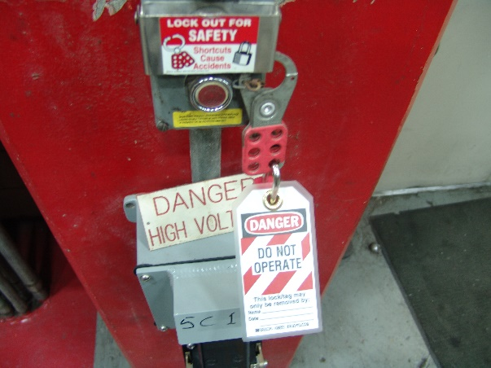
Each rail car technician has their own combination lock(s) that is used when they are working on electrical circuits. The technician will secure the lock on the control lever of a disconnected device prior to beginning work on the system. In addition to securing the lock, technicians must fill out and sign a tag, which is hung from their lock. The tag describes the nature of the work to be performed and the duration of time they estimate to complete the job. A worker can use more than one lock if there are multiple sources of energy to be “locked out”. This will result in the system maintaining a zero-energy state until every lock is removed from each device. When it comes time to re-energize the system, the workers must look to ensure that all locks have been removed from the shutoff devices. If a lock remains, the tag will indicate the technician that is still working on the device and the work that is being performed.
Figure 1.1 LOTO. Courtesy of LA Metro.
For some equipment, it may be simple enough to turn the power switch off to remove power from the equipment. However, in many cases, equipment in the system have several energy sources. Therefore, following proper LOTO procedures is crucial to the safety of all workers.
Remember to follow four basic actions in a LOTO procedure:
- Identify all energy sources connected to the equipment needing repair and maintenance;
- Disable, redirect or stop all energy from being energized to the subject equipment;
- Apply restraint devices to prevent the system from starting up while work is being performed; and
- Confirm that the equipment has reached a zero-energy state.
LOTO safety programs are required and are essential to ensure worker safety, however, it is still important for workers to use diligence on the job. There may be several people working on a system at one time. Some workers might not know the proper LOTO procedure, or may choose to ignore it altogether. For your safety, and of others, it is important to follow your agency’s procedures regarding LOTO.
Road Worker Protection
Road Worker Protection (RWP) provides a safe work zone for technicians while they are working on the Right-of-Way. RWP helps to reduce the risk of accidents, such as being struck by moving vehicles or exposure to the overhead catenary system. Policies regarding RWP must be strictly enforced and adhered to, in order to ensure the safety of all persons working on or near the tracks.
In a situation where a technician is working on the right-of-way, the American Public Transportation Association (APTA) states the following shall happen:
- A definition of track fouling distances;
- Procedures designed to put in place practices for working in a manner that minimize danger to roadway workers being struck by moving trains or other on-track equipment;
- A program of training and qualification to ensure competence and demonstrated proficiency in on-track safety procedures;
- A record-keeping system capable of monitoring training and qualification records;
- A process to encourage and allow roadway workers to report near misses, unsafe acts, and/or conditions;
- A process for the rail transportation system (RTS) to address reported near misses, unsafe acts or conditions;
- Procedures to be used by each RTS for monitoring the effectiveness of and compliance with the program;
- An on-track safety program document that includes all rules and operating procedures governing track occupancy and protection, which is readily available to all roadway worker;
- Procedures to guarantee that roadway workers have the absolute right to challenge in good faith whether the on-track safety procedures comply with the rules of the RTS, and to remain clear of the track until the challenge is resolved;
- Provisions for multiple work groups within a common area; and
- A process for determining the level of access, training, supervision and/or escort required for all individuals accessing the roadway.
Additional (Optional) Reading – Refer to APTA’s Roadway Worker Protection Program Requirements for additional safety information.
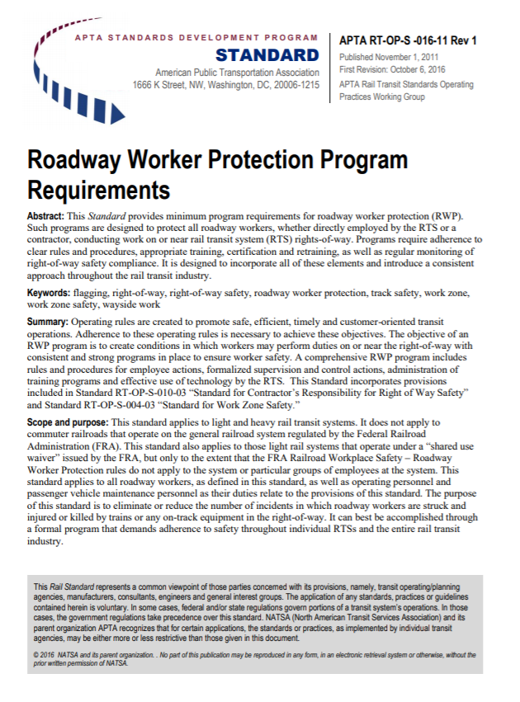

The following Case Study provides an example of the safety rules and procedures followed at Greater Cleveland Regional Transit Authority (GCRTA) for workers performing maintenance or inspection on-track.
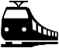
Case Study 1.1: Greater Cleveland Regional Transit Authority GCRTA On-Track Safety Procedures
- Personnel shall wear the minimum PPE as required. Gloves and hearing protection are required by specific tasks or exposure.
- Before crossing tracks, STOP, LISTEN and LOOK for trains or vehicles approaching from either direction. Do not cross tracks unless there is time to walk normally without taking chances that would make a misstep serious. Do not step on the head of the rail. Never cross the track within switches, which may be operated at any time.
- Do not walk on-tracks except when absolutely necessary. When walking alongside the tracks, face the normal direction of traffic.
- Consider all tracks as operating tracks and be on the alert for trains operating in either direction on any track at any time.
- As a train approaches, move to a position of at least ten (10) feet from the centerline of the running rail while facing the approaching train.
- Do not step into the first 20 feet of the track area behind or in front of a stopped train.
- The overhead wires of the 600-volt catenary system should always be considered as energized. Use the 10’ Rule and refrain from performing work near the energized catenary system.
- Cell phone or other personal electronic device use is strictly forbidden while working active track.

Learning Application 1.1 – Road Worker Protection Plan
Together as a class, identify and discuss the Road Worker Protection policies and procedures put in place at your agency.

Road Worker Protection Policy:
Blue Light/Blue Flag Protection
Blue Light/Blue Flag protection is a procedural plan put in place, similar to LOTO, to ensure the safety of all workers performing inspection or maintenance on, in, under, on top of, between or near a rail vehicle, subject to danger of personal injury by any moving equipment.

Together, employers and employees share in the responsibility to ensure the safety of all. The diagram below identifies the responsibilities of different parties and how all play an important role in enforcing the proper blue light/blue flag safety procedures.

The blue light/blue flag signifies that work is being performed in, on, under, on top of, between or near the rail vehicle. When work is being performed in any of these locations, a clearly distinguishable blue light or flag shall be placed at the end of each rail vehicle, in the center of the track. Additionally, trains must be uncoupled. If a blue light/flag is present, vehicles may not enter or leave the designated area. Only the group of workers which displayed the blue signal may remove it.
Federal Rail Administration (FRA), Regulation 218 states when blue lights/flags are displayed, the following must be adhered to:
- The equipment may not be coupled.
- The equipment may not be moved.
- Other rolling equipment may not be placed on the same track so as to reduce or block the view.
- Rolling equipment may not pass a displayed blue signal.
Personal Protective Equipment (PPE)
Personal Protective Equipment, often referred to as PPE, is equipment provided to the worker to limit exposure to workplace hazards. Hazards exist in every workplace in many different forms; sharp edges, falling objects, flying sparks, chemicals, noise, and a myriad of other potentially dangerous situations. The Occupational Safety and Health Administration (OSHA) requires that employers protect their employees from workplace hazards that can cause injury.
Hard hats, safety glasses, ear plugs and safety boots are common pieces of PPE. According to OSHA, PPE is worn to minimize the risk the exposure to chemical, radiological, physical, electrical, mechanical or other workplace hazards.
OSHA Standard 1920.132(a) states that PPE, including protective equipment for eyes, face, head, and extremities, protective clothing, respiratory devices, and protective shields and barriers, shall be provided, used, and maintained in a sanitary and reliable condition whenever it is necessary by reason of hazards, processes, environment, chemical hazards, radiological hazards, or mechanical irritants encountered in a manner capable of causing injury or impairment in the function of any part of the body through absorption, inhalation or physical contact.
PPE should be maintained and cleaned per equipment and agency guidelines. PPE should fit comfortably. The difference between properly and ill-fitting PPE, could result in injury or death.
Employer Responsibility
Employers are responsible to assess the workplace to determine if hazards are present, or likely to be present. The hazards that are present, or that are likely to be present, will necessitate the use of PPE. If such hazards are present, or likely to be present, the employer is required to train and educate employees on the following.
- When PPE is necessary;
- What kind of PPE is necessary;
- How to properly wear, adjust and take off PPE;
- Limitations of the equipment; and
- Proper care, maintenance, life-span and disposal of equipment.
Employee Responsibility
Employees also have a responsible to ensure their safety. The employee shall:

- Attend PPE training sessions;
- When required, wear PPE properly;
- Care for and maintain PPE; and
- Advise a supervisor regarding the replacement of damaged PPE.

Employees should have a clear understanding on which piece of PPE to use for each job function and how to properly use PPE before beginning any work.

In some cases, employers may have reason to believe that an employee who has already been trained on PPE does not have an adequate understanding required to safely utilize the PPE. In this situation, the employer shall retrain the employee. Retraining is required in the following situations, but is not limited to:
- Changes in the workplace which renders previous training obsolete;
- Changes in the types of PPE to be used which renders previous training obsolete; and
- Unsatisfactory knowledge or skills in an employees’ use of assigned PPE, which indicate that the employee has not retained the requisite understanding or skill.
A full list of PPE items was provided in Course 100. When performing Automatic Train Control (ATC) maintenance or inspection checks, it is necessary to wear the appropriate PPE for the task. PPE for rail car technicians may include:
- Safety vest;
- Bump cap;
- Gloves;
- Dust mask; and
- Safety glasses.

Figure 1.2 Personal Protective Equipment (PPE)

Learning Application 1.2 – Agency Specific Shop Procedures
Although some safety procedures can be generalized, each agency will have their own specific safety protocols and procedures. With the help of your instructor, identify other shop procedures which relate to the safety of employees.

Shop Procedures:

  - Overview to Automatic Train Control (ATC)
Overview of Signaling
Signaling is a way of ensuring a train is operating safely and efficiently on the track and by keeping a required distance between trains.
Signaling is achieved through the interaction of equipment at different locations within the signaling system, including:
- Wayside: (Central Control Center)
- Carborne Equipment

Communication exchanged between a location and/or a signaling system will provide the following data associated with that particular train:
- Distance Traveled | - Run Number | - Train Location
- Overspeed Condition | - Signal Display | - Train Number
- Route Number | - Speed Commands
- Route Requests | - Train Identification

Overview of Automatic Train Control
Automatic Train Control (ATC) is a system that uses various subsystems and continuous communication between the train and the wayside to determine train location, without the need for traditional track circuits. Instead, ATC uses segments, which are best defined as being virtual track circuits and helps to more accurately pinpoint the exact position of a train. This results in a more efficient and safe way to manage railway traffic.
In the modern moving block ATC systems, the protected section for each train is not statically defined by the infrastructure. Instead ATC uses segments. Segments have the operating appearance of a moving block but are still constrained by physical blocks. The trains themselves are continuously communicating their exact position to the equipment in the track by means of a bi-directional link, either inductive loop or radio communication.
In Figure 1.3, the train position and its braking curve is continuously calculated by the train, and then communicated via train to wayside. A moving block system allows for the reduction of the safety distance between the two consecutive trains. The distance is varying according to the continuous updates of the train location and speed, maintaining the safety requirements. This results in a reduced headway between consecutive trains and an increased transport capacity.
Figure 1.3, Moving Block System. Source: Wikipedia

The video below provides a high-level overview to Communication Based Train Control (CBTC), which can also be referred to as ATC For purpose of this training course, the term Automatic Train Control (ATC) will be used but, be sure to check with your agency for terminology specific to your trains.

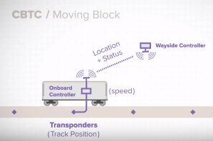 | Watch a 5-minute video that covers the basic principles of CBTC.  Source: Siemens Industry https://www.youtube.com/watch?v=oGq_oFZX1Bg

The four (4) ATC subsystems that will be discussed in this course are:
- Automatic Train Operation (ATO)
- Automatic Train Protection (ATP)
- Automatic Train Control Supervision (ATCS)
- Train to Wayside Communication (TWC)
It is important to note that not all trains will have every type of ATC subsystem and therefore, each Module may not be applicable to the trains at your agency. Because of this, Course 111 is developed so that the instructor may choose to only teach the modules specific to the subsystems on trains at your agency.

Important Note
Though the general principles of operation of ATC can be applied across all rail cars, nomenclature used for certain components also varies by agency, OEM, and type of rail car. It is important therefore for the participant and instructor to note that some of the terms used in this course for specific ATC components may differ from the ones used in their agency for a particular rail car.

1-4 summary
Hazards exist in every workplace. Following the proper safety policies and procedures will help to avoid injury and accident. Remember, safety is of utmost importance and should always be taken seriously. Always follow your agency’s safety plans.
In this Module, participants learned about the following safety procedures:
- Lockout/Tagout (LOTO)
- Road Worker Protection (RWP) plan
- Blue Light/Blue Flag
- Personal Protective Equipment (PPE)
Additionally, participants were introduced to a high-level overview of ATC. This course is designed in which Modules 2-5 can be taught independently, and therefore the instructor will only teach modules which pertain to the trains at your agency. Subsequent modules will go into greater detail regarding the ATC subsystems.

Sources

Communication Based Train Control. In Wikipedia. Retrieved August 2018, from https://en.wikipedia.org/wiki/Communications-based_train_control

Module 2

Automatic Train Protection (ATP)
Outline
  - Principles of Operation
  - Summary
Purpose and Objectives
The purpose of this Module is to provide participants with an understanding on the principle of operation of Automatic Train Protection.
Following the completion of this Module, the participant should be able to complete the objectives with an accuracy of 75% or greater:
- Explain the principles of operation of Automatic Train Protection; and
- Describe the function of the Automatic Train Protection system.
Key Terms
- Automatic Train Control  - Automatic Train Operation  - Speed Sensors  - Antennas  - Receiver Coils | - By-Pass Switch  - Decelerometer  - Interlockings | - Interface Board  - Unoccupied Block

2-1 principles of operation
Automatic Train Protection (ATP) assists in enforcement of safe operation of the rail vehicle and prevents collisions and derailments. ATP imposes speed limits to maintain safe train operation and to operate trains in accordance with civil speed restrictions. At interlockings, which are locations in the track that contain track crossings, ATP ensures safe guards train movement. Trains can cross an interlocking when a clear, uncontested route is available and the track switches are locked in position. In a situation when two or more trains are competing for the use of a common track segment, ATP allocates the track to one train at a time and locks out all others.
The ATP system provides vital, safety-related, vehicle control, non-vital outputs for the operator’s use and non-vital outputs to an Event Recorder and Diagnostic Monitoring System. The main ATP functions are:
- Train Detection;
- Speed Commands;
- Overspeed Protection; and
- No motion determination.
Train Detection
ATP uses multiple track blocks to monitor train detection. Track segments are divided into sections that are continuously monitored for train occupancy by track circuits.
Speed Commands
A speed command, or speed limit, is signed by the ATP and is based on the number of unoccupied blocks separating two trains. As the distance between the lead and following train decreases, the speed limit reduces to prevent collisions. The minimum separation between two trains is typically one unoccupied block. Under normal conditions, two trains are never allowed to occupy the same block.
Figure 2.1 below is an example of the various speed command signals on the trains at WMATA. The number of speed commands will vary by agency.

Speed Command | Cab Display | Carrier Frequency +/-0.5% | Code Rate +/-5% | Maximum Velocity
75 Code | 75 | 5525 Hz | 21.5 Hz | 75 mph
65 Code | 65 | 5525 HZ | 15.3 Hz | 65 mph
55 Code | 55 | 5525 Hz | 10.1 Hz | 55 mph
50 Code | 50 | 5525 Hz | 6.83 Hz | 50 mph
45 Code | 45 | 5525 Hz | 4.5 Hz | 45 mph
40 Code | 40 | 4550 Hz | 21.5 Hz | 40 mph
35 Code | 35 | 4550 Hz | 15.3 Hz | 35 mph
28 Code | 28 | 4550 Hz | 10.1 Hz | 28 mph
22 Code | 22 | 4550 Hz | 6.83 Hz | 22 mph
15 Code | 15 | 4550 Hz | 4.5 Hz | 15 mph
Stop and Proceed | 0 | None | None | Train comes to a complete stop by applying full service brakes.  Configure for Stop and Proceed, then maximum train speed is 15 mph.
Left Door Open | 0 | 4550 Hz | 3 Hz | Left door open, zero velocity
Right Door Open | 0 | 5525 Hz | 3 Hz | Right door open, zero velocity
Figure 2.1, ATP Speed Commands, Courtesy of WMATA

Learning Application 2.1 – Speed Commands
Together as a class, identify the speed command signals at your agency.

Speed Command | Cab Display | Carrier Frequency | Code Rate | Maximum Speed

Overspeed Protection
The overspeed protection function assures trains on the same track maintain a safe following distance by requiring that the train speed remains at or below the value set by the ATP. Overspeed protection prevents collisions resulting from the following train going too fast to stop within the available distance. The ATP system declares overspeed if the vehicle speed equals or is greater than the set overspeed limit for the speed command the train is operating under. Figure 2.2 shows the overspeed setpoints for each speed command. When an overspeed is detected, the ATP system will:
- Alert the operator by way of audible alarm.
- Require operator to acknowledge overspeed within 2.5-3 seconds. The vehicle speed will need to be brought down to 1mph or greater below the current speed command.
- If overspeed is not acknowledged, ATP will automatically apply the brakes and bring the train to a stop.
In the event an overspeed condition is not acknowledged by the operator, the train will be brought to a complete stop. The process to recover from an overspeed condition will vary by agency. For example, at Denver RTD, the operator would have to key out and key back up while also calling control and acknowledge they “ran a red.”
Figure 2.2 below identifies the Speed Command and Overspeed Setpoint on the rail vehicle at CATS.
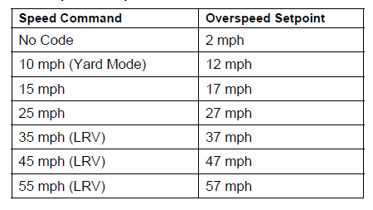
Figure 2.2 Overspeed Setpoints, Courtesy of CATS

No-Motion Determination
The ATP system is also used to determine no-motion, which occurs when the vehicle is completely stopped. Depending on the agency, a no-motion determination may or may not control door operation. Refer to your agency for specific information.
In addition to the above-mentioned functions of the ATP system, the following propulsion, braking control and door functions function are also supported:
- Propulsion enable;
- Full service brake;
- Emergency brake; and
- Door control.
Propulsion and Braking Controls
Under normal circumstances, the ATP does not use any of its braking or propulsion controls. The use of the propulsion and braking controls are only used in the event of an unacknowledged overspeed. If unacknowledged, the ATP system will use its braking controls to bring the vehicle to a stop.
Door Control
The ATP system monitors and controls the enabling and disabling of doors. However, the ATP system does not perform the actual function of opening the doors as that is a manual operation of the vehicle operator.
Modes of Operation
The ATP system will typically have three (3) modes of operation: Normal, yard, and by-pass, although specific terminology may vary by agency.
Normal Mode
Normal ATP mode is indicated by an illuminated ATP indicator on the console in the operator’s cab. When in normal mode:
- The operator controls vehicle speed.
- Speed limits are imposed by the ATP system.
- Audible and visual alarms are initiated in the event of an overspeed condition.
- The ATP system applies vehicle brakes and brings train to a complete stop if operator does not acknowledge overspeed within the predetermined amount on time.
Yard Mode
Entry into or exit from Yard mode is always signaled by an audible alarm. Yard Mode of the ATP system may happen in one of two ways:
- Automatically, when the ATP system detects and decodes a yard mode specific code.
- Manually, if there is a valid No Code cab signal.
When in Yard mode:
- The Yard indicator illuminates.
- Overspeed functions, ATP alarms and automatic braking function as if in Normal mode.
- A 10mph speed limit is set with a 12mph overspeed setpoint.
- Yard mode is automatically exited when any code, other than the yard specific code is detected. The Yard mode indicator will then distinguish.
Bypass Mode
ATP Bypass mode is typically initiated when there is a failure in the ATP system. When in bypass mode, some normal functions of the ATP system will no longer function, such as overspeed protection, alarms and automatic braking. Bypass mode is initiated by use of the cutout switch, although specific terminology may vary regarding the component’s name.
When Bypass mode is activated, the ATC subsystem will continue to:
- Monitor all vital and non-vital inputs:
- Monitor for cab signals from the receiver coils;
- Monitor inputs from speed sensors and calculate vehicle speed; and
- Monitor brake-rate input from decelerometer.
When Bypass mode is activated, the following functions are disabled:
- Overspeed detection and protection;
- ATC subsystem alarm;
- Departure test;
- Cab signal calibration;
- Decelerometer calibration; and
- Wheel size calibration.
An intermittent, non-ATP alarm is audible when the system is in Bypass mode. When in Bypass mode, transfer to ATP normal mode can only happen, when no-motion status is achieved. If a mode change is implemented before no-motion status is achieved, the penalty brake is applied and the vehicle is brought to a complete stop. The ATP mode change will then be implemented.
Learning Application 2.2 – Automatic Train Protection
As a class, identify and make note of any differences to the ATP system used at your agency.

2-2 Summary
In this Module, participants learned about ATP and its main functions, which include:
- Train Detection;
- Speed Commands;
- Overspeed Protection; and
- No motion determination.
Additionally, this Module also presented the three modes of operation under ATP, to include:
- Normal Mode;
- Yard Mode; and
- Bypass Mode.
It is important to remember that the information in this Module general, participants should always refer to your agency regarding specifics to the ATP system used at their agency.

Module 3

Automatic Train Operation (ATO)
Outline
3-1 Principles of Operation
3-2 Summary
Purpose and Objectives
The purpose of this Module is to provide participants with an understanding on the principles of operation of Automatic Train Operation (ATO).
Following the completion of this Module, the participant should be able to complete the objectives with an accuracy of 75% or greater:
- Explain the principles of operation of ATO; and
- Describe the function of the ATO system.
Key Terms
- Automatic Train Operation (ATO)  - Speed Regulation | - Station Stopping

3-1 Principles of operation
The role of ATO is similar to that of ATP, the difference is that ATO also performs the functions of the train operator. If a vehicle is operating under ATO, the functions of ATP are always incorporated. The functions of ATO may include:
- Smooth acceleration of the train to running speed.
- Regulation of the train’s speed to the command speed.
- Stopping the train smoothly at the proper position at the station.
- Controls doors at stations to allow passengers to board and/or exit.
- Initiates train departures from a station after the doors are closed.
Speed Regulation
The speed regulation function matches the actual train speed to the command speed. Speed commands are received from coded track circuits and picked up by a carborne receiver, decoded, and compared to actual train speed. There are also speed sensors, located on one of the axles, which provide speed data to the ATO system. The speed limit and speed are displayed to the operator on the console in the operator’s cab. The speed regulation function works like the ATP over-speed function except for how each operating system responds to speed commands and regulations. The ATP over-speed function, and is the comparison between the speed command and the actual speed that is used to apply a penalty brake to slow or stop the train when the actual speed exceeds the command speed. The ATO speed regulation function is the comparison that is used to control the propulsion and braking to maintain the actual speed close to the commanded speed. In effect, speed regulation removes the human operator from the control loop for running the train and provides for a constant response by propulsion and braking, without the delay of human reaction time and without the variability inherent in manual train operation.
Station Stopping
Station stopping is another function of the ATO subsystem, which involves bringing the train to a stop automatically at a predetermined location in each station. Station stopping is accomplished by wayside units working together with receivers, logic circuits, and speed regulation equipment on the train. The wayside units consist of triggers or “markers” spaced some distance from the station as reference points for programmed stopping.

The speed regulation and station stopping abilities of ATO operate similarly. When ATO is engaged, the operator controls the speed of the car as long as the operator doesn’t go over the speed command displayed on the aspect display unit. If the train speed is exceeds the command displayed, an interface between the train (receiver coil) and the wayside (speed command through the rail) is activated. An audible alarm notifies the operator of the overspeed. If the speed is not adjusted appropriately within a given time frame, the carborne control unit reconciles the actual speed to allowable and the train is brakes accordingly through carborne equipment – similar to train stops.

Learning Application 3.1 – Automatic Train Operation
As a class, identify and make note of any differences to the ATO system used at your agency.

3-2 summary
In this Module, the participant learned about Automatic Train Operation (ATO) and its functions, which include:
- Speed regulation; and
- Station stopping.
As always, refer to your agency regarding any additional specifics related to the ATO system used at your agency.

Module 4

Train to Wayside Communication (TWC)
Outline
4-1 Principle of Operation
4-2 Train Wayside Communication Specific Components
4-3 Summary
Purpose and Objectives
The purpose of this Module is to provide participants with an overview to the principle of operation and components specific to Train to Wayside Communication (TWC).
Following the completion of this Module, the participant should be able to complete the objectives with an accuracy of 75% or greater:
- Explain the principle of operation of TWC;
- Explain the function of train to wayside communication; and
- Identify and Explain:
  - TWC Antenna; and
  - TWC Code Control Box.
Key Terms
- Train to Wayside Communication (TWC)  - Code Control Box (CCB) | - Radio Frequency Identifier (RFID)  - TWC Antenna | - Printed Circuit Board (PCB)

4-1 Principle of operation
Train-to-Wayside Communication (TWC)
TWC is a subsystem of ATC. TWC enables the effective exchange of data between the rail vehicle and traffic control center. Via a TWC link, route information, train number, train length, train ready, train berthed, train motion and doors status information stored onboard the train is transmitted to the wayside.

The TWC subsystem uses a radio frequency identifier (RFID), in which Central Command is able to see which vehicle is occupying which space.

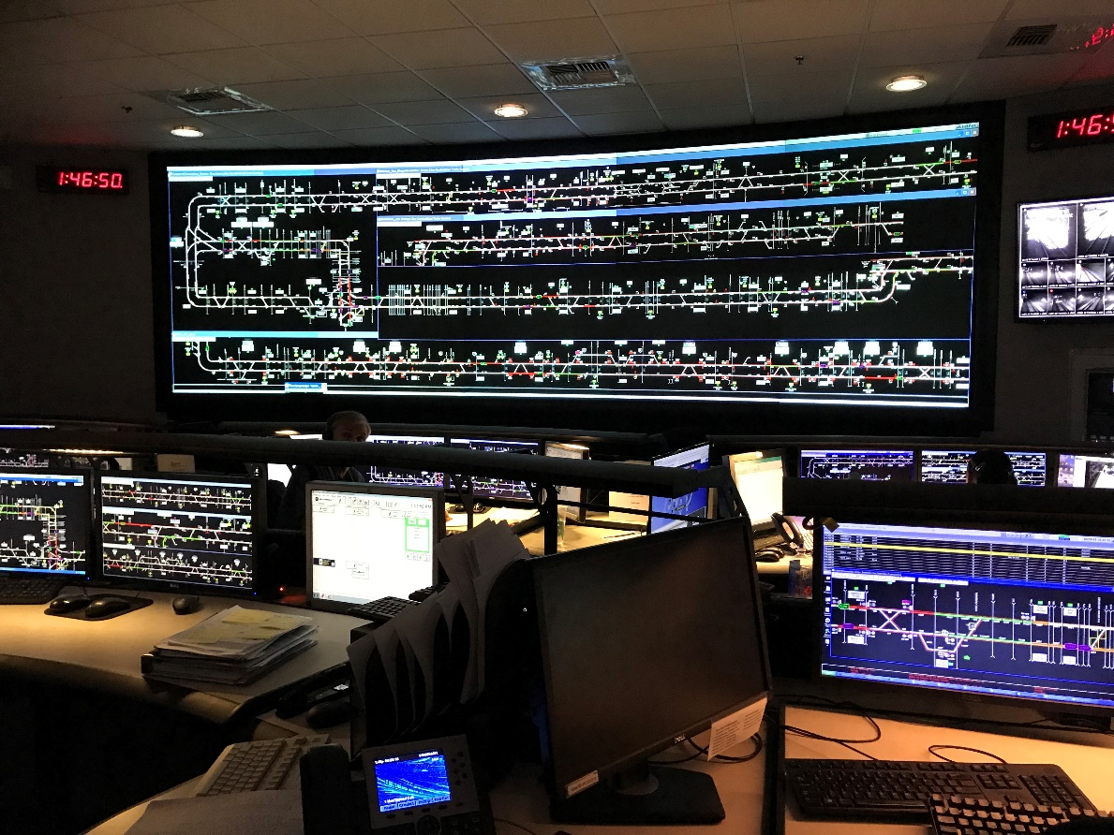
Figure 4.1 Operation Control Center. Courtesy of SD MTS

4-2 twc specific components
There are many common components used regardless of the type of ATC subsystem, and will be discussed in Module 5, however, there are a few which are specific to the TWC system.
TWC Antenna
Two Antennas are located underneath, on opposite ends of the vehicle. The antenna receives and transmits signals to and from the TWC loops mounted between the rails. The TWC antennas are connected to the TWC specific printed circuit board (PCB), located in the ATC subsystem enclosure.
Only one TWC antenna is used at a time and therefore, the TWC PCB will use relays to determine which antenna should be used. The same process is used for determining the appropriate coils to use.

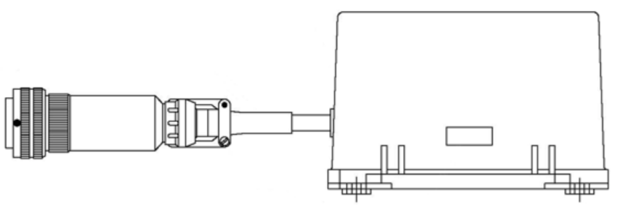
Figure 4.2 TWC Antenna. Courtesy of CATS
TWC Code Control Box (CCB)
A code control box can be found in each operator’s cab. The CCB sends route requests and other information to the wayside TWC system. The system can only send information to the wayside system when the vehicle is positioned over a TWC antenna. Figure 4.3 provides an example of a CCB used at San Diego MTS.

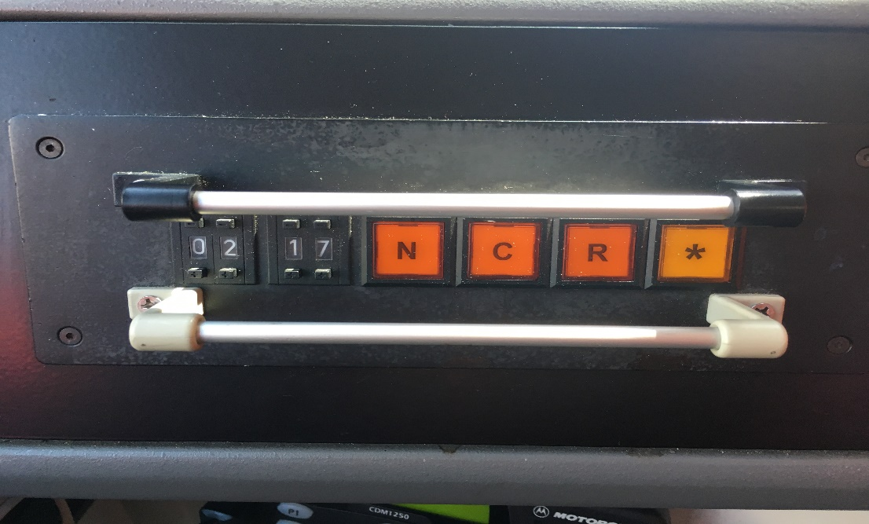
Figure 4.3 TWC Code Control Box. Courtesy of SDMTS
Four orange buttons, N, C, R and * are located on the CCB. The meaning of each initial is listed below.
N: Normal
C: Cancel
R: Reverse
*: Name will vary by agency
The buttons on the TWC CCB are control switches to manually operate the rail vehicle. They are used to call on track switches and traffic signals and allow the operator to change routes. If the operator decides to go into manual mode, she will push the asterisk button to change the route. At Denver RTD, the rail vehicle has to be physically located over an antenna. At this time, the buttons will light up and the operator can make the call to switch routes. At SFMTA, the rail vehicle has to stop within brackets, at which time the buttons will illuminate and then the operator can make the desired change.

Learning Application 4.1 – TWC Code Control Box
If different than the example provided above, in the space below, draw the TWC code control box on rail vehicles at your agency. Be sure to identify the function for each button.

Use this space to draw the TWC box on rail vehicles at your agency.

Learning Application 4.2 – Train to Wayside Communication
As a class, identify and make note of any differences to the TWC system used at your agency.

4-3 summary
In this Module, the participant learned about Train-to-Wayside Communication (TWC) how it allows effective communication between the rail vehicle and the control center. Additionally, TWC specific components, Antennas and the TWC CCB, were also discussed in this Module.

Module 5

Automatic Train Control Supervision (ATCS)
Outline
5-1 Principles of Operation
5-2 Summary
Purpose and Objectives
The purpose of this Module is to provide participants with and understanding on the principles of operation of Automatic Train Control Supervision.
Following the completion of this Module, the participant should be able to complete the objectives with an accuracy of 75% or greater:
- Explain the principle of operation of automatic train control supervision.
- Explain the function of automatic train control supervision.

Key Terms
- Automatic Train Control Supervision (ATCS) | - Central control | - Track sensors

5-1 Principle of Operation
Unlike the other subsystems of ATC, Automatic Train Control Supervision (ATCS) is not a safety critical aspect of the train control system. Central Control oversees ATCS on the rail vehicle and monitors vital information through video and track sensors. Destination information, on-time performance and regulated speed is controlled by the central command center. When operating under ATCS, the regulated speed is more restrictive than that of ATP to ensure proper timing of the rail vehicle. ATCS also allows vehicles to travel closer to each other, since they are monitored closer. All information for ATCS is transmitted through the TWC antenna.
Learning Application 5.1 – Automatic Train Control Supervision
Together as a class, identify the speed that rail vehicles operate under ATCS.

Automatic Train Control Supervision
Agency | ATCS speed
Example: San Francisco Municipal Transportation Agency (SFMTA) | 40-45 mph

5-2 summary
In this Module, participants learned about Automatic Train Control Supervision (ATCS) and that it is not a safety-critical aspect of the train control system. Today, many agencies do not have ATCS on their vehicles, so be sure to refer to your agency for specific information, if ATCS is used.

Module 6

Common Components
Outline
6-1 Overview
6-2 Exterior Components
6-3 Interior Components
6-4 Summary
Purpose and Objectives
The purpose of this Module is to provide participants with and understanding of common components which make up ATC subsystems.
Following the completion of this Module, the participant should be able to complete the objectives with an accuracy of 75% or greater:
- Demonstrate the ability to identify and explain the function of ATC components.

Key Terms
- Antenna/Receiver Coils | - Interface Board
- Speed Sensors | - Decelerometer
- Train ID | - Aspect Display Unit
- CPU Board | - Master Controller
- Vital Relays | - Operator Acknowledgment Button
- Power Supply | - Bypass Switch

6-1 Overview
There are many common components that comprise the ATC subsystem, regardless of make or type of system. The components discussed in this Module will be divided into exterior and interior categories. Always refer to your agency for specific information regarding the ATC subsystem and components used at your location. Components discussed in this section include:
Exterior Components | Interior Components
Antenna/Receiver Coils | CPU Board | Decelerometer
Speed Sensors | Vital Relays | Aspect Display Unit
Train ID | Relays | Master Controller
 | Power Supply | Operator Acknowledgement Button
 | Interface Board | Bypass Switch

6-2 Exterior components
Antenna/Receiver Coils
Antennas and Receiver Coils pickup and receive information from the wayside portion of ATC. Antennas and Coils are bracket-mounted on the truck at each end of the rail vehicle and inductively receives the speed command signal present in the running rails. In the event more than one speed command is picked up at the same time, the ATC subsystem responds to the lowest speed command.
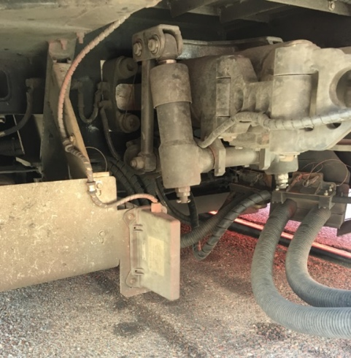
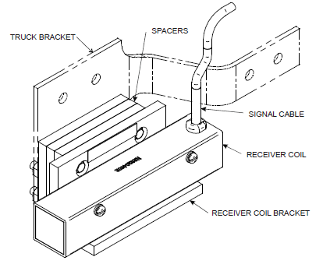
Figure 6.1 Receiver Coil. Courtesy of CATS Figure 6.2 Antenna. Courtesy of CTA

Speed Sensors
Speed sensors measure train speed. There are typically two (2) speed sensors that are mounted on one axle of the truck at each end of the vehicle. To ensure vehicle speed measurement cannot be lost, speed sensors receive power from a separate supply within the ATC specific subsystem enclosure. The speed sensors output a series of signals as the axles turn. The ATC subsystem counts the sensor pulses and calculates vehicle speed by applying conversion factors. The speeds are calculated by sensor pulses per axle revolution and wheel diameter to the sensor pulse count. If the two calculated speeds differ, the higher speed is used.

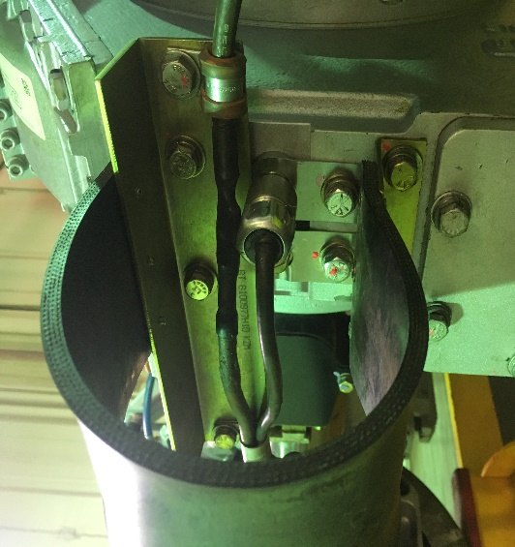
Figure 6.3 Speed Sensor. Courtesy of CTA
Train ID
The Train ID sends information to the ATC subsystem such as, station stopping pattern and local or express trip. The operator will enter a 4-digit number into the LCD screen on the console to indicate the specific route.

6-3 interior components
CPU Board
The CPU Board is the “Brain” of ATC, which interprets speed sensors and picks ups signals from receiver coils.
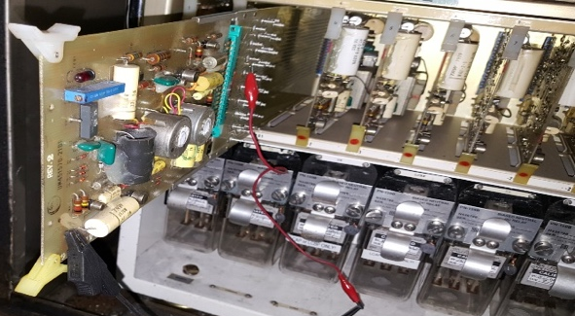

Figure 6.4 Receiver Board. Courtesy of MTA
Relays and Vital Relays
Relays are an electrically operated switch and many are involved in ensuring the ATC system is functionally properly. It is important to note that vital relays are safety sensitive relays, such as an automatic brake relay. The type, number of and function of relays will vary by agency. For example, Cleveland’s GCRTA trains have four (4) vital relays and eight (8) relays for other functions. Some examples of Relays and Vital Relays can include:
- Zero Velocity Relay: When the train is at a standstill, the zero velocity relay allows other relays to function.
- Underspeed Relay: The train is allowed to keep moving when kept under the allowable maximum speed.
- Automatic Braking Relay: If the train does not adhere to allowable maximum speed, the brakes will be applied automatically.
- Cutout Relay: If the system is inactive, the Cutout Relay bypasses the cab signal and allows the train to operate.

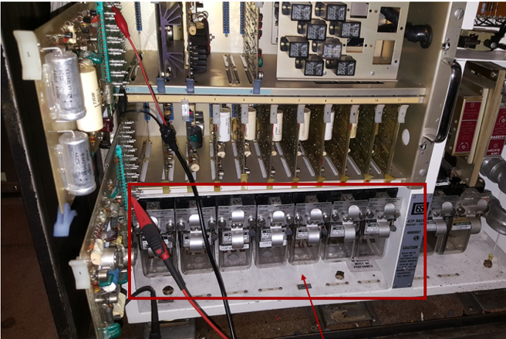
Figure 6.5 Relays. Courtesy of MTA

Learning Application 6.1 – Relays
Together as a class, identify the number and functions of vital relays and relays that makeup the ATO system at your location.

How many Vital Relays are part of the ATC system? __________

How many Relays are part of the ATC system? __________

Vital Relay/Relay Name | Function
Power Supply
The Power Supply provides power to the system.

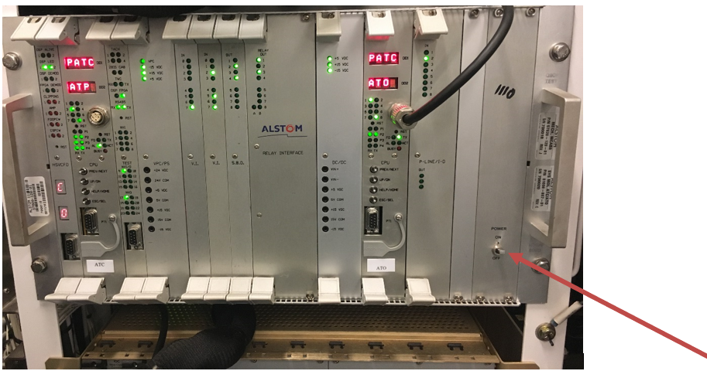
Figure 6.6 Power Supply. Courtesy of MTA
Interface Board
The interface board is mounted in the ATC subsystem enclosure rack and performs various functions, which may include:
- Provide vital outputs;
- Provide departure test signals;
- Receive non-vital inputs;
- Processing accelerometer signals; and
- Process speed sensor signals.

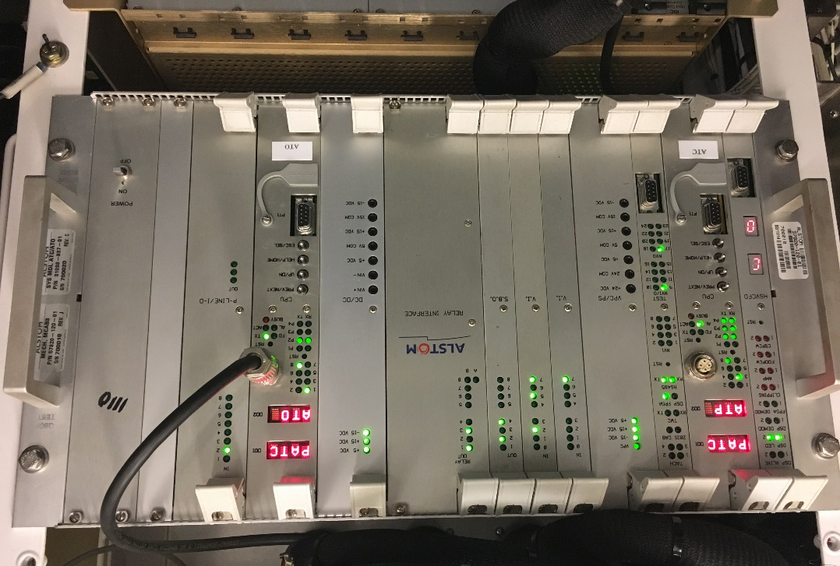
Figure 6.7 Interface Board. Courtesy of PATCO
Learning Application 6.2 – Interface Board
Identify the number and functions of boards on the Interface Board in your ATC subsystem rack.

Board | Function
Decelerometer
The decelerometer ensures the Operator brakes fast enough if the train is speeding. It is an electro-mechanical component mounted to the ATC subsystems enclosure frame that senses the instantaneous braking rate of the vehicle. Typically, the Operator has 2.5-3 seconds to respond and acknowledge their overspeed. If the Operator does not acknowledge the overspeed, a code drop will happen, which will automatically apply the brakes and bring the train to a stop.

Figure 6.8 Decelerometer. Courtesy of MTA
Aspect Display Unit (ADU)
The Aspect Display Unit (ADU), displays the Actual Speed and Allowable Speed. The ADU is mounted at the operator station in each cab of the rail vehicle. The ATP system communicates to each ADU through the use of the vehicle Train Control and Monitoring System (TCMS) network. The ATP system only communicates with one ADU at a time, depending on which cab end is keyed on. The ADUs are interchangeable between cab ends and will self-configure upon power-up to determine whether it is operating as the A-end or B-end ADU.
Depending on agency, the ADU may use tri-color (amber/red/green) LEDs to indicate current speed, speed command and overspeed. Although they will vary, all ADUs will have, at a minimum:
- Command Speed
- Train Speed
- Overspeed Indicator
- Audible alarm to indicate operator of a condition which needs to be acknowledged, such as overspeed.
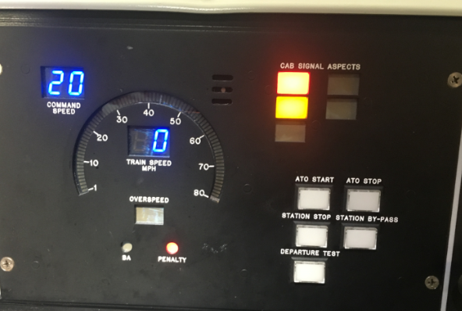
Figure 6.9 ADU. Courtesy of PATCO
The table below provides some examples of different controls that may be found on the ADU. Space is provided at the bottom to add any agency specific information.

NAME | FUNCTION | DEVICE TYPE
Speed/Speed Limit Display | Analog display of speed and speed limit (mph)
Speed | Digital display of vehicle speed (mph) | LED displays
Target Speed | Digital display of ATP determined target speed limit (mph) | LED displays
ATP Bypass | Indicate that ATP control and supervision is bypassed | LED lamp
Overspeed | Indicate an ATP overspeed condition | LED lamp
ATP Failure | Indicate that the ATP system has failed | LED lamp
Depart Test | Departure test initiation and status | Pushbutton and LED lamp
Cab Signal | Indicates that a valid cab signal is being received and decoded by the ATP | LED lamp
Stop & Proceed | Initiated and indicates stop and proceed operation | Pushbutton and LED lamp
Street Running | Initiated and indicates Street Running operation | Pushbutton and LED lamp
Alarm | Audible alert of overspeed conditions or other appropriate conditions | alarm
Agency Specific:

Agency Specific:

Figure 6.6 ADU Control Functions

By-Pass Switch
The By-Pass Switch may have different functions depending on the agency and the type of ATC subsystem. The By-Pass Switch turns the ATC subsystem off for trains in Cleveland. For example, on the trains in Cleveland, GCRTA have ATC on only a portion of their light rail. Therefore, train operators will go into by-pass to disable the ATC system and run with the speed limit of 15mph.

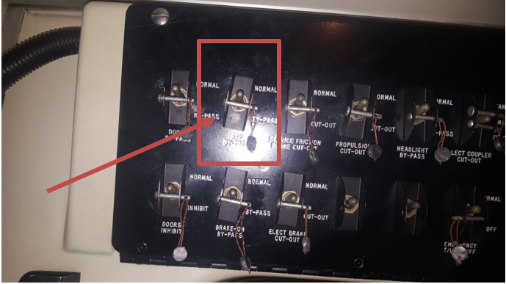
Figure 6.10 Bypass Switch. Courtesy of MTA
BYPASS SWITCH AGENCY SPECIFIC NOTES:

Master Controller
The Master Controller controls the operational state of the rail car.
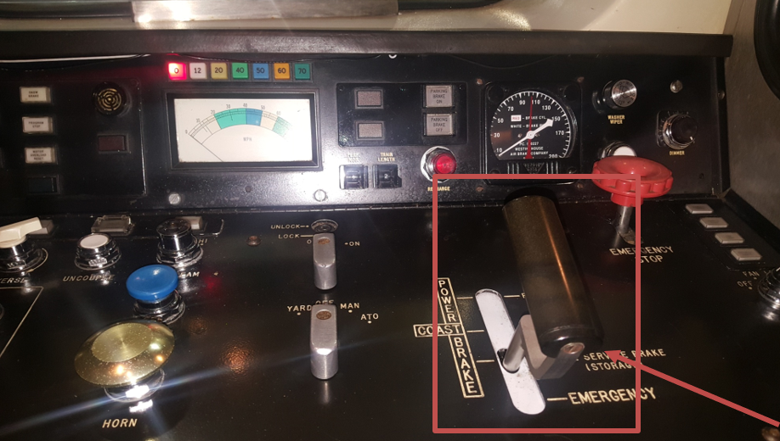
Figure 6.11 Master Controller. Courtesy of MTA
Operator Acknowledgment Button
The operator acknowledgement button is located in the operator’s cab on the console. The operator will have to suppress the button and acknowledge, in the event of an error, such as overspeed.

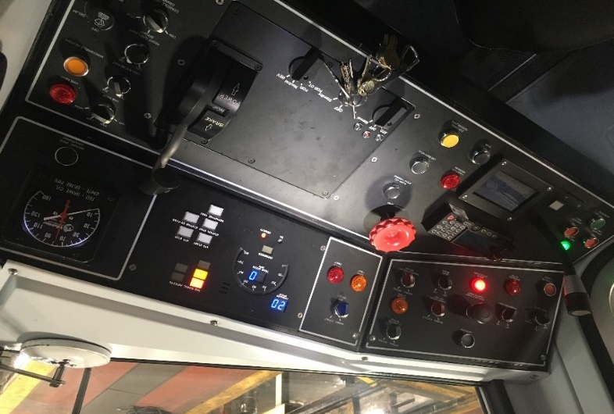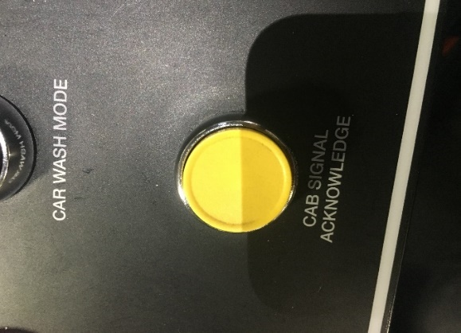
Figure 6.12 Acknowledgement Button. Courtesy of PATCO.

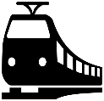  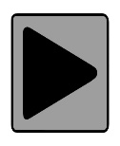 | Instructional Video – ATC Components  The instructional video produced at PATCO provides the participant with an overview to ATC components. Password: railcar Click the image below to view video.

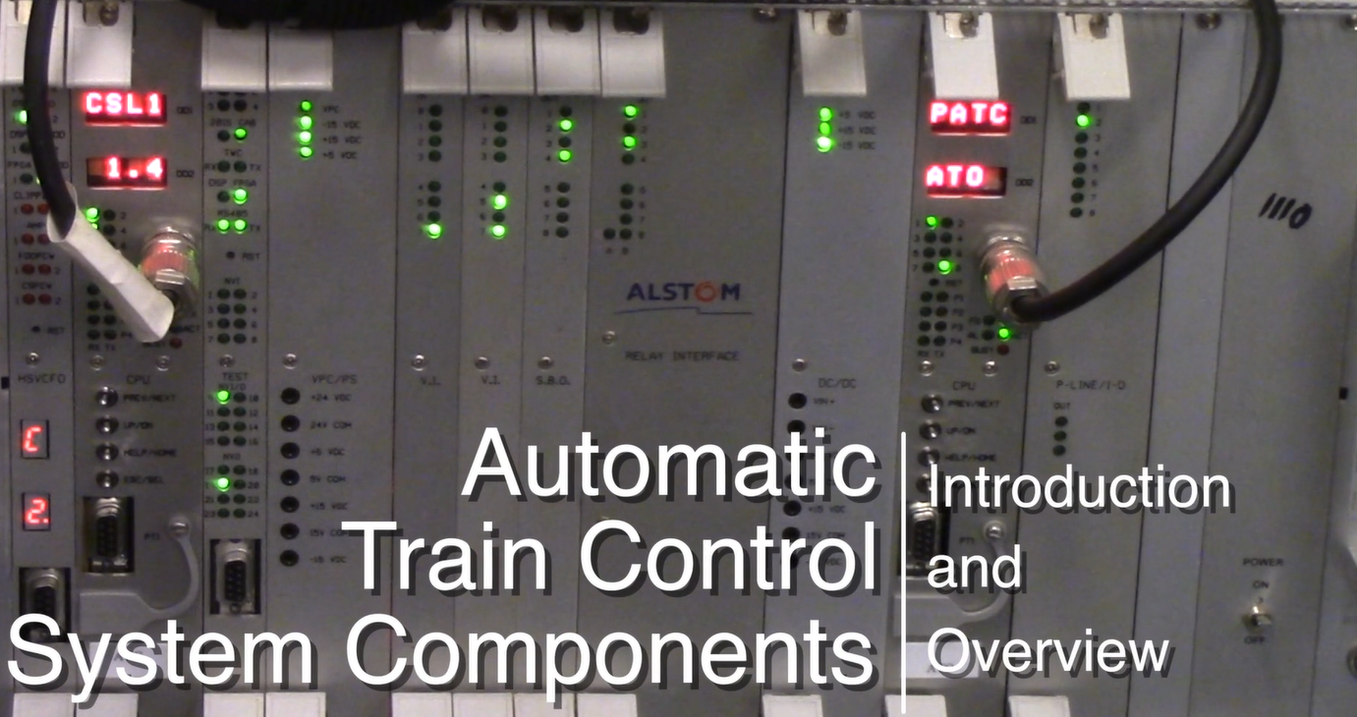

Learning Application 6.3 – Other Components
Identify any other components, which make up the ATP system at your agency. Write the component name, function and any other relevant information.

Component | Function | Notes

  - Summary
In this Module, participants learned about the common components used across ATC subsystems. Components were separated by exterior and interior and include:
Exterior Components | Interior Components
Antenna/Receiver Coils | CPU Board | Decelerometer
Speed Sensors | Vital Relays | ADU
Train ID | Relays | Master Controller
 | Power Supply | Operator Acknowledgement Button
 | Interface Board | Bypass Switch

Module 7

Tools
Outline
6-1 Overview
6-2 Tools
6-3 Summary
Purpose and Objectives
The purpose of this Module is to provide participants with an overview of tools rail car technicians will use, specific to ATC inspection and maintenance.
Following the completion of this Module, the participant should be able to complete the objectives with an accuracy of 75% or greater:
- Demonstrate the ability to identify, explain and use:
  - PTU/PTE
  - Crew/Activation Key
  - Cab Signal Generator
Key Terms
- PTU/PTE
- Crew/Activation Key
- Cab Signal Generator

7-1 overview
This Module will guide the Participant through several ATC specific tools used within the scope of the rail vehicle technician’s job. For a full list of tools a rail vehicle technician may use within the scope of their job, not just for ATC inspection, maintenance and troubleshooting, please refer to Course 100 on Transit Training Network. Examples of these tools include:
- Multimeter
- Flashlight
- RF Scanner
- Decibel meter
- Screw driver/nose plier
- Radio
- Torques
- Tachometer

7-2 tools
Tools specific to ATC will vary by agency but are generally, the following will be used for inspection and maintenance:
- Portable Test Unit (PTU)/Portable Test Equipment (PTE)/Laptop
- Crew/Activation Key
- Cab Signal Generator
TOOL | PICTURE | FUNCTION
PTU/PTE/ Laptop | 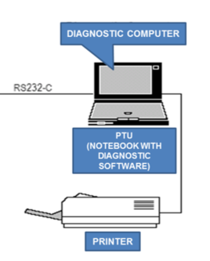 | Used to ensure components are within OEM required parameters and diagnose problems.
Crew/Activation Key |  | Every operator has a crew key but only certain employees hold an activation key. An activation key gains access to specific designated areas of the rail vehicle.
Cab signal generator | 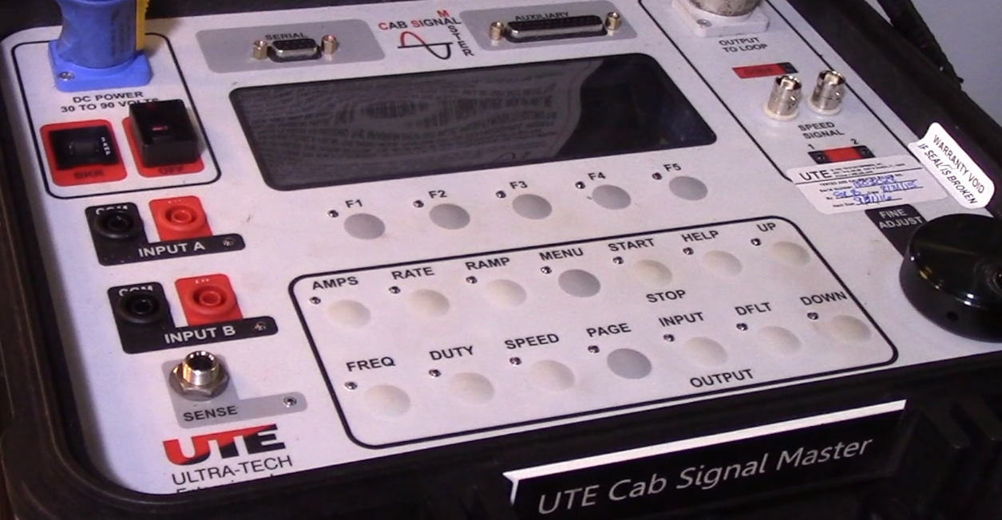 | Used to check cab signal level every 15,000 miles.
Instructional Video - The instructional video provided by PATCO shows how to use a Cab Generator. Watch the video and discuss the similarities and differences between PATCO and your agency.

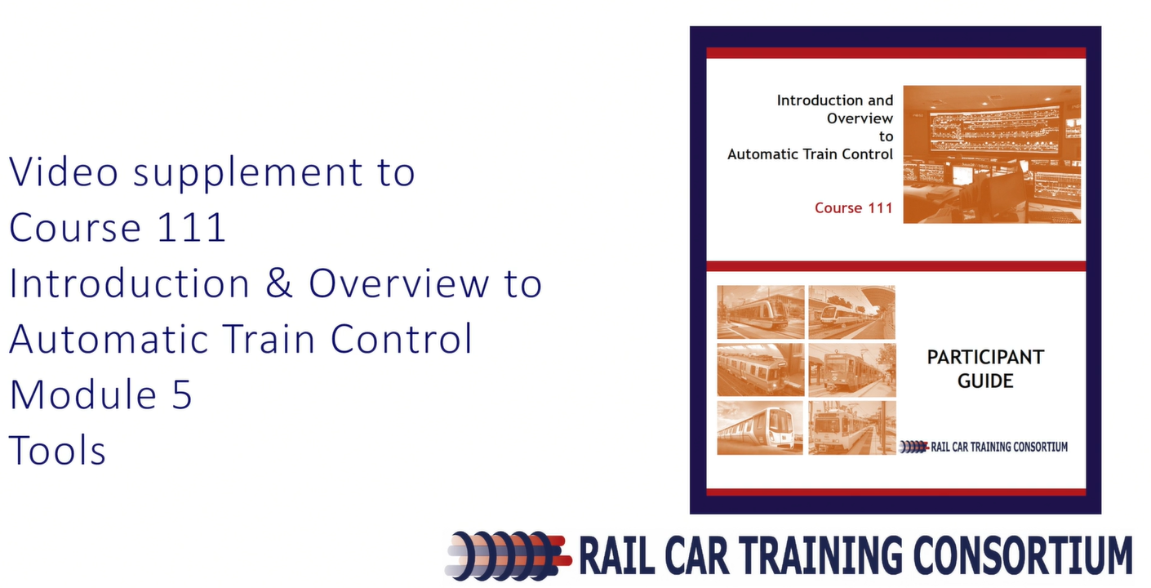

Learning Application 7.1 - Identify any other tools which may be used within the scope of inspections, maintenance or troubleshooting ATC components. Write the tool name, function and any other relevant information.
TOOL | FUNCTION

7-3 summary
This Module provided an introduction to ATC specific tools that rail car technician will use within the scope of his job. Practice makes perfect so be sure to seek out opportunities to observe and use the tools within the scope of inspections, maintenance or troubleshooting ATC components.

